





|  |  |  |  |  |
| --- | --- | --- | --- | --- |
| User Training -  Employee Self Service | | | | |
|  |  | | |  |
| **Author:** | Cognizant Technology Solutions | | |  |
| **Creation Date:** | 19-FEB-2019 | | |  |
| **Last Updated:** | 08-OCT-2019 | | |  |
| **Version:** | 5.0 | | |  |
|  |  | | |  |
| **Approvers:** | **Approval Signatures** |  | **Signoff Date:** |  |
| <Enter Approver> |  |  |  |  |
|  | Signature |  | Date |  |
| <Enter Approver> |  |  |  |  |
|  | Signature |  | Date |  |
| <Enter Approver> |  |  |  |  |
|  | Signature |  | Date |  |



Document Control

Change Record

|  |  |  |  |
| --- | --- | --- | --- |
| Date | Author | Version | Change Reference |
| 19-FEB-2019 | Cognizant Technology Solutions | 1.0 | No Previous Document |
| 21-FEB-2019 | Cognizant Technology Solutions | 2.0 | Added Absence, OTL self-service, PaaS solution |
| 22-FEB-2019 | Cognizant Technology Solutions | 3.0 | Added HOP flow |
| 9- Sep-2019 | Cognizant Technology Solutions | 4.0 | Added Disciplinary , Travel & Saving Plan Detail |
| 8-Oct-2019 | Cognizant Technology Solutions | 5.0 | Updated ‘Add or Update Family/ Emergency Contacts’ , ‘Add or Update Email Address transaction’ , ‘Submit Resignation Transaction’ transactions. |

Reviewers

|  |  |
| --- | --- |
| Reviewer | Position |
|  |  |
|  |  |
|  |  |

Note to Holders:

If you receive an electronic copy of this document and print it out, please write your name on the equivalent of the cover page, for document control purposes.

If you receive a hard copy of this document, please write your name on the front cover, for document control purposes.

Table of Contents

Document Control ii

Change Record ii

Reviewers ii

Introduction 5

About the Employee Self Service Process 6

Employee Login 6

Home Page 8

Personal Information 8

Update Name Details 11

Change Marital Status 13

Add or Update Phone Numbers 15

Add or Update Email Address 17

Add or Update Address Details 19

Add or Update Citizenship/Nationality 21

Add or Update Passport Information 23

Add or Update Visa and Permits (Iqama) Information 25

Add or Update Driving License Information 27

Add or Update Family/ Emergency Dependents 29

View Employment Information 33

View My Organization 34

View Performance Rating History 35

View My Compensation 36

Add Previous Employment section 37

Update Previous Employment 40

Add Languages Section 43

Submit Resignation 47

Worklist – Pending Actions/Approvals 50

Delegation of Approvals 54

Letters and Certificates 57

Individual Compensation Plan Request 59

Applying Absence with Designated Work Schedule 62

Applying Absence with Standard Work Schedule 64

Submitting Rejoining Info 66

Time Card Submission 68

Air Ticket – Booking Request 73

Air Ticket – Encashment Request 80

Employee Disciplinary Action Management 87

Submit Travel Request 91

Submit Travel Claim Request 94

Saving Plan Enrollment 97

Saving Plan Update 99

Open and Closed Issues 104

Open Issues 104

Closed Issues 104

Introduction

Oracle HCM Cloud is user centric, truly global, information-led, collaborative and analytical. Oracle HCM Cloud includes significant functionality enhancements that help you manage Human Resources better.

Purpose

The purpose of this documentation is to guide the steps involved in executing the Employee Self-service business processes specific to Ma’aden in Oracle HCM Cloud. This document will be used as a reference tool to supplement the key user training for Oracle HCM Cloud.

Scope

The scope of this document is to describe the Employee Self-Service & Manager Self Service navigation, with necessary screenshots to add/update/view personal information like phone, email, driver’s license, passport, contacts including emergency contacts, marital status manually by the Employee and Line Manager.

Audience

Employees

Definitions, Acronyms & Abbreviations

|  |  |
| --- | --- |
| Acronym/Technical Term | Position |
| HCM | Human Capital Management |
| LM | Line Manager |
| MDN | Maaden |
| CTS | Cognizant Technology Solutions |

References

|  |  |  |
| --- | --- | --- |
| Document | Version | Date |
| Maaden - AN.010-030 - Requirements Fit Gap - Absence Management - 2018_1016 | 3.0 | 25-OCT-2018 |
| Maaden - AN.010-030 - Requirements Fit Gap - Time and Labor - 2018_1105 | 3.0 | 05-NOV-2018 |

About the Employee Self Service Process

The Employee Self-service helps the employee to independently view and update their personal information in the system.

* Employees can update personal information such as address, phone number, email & address, family and emergency contacts by themselves.
* Employees can update marital status and add dependents in Oracle HCM Cloud.
* Employees can generate soft-copy/hardcopy English letters to be generated from the system. Letters can be generated as soft copy PDF documents by employee.
* Employee can view and update personal information, view notifications, approve transactions through mobile and tablet devices.
* Employees will be able to initiate a new absence request and also update an existing request, withdraw an absence application etc.

Employee Login

Once the hiring process is complete, employee account is created in Oracle HCM Cloud application. On accessing the Oracle HCM Cloud URL, employee will be first directed to the below login page.

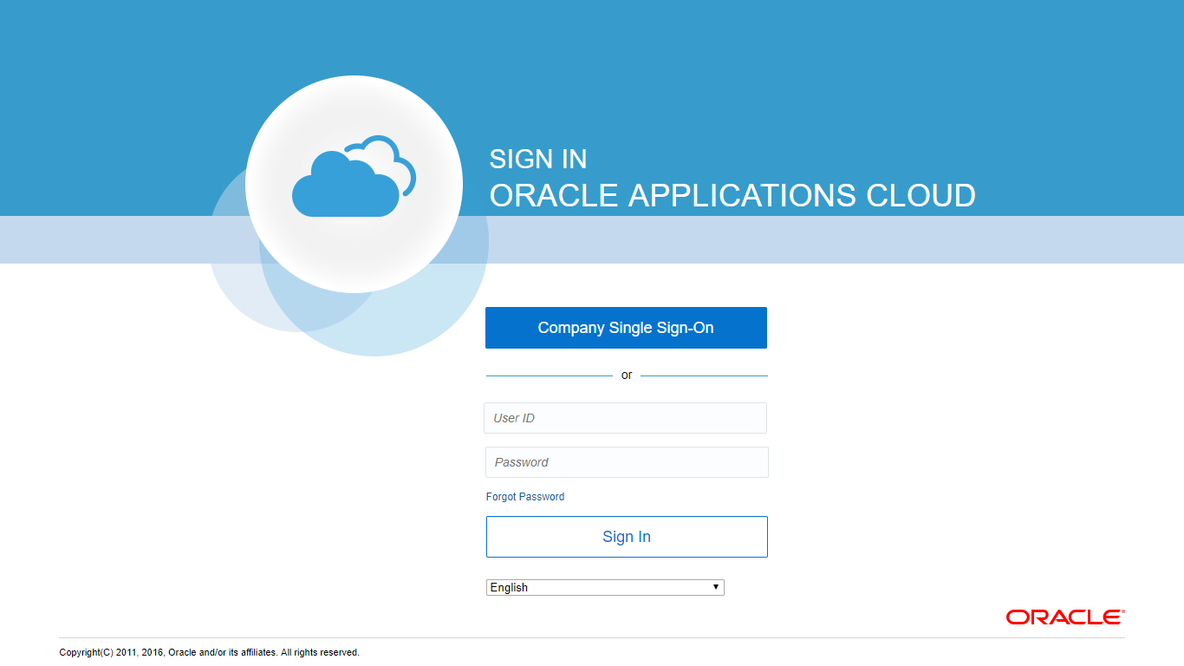

In order to login, click ‘Company Single Sign-On’ and the application takes you to the company’s internal login page like below.

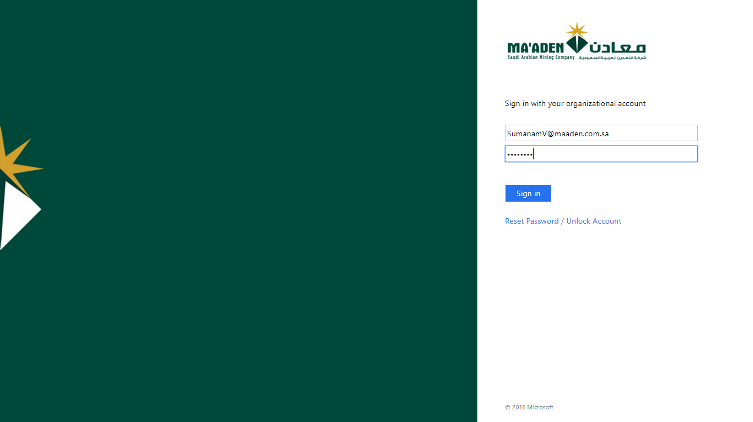

**Enter your Ma’aden login credentials** to authenticate and successful login. Once the credentials are verified, the employee will be taken to the Oracle HCM Cloud home page.

Home Page

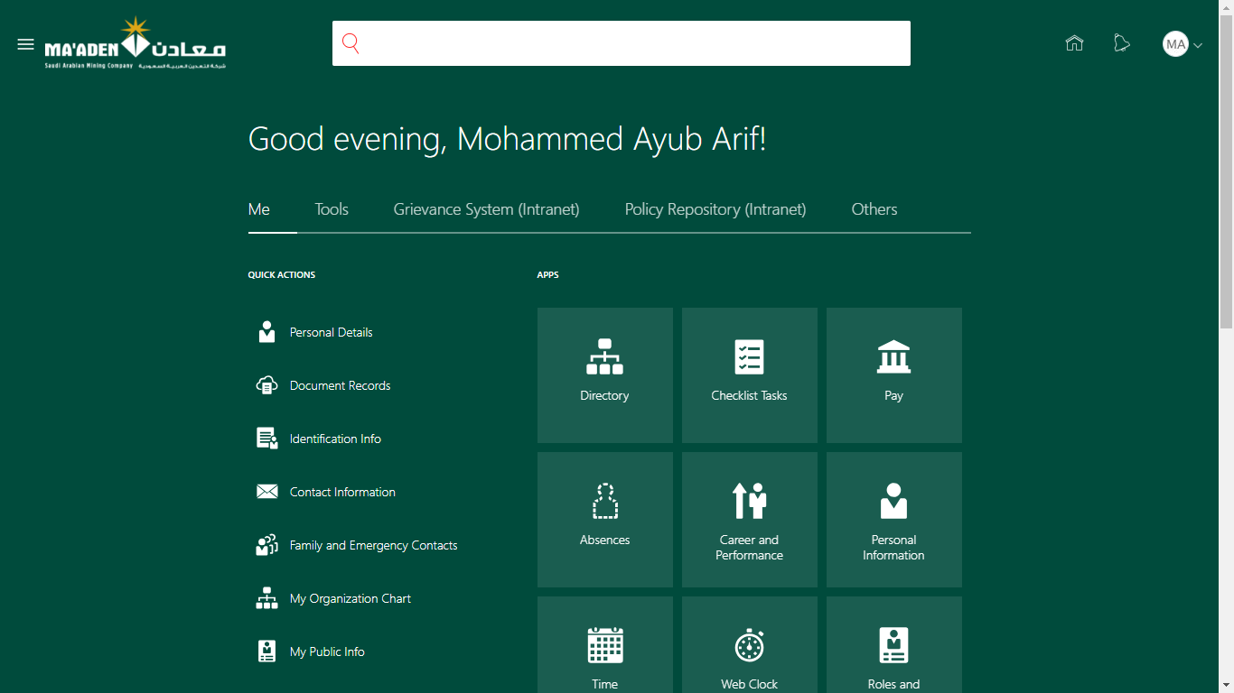

On every login into the HCM application, the user will be directed to the homepage. The homepage contains the various icons which the employee will be able to use in the HCM application.

The forthcoming sections will explain the different icons and their associated functionality. The homepage also contains Quick Actions (shortcuts) to the existing functionalities.

Personal Information

This section illustrates the various actions the employee can perform using the Personal Information icon on the Home Page.

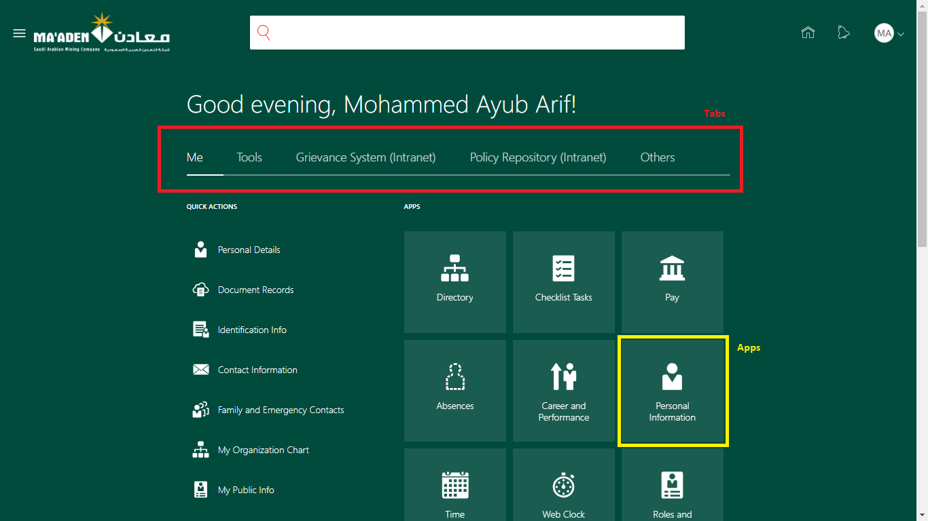

Employee can view their biographical and individual information using **Personal Information** app available under the **Me** tab on the home page. Once the Personal Information page is opened, system by default shows the following cards:

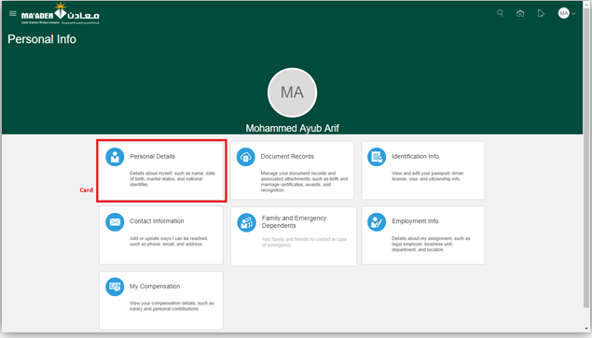

Upon clicking each of the above cards, employee will be able to look at the current information on the system. For example, the personal and employment information tabs are shown below.

Personal Details card:

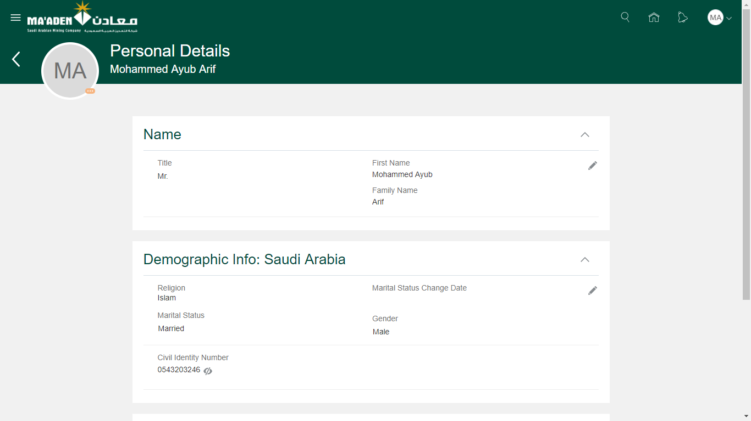

Employment Info card:

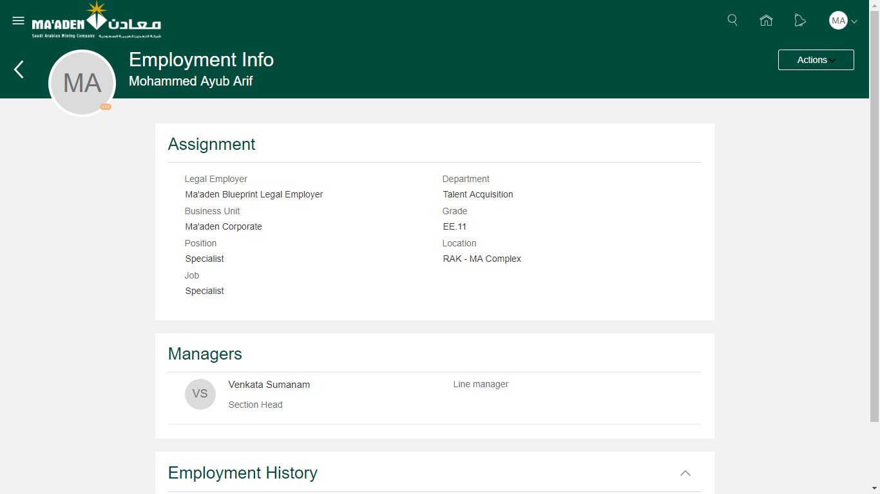

Update Name Details

1. Login as Employee to the Oracle HCM Cloud application.
2. Navigate to Me (tab) > Personal Information (app) > Person Details (card)

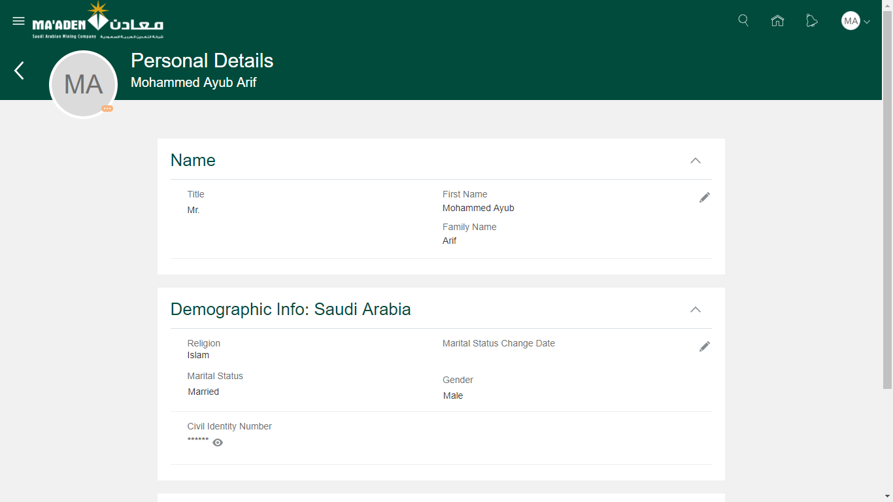

1. Click **Edit** to update the exisitng name details

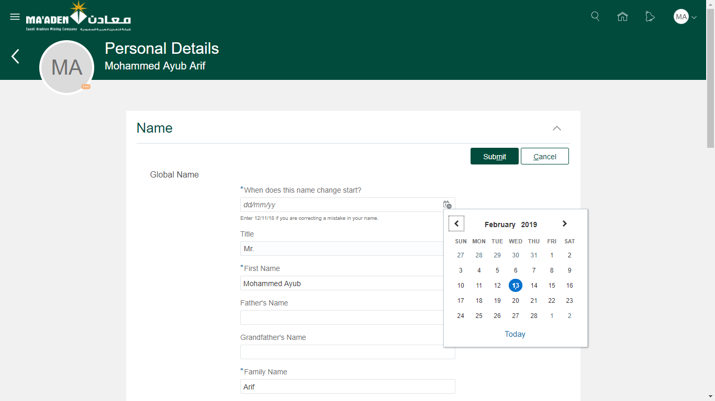

1. Select the date from which the change is effective. This is a mandatory field.
2. Select the mandatory fields and enter the updated details in the respective attributes like Father’s Name and Grandfather’s Name.
3. Employee can also enter their arabic name details by selecting **Enter Local Name** checkbox.

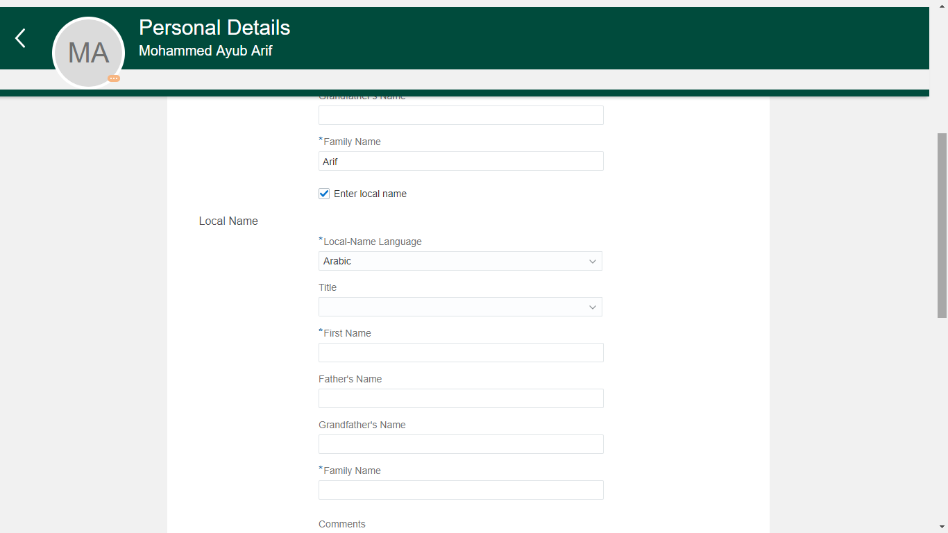

1. Employee may enter the comments and add attachments if necessary.
2. Once all details are entered, click **Submit**.
3. The request is redirected to Employee Relations to validate and approve. Once the request is approved, the new name details will be updated in the system.

Change Marital Status

1. Login as Employee to the Oracle HCM Cloud application.
2. Navigate to Me (tab) > Personal Information (app) > Person Details (card)



1. Click **Edit** under Demographic Info: Saudi Arabiato update the Marital Status details.
2. Select the fields like Religion and the Marital Status from the list of values displayed in the system.
3. If the Marital Status is changed from one value to another, the Marital Status Change Date is mandatory.

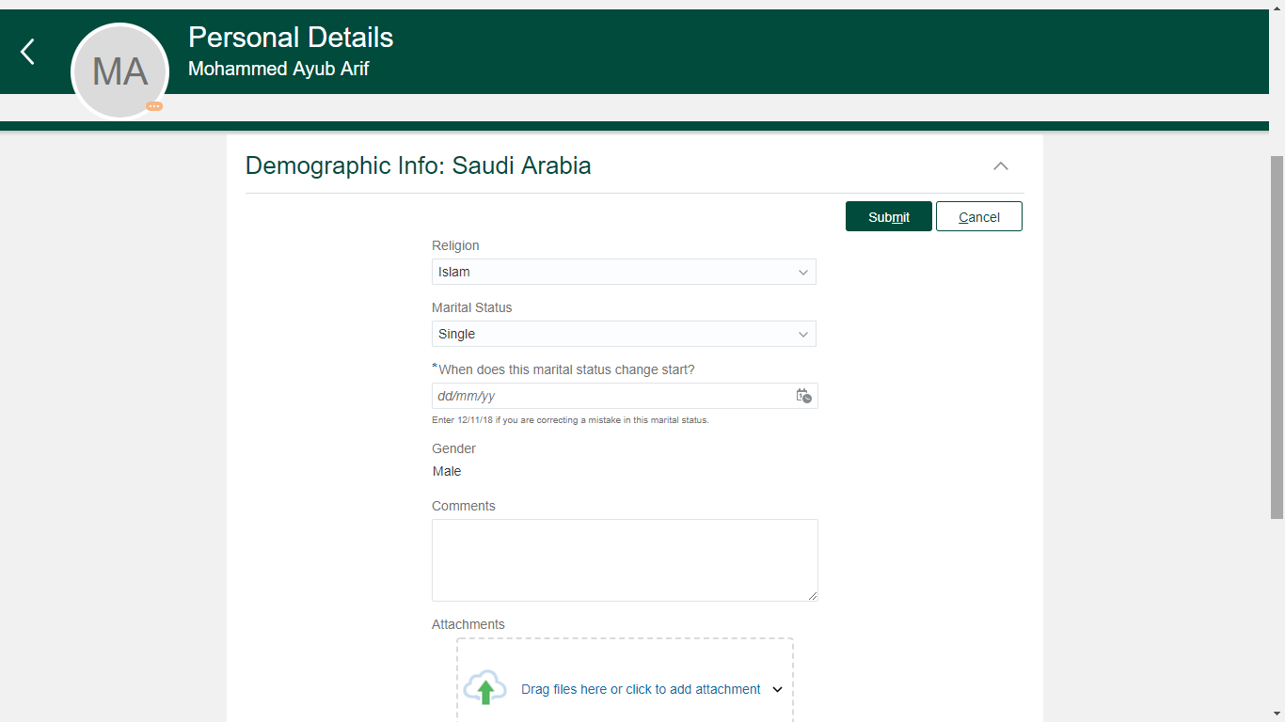

1. Employee may enter the comments and add attachments if necessary.
2. Once all details are entered, click **Submit**.
3. The request is redirected to Employee Relations to validate and approve. Once the request is approved, the updated religion and marital status will be updated in the system.

Note:

1. Civil Identity Number, Gender and the Date of Birth are not editable by the employee. If the value has to be changed for any reason, employee can reach out to the Employee Relations team outside the system.

Add or Update Phone Numbers

1. Login as Employee to the Oracle HCM Cloud application.
2. Navigate to Me (tab) > Personal Information (app) > Contact Information (card)

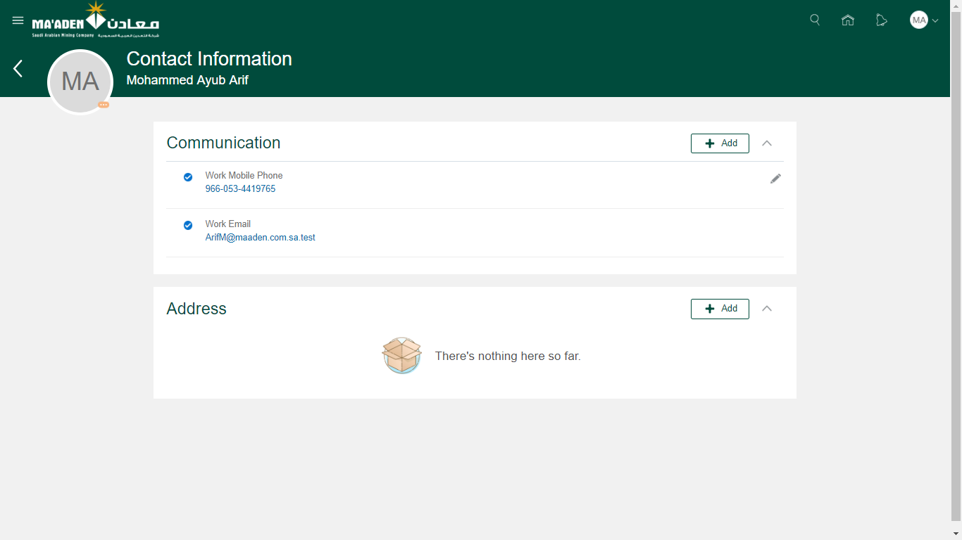

1. Click **Edit** to update the exisitng phone number detail (or)
2. Click **Add** and select Phone Details from the list to add a phone number.

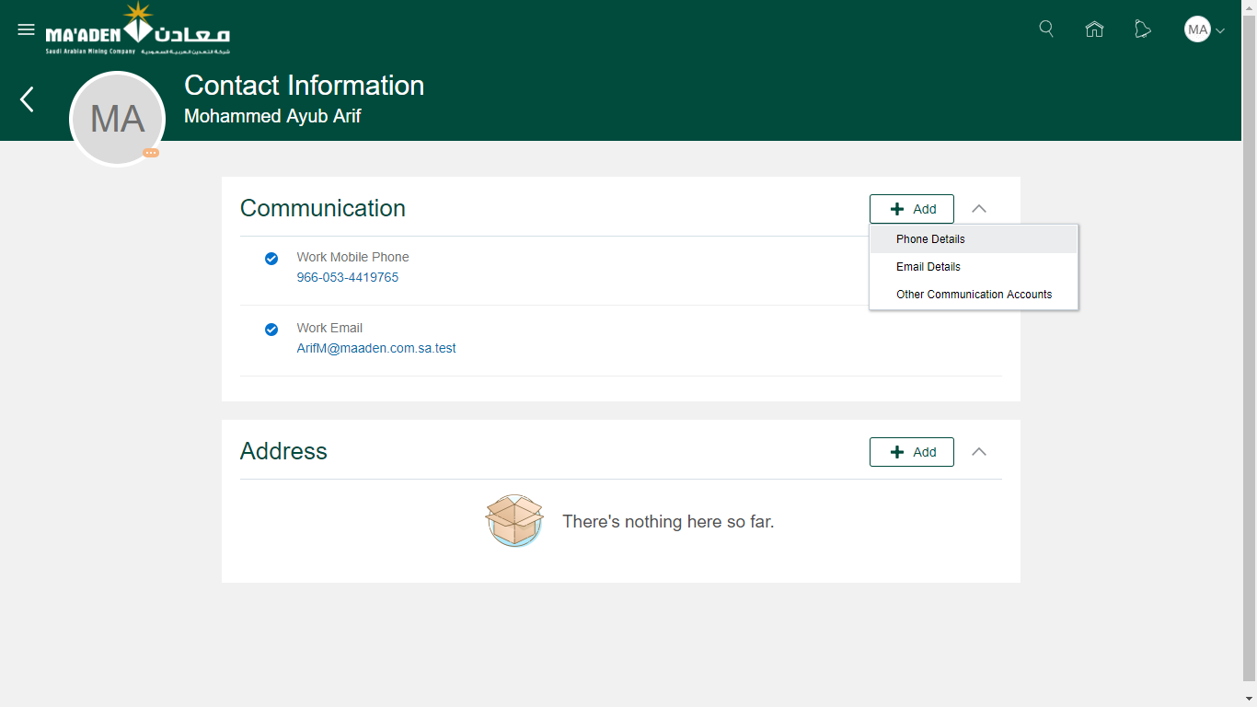

1. Select the mandatory fields like the phone type, country code and the number.

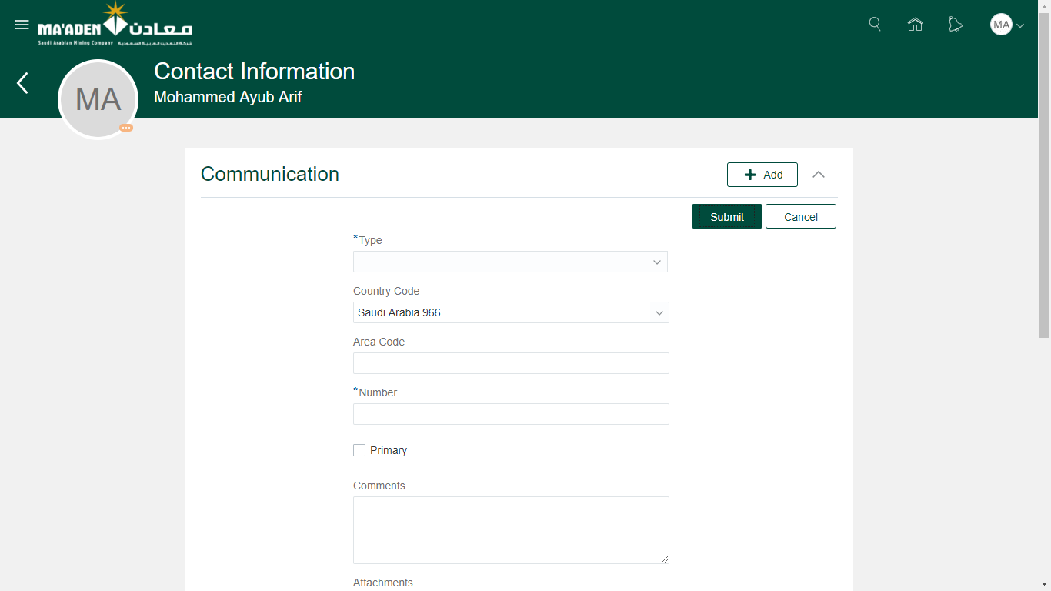

1. Employee may enter the comments and add attachments if necessary.
2. Once all details are entered, click **Submit**.
3. The request is redirected to Employee Relations to validate and approve. Once the request is approved, the phone number will be updated in the system.

Note:

1. To edit or correct an existing phone number, directly click **Edit** and change the Phone Type, Country , Country Code and Phone number. Then Click **Submit**.
2. Only one phone can be primary contact number and to change the primary phone number, uncheck the primary field and check against the new phone number.

Add or Update Email Address

1. Login as Employee to the Oracle HCM Cloud application.
2. Navigate to Me (tab) > Personal Information (app) > Contact Information (card)



1. Click **Edit** to update the exisitng Personal email address details (or)
2. Click **Add** and select Email Details to add Personal Email address.

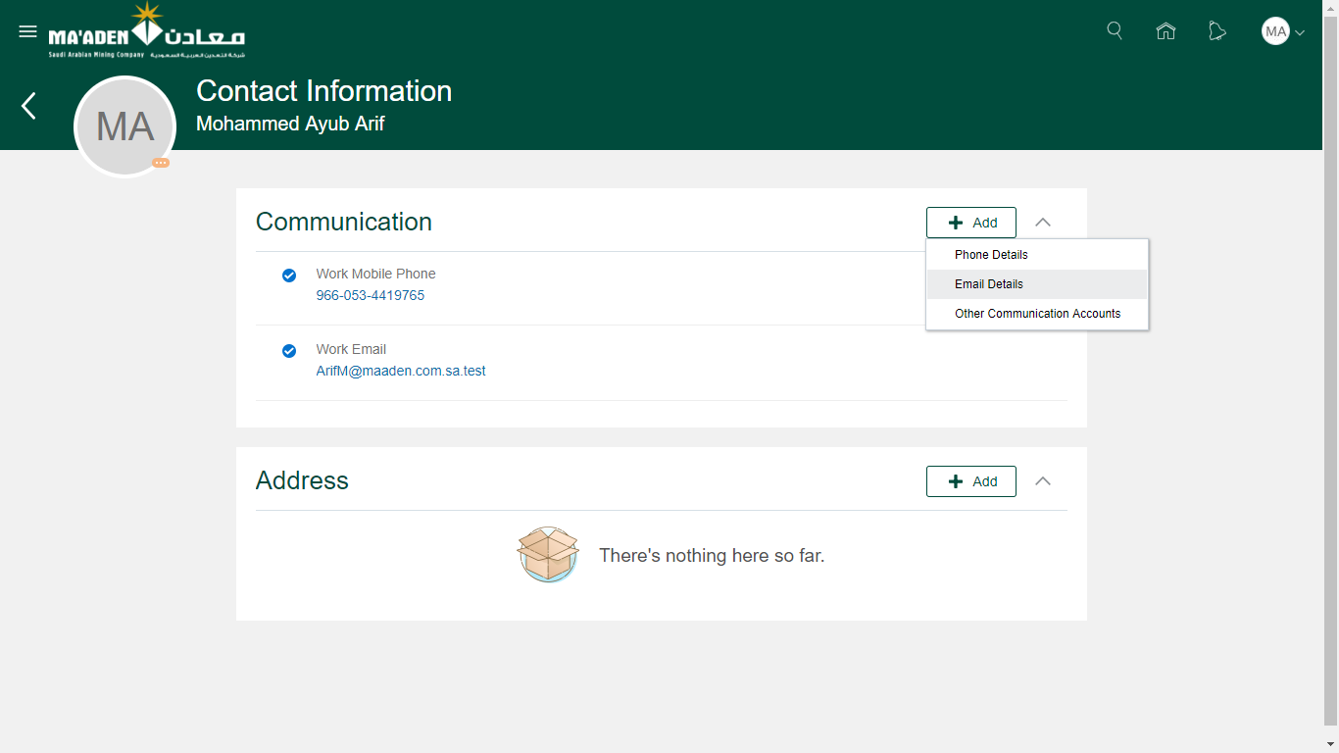

1. Select the mandatory fields like the email type and the email address.

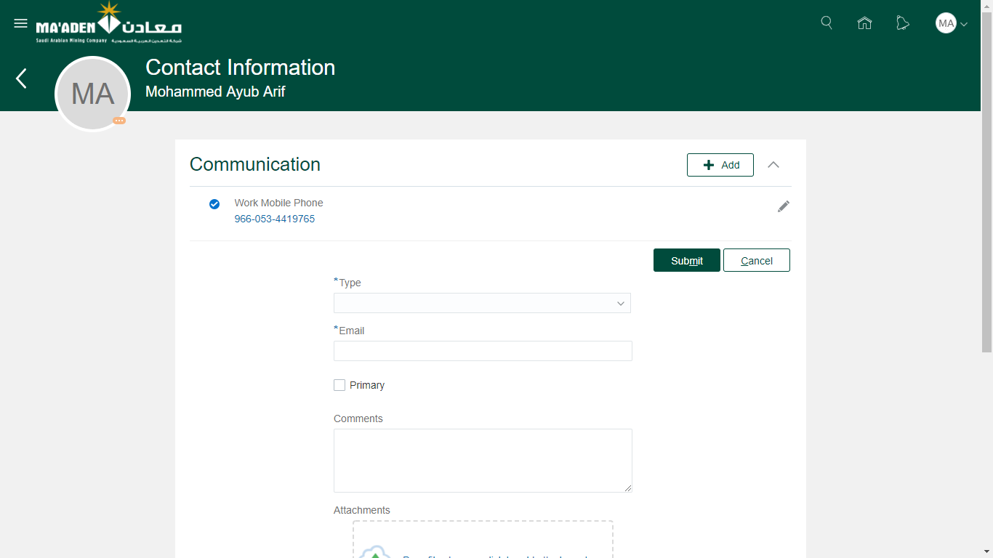

1. Employee may enter the comments and add attachments if necessary while adding the phone number to the contact information.
2. Once all details are entered, click **Submit**.
3. The request is redirected to Employee Relations to validate and approve. Once the request is approved, the phone number will be updated in the system.

Note:

1. Employee cannot edit their Work-Email once created. Any change to the Work Email should be routed only through the IT administrators.
2. Even if an employee changes the primary checkbox from Work Email to the Home Email address, system continues to send all communications on work email address by default.

Add or Update Address Details

1. Login as Employee to the Oracle HCM Cloud application.
2. Navigate to Me (tab) > Personal Information (app) > Contact Information (card)



1. Click **Edit** to update the exisitng Address details (or)
2. Click **Add** to add a new address details.

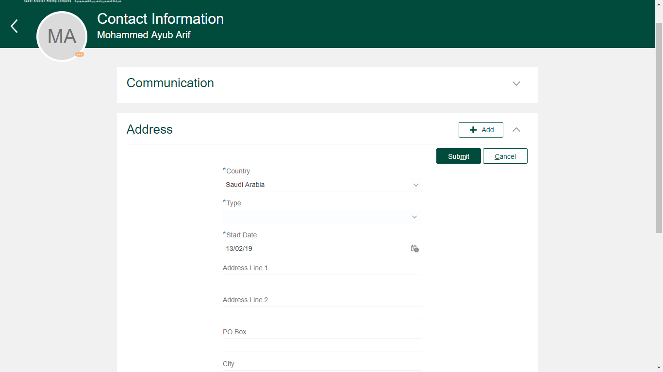

1. Select the mandatory fields like the address type, start date and other address fields.
2. Address Type can be selected based on the reasons below.

|  |  |
| --- | --- |
| Address Type | Description |
| Kingdom Address | If the address being entered is for the current place of residence with in Saudi Arabia. |
| Home Address | If the address is for permanent residence (which can be away from the current place of residence) |

1. Employee may enter the comments and add attachments if necessary while adding the address details to the contact information.
2. Once all details are entered, click **Submit**.
3. The request is redirected to Employee Relations to validate and approve. Once the request is approved, the address details will be updated in the system.

Note:

1. The address fields will differ from country to country based on the localization and address format provided by Oracle.

Add or Update Citizenship/Nationality

1. Login as Employee to the Oracle HCM Cloud application.
2. Navigate to Me (tab) > Personal Information (app) > Identification Information (card)

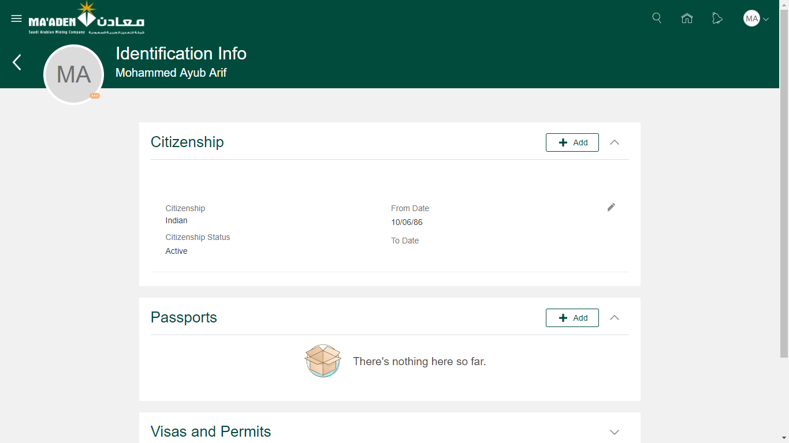

1. Click **Edit** to update the exisitng citizenship details (or)
2. Click **Add** to add a new citizenship details.

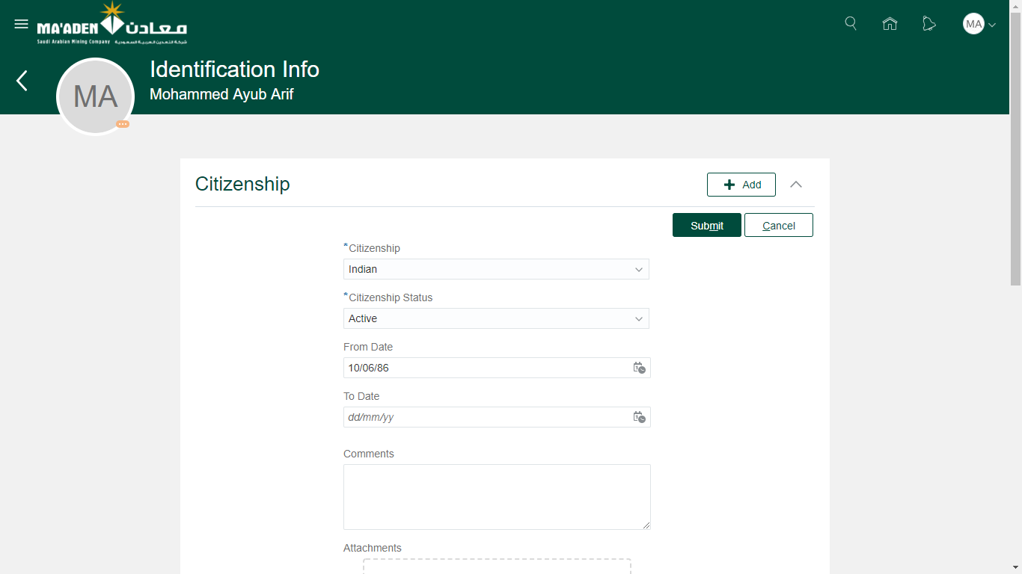

1. Select the mandatory fields like the Citizenship country and the start date.
2. Employee may enter the comments and add attachments if necessary while adding the details to the identification information.
3. Once all details are entered, click **Submit**.
4. The request is redirected to Employee Relations to validate and approve. Once the request is approved, the citizenship details will be updated in the system.

Note:

1. It is advised to have only one active primary citizenship at all times. In case of dual citizenships, the citizenship used to enter into Saudi Arabia takes precedence and will have to be recorded in the system.

Add or Update Passport Information

1. Login as Employee to the Oracle HCM Cloud application.
2. Navigate to Me (tab) > Personal Information (app) > Identification Information (card)



1. Click **Edit** to update the exisitng passport details (or)
2. Click **Add** to add a new passport details.

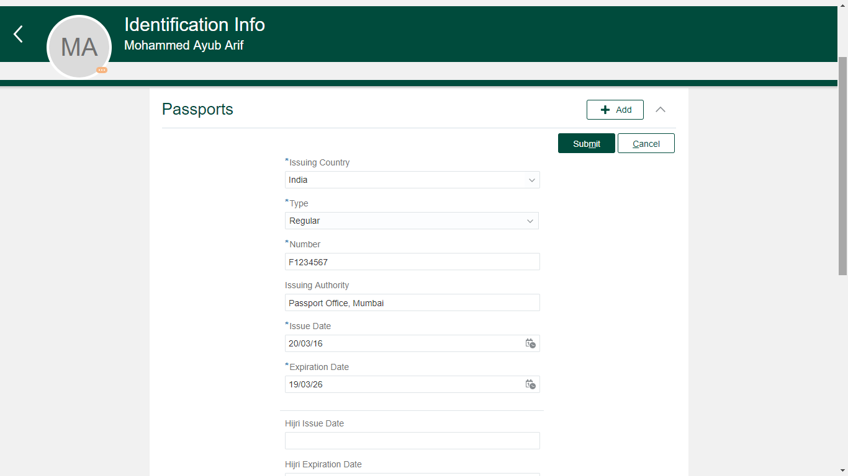

1. Select the mandatory fields like the passport issuing country, passport type, passport number, Issue date and the expiration date.
2. Employee may enter the comments and add attachments if necessary while adding the details to the identification information.
3. Once all details are entered, click **Submit**.
4. The request is redirected to Employee Relations to validate and approve. Once the request is approved, the passport details will be updated in the system.

Note:

1. It is advised to have only one active primary passport at all times. In case of dual citizenships, the passport used to enter into Saudi Arabia takes precedence and will have to be recorded in the system.
2. In all ideal scenarios, the country of citizenship and the passport country should always match.
3. In certain scenarios, when the employee renews their passport while living outside their country of origin, the issuing country will still remain the same (as the country of origin) and the issuing authority may change.

For ex: An employee is from India and working in Saudi Arabia. When the employee’s passport is nearing expiration, he has applied for a new passport with the Indian consulate in KSA. For the newly issued passport, the Issuing Country is India (and not KSA). But the Issuing Authority will be Indian Consulate, KSA.

Add or Update Visa and Permits (Iqama) Information

1. Login as Employee to the Oracle HCM Cloud application.
2. Navigate to Me (tab) > Personal Information (app) > Identification Information (card)

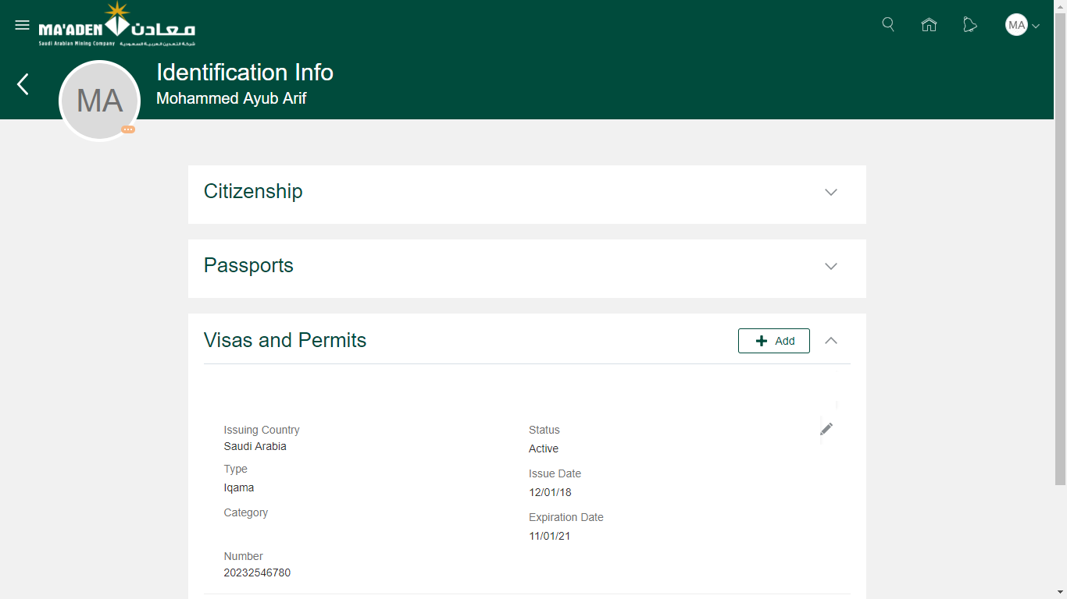

1. Click **Edit** to update the exisitng work permit details (or)
2. Click **Add** to add a new work permit details.

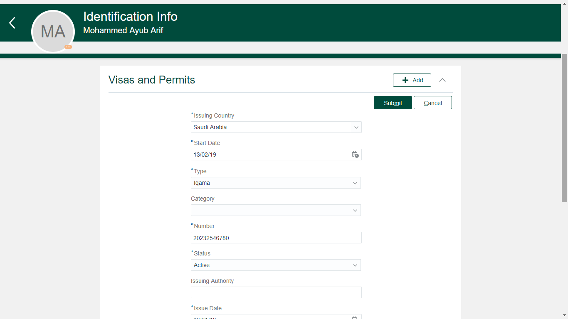

1. Select the mandatory fields like the visa issuing country, visa type, visa number, Issue date and the expiration date.
2. Employee may enter the comments and add attachments if necessary while adding the details to the identification information.
3. Once all details are entered, click **Submit**.
4. The request is redirected to Employee Relations to validate and approve. Once the request is approved, the visa/work permit details will be updated in the system.

Note:

1. It is advised to have only one active primary work permit at all times for expatriates. Employees can always update the existing details and new information will take effect once approved by Employee Relations.

Add or Update Driving License Information

1. Login as Employee to the Oracle HCM Cloud application.
2. Navigate to Me (tab) > Personal Information (app) > Identification Information (card)

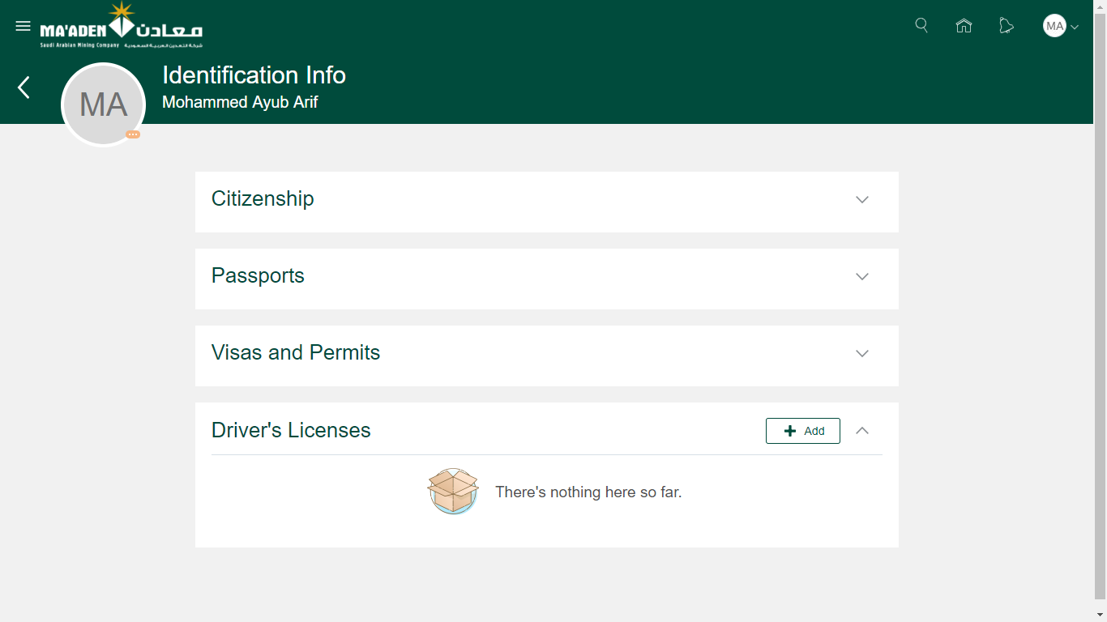

1. Click **Edit** to update the exisitng driving license details (or)
2. Click **Add** to add a new driving license details.

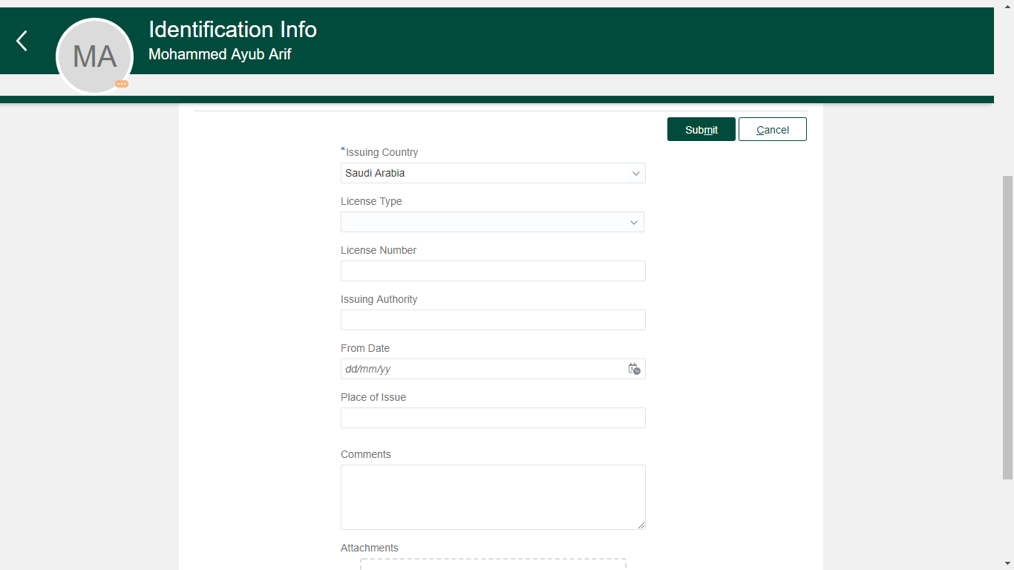

1. Select the necessary fields like the license type, issuing country, license number, issuing authority, From date and the place of issue.
2. Employee may enter the comments and add attachments if necessary while adding the details to the identification information.
3. Once all details are entered, click **Submit**.
4. The request is redirected to Employee Relations to validate and approve. Once the request is approved, the driving license details will be updated in the system.

Add or Update Family/ Emergency Dependents

1. Login as Employee to the Oracle HCM Cloud application.
2. Navigate to Me (tab) > Personal Information (app) > Family and Emergency Dependents
3. Click on the name of the existing dependent to update the details (or)
4. Click **Add** to add a new dependent details.

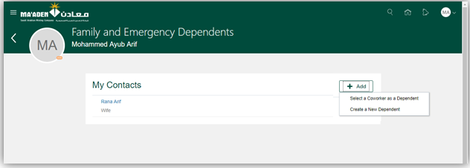

1. Employee can select one of the following

|  |  |
| --- | --- |
| Option | Description |
| Select a coworker as a Dependent | Choose this option if the contact is working in Ma’aden already. |
| Create a new Dependent | Choose this option if the contact is working outside Ma’aden. |

**Select a coworker as a Dependent:**

1. Select the necessary fields like the relationship, employee details and the start date of the relationship.

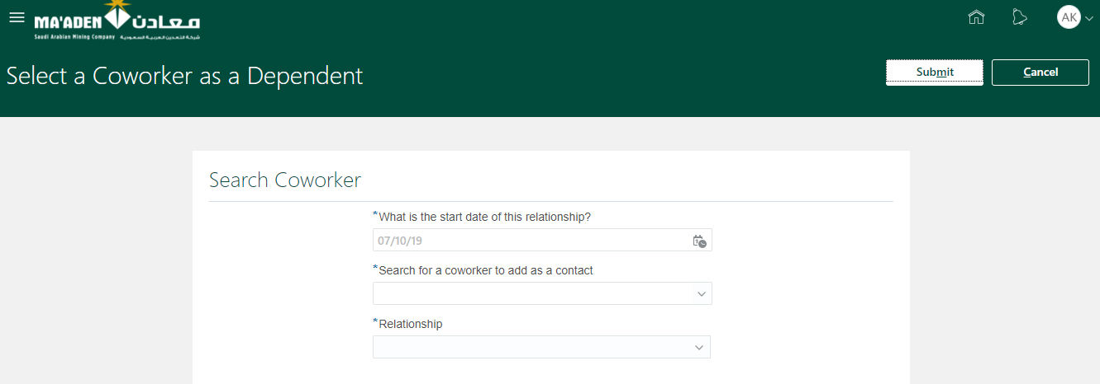

1. Employee may enter the comments and add attachments if necessary while adding the details to the dependent information.
2. Once all details are entered, click **Submit**.
3. Adding an existing employee as a dependent will send a notification to the respective employee to confirm if the relationship is valid. Once the resepctive employee approves the request, the dependent will be successfully added.

**Create a new Dependnet:**

1. Select the necessary fields like the Title, Name, relationship, start date, Gender and Date of Birth.

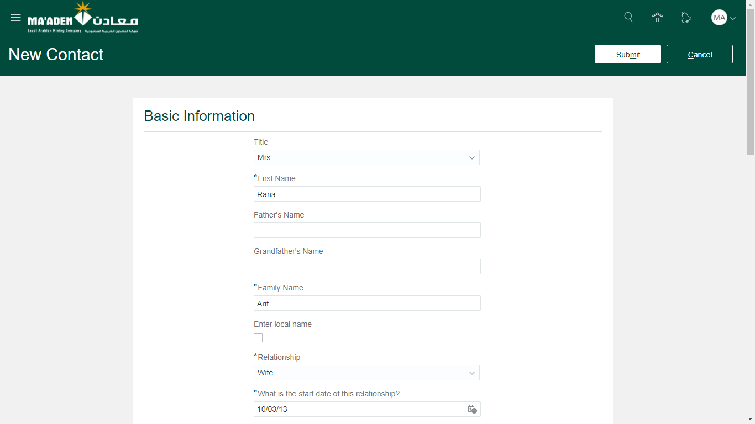

1. Select **Enter a local name** checkbox to record the arabic name for the contact.

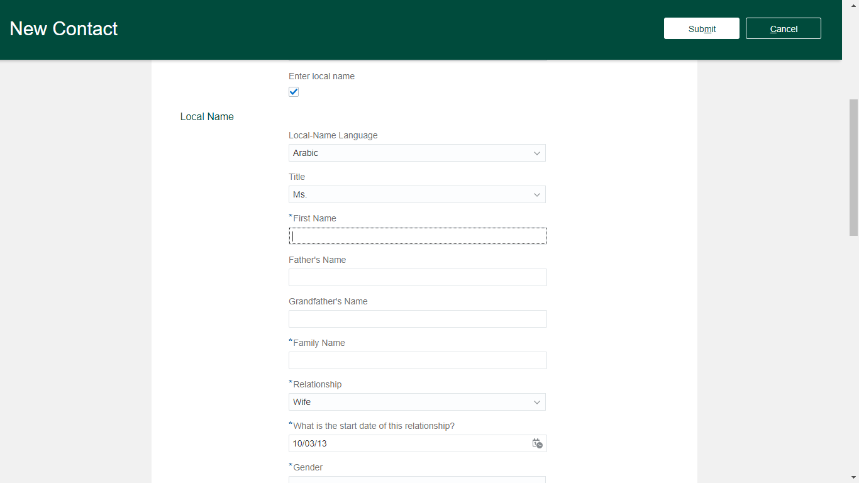

1. Select **Request for Medical Card** as Yes only if the contact being added is spouse, parents or children. If the value is not chosen correctly, the Employee Relations team may reject the request to add the contact.

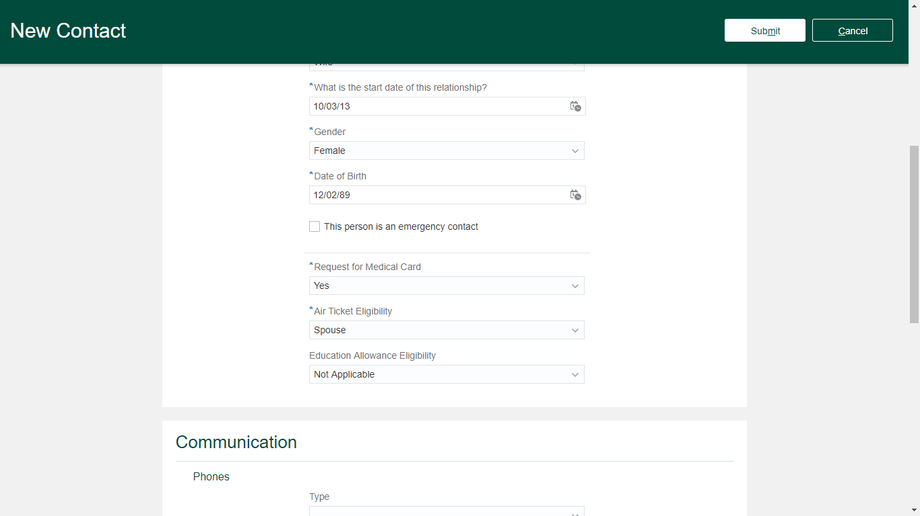

1. Select **Air Ticket Eligibility** as Spouse/ Child 1/ Child 2 only if the dependent being added is spouse or children. If the value is not chosen correctly, the Employee Relations team may reject the request to add the dependent.
2. Select **Education Allowance Eligibility** as Child 1/ Child 2 only if the contact being added is children. If the value is not chosen correctly, the Employee Relations team may reject the request to add the dependent.
3. Employee may enter the comments and add attachments if necessary while adding the details to the identification information.
4. Employees can add the following for the dependent while adding them.
5. Communiation
   1. Phone Details
   2. Email Details
6. Address
   1. Home or Kingdom Address
7. National Identifiers Detail
8. Passport Details
9. Visa/ Work Permit (Iqama) details
10. Once all details are entered, click **Submit**.
11. The request is redirected to Employee Relations to validate and approve. Once the request is approved, the dependent details will be updated in the system.

View Employment Information

1. Login as Employee to the Oracle HCM Cloud application.
2. Navigate to Me (tab) > Personal Information (app) > Employment Info (card)

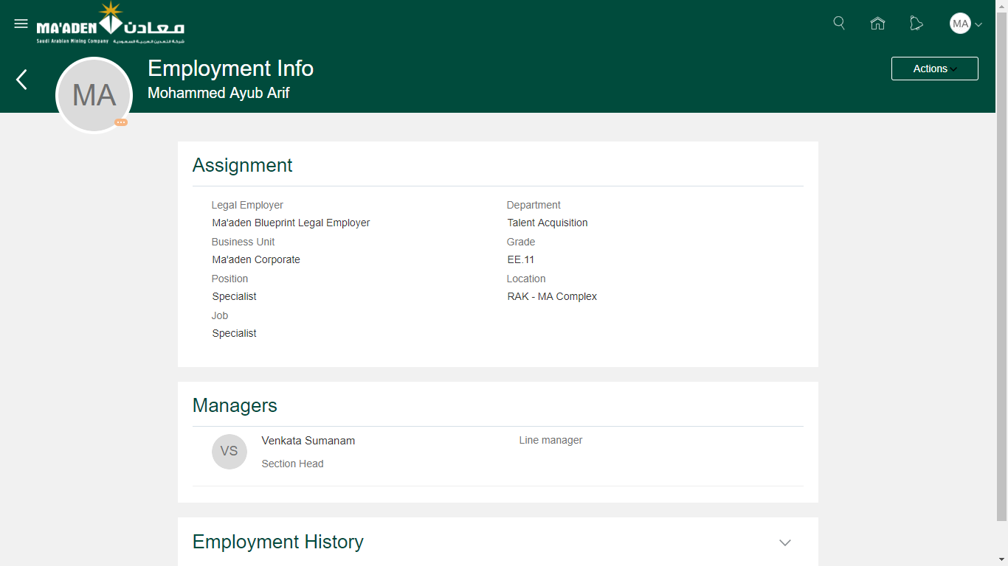

View My Organization

1. Login as Employee to the Oracle HCM Cloud application.
2. Navigate to Me (tab) > Directory (app)

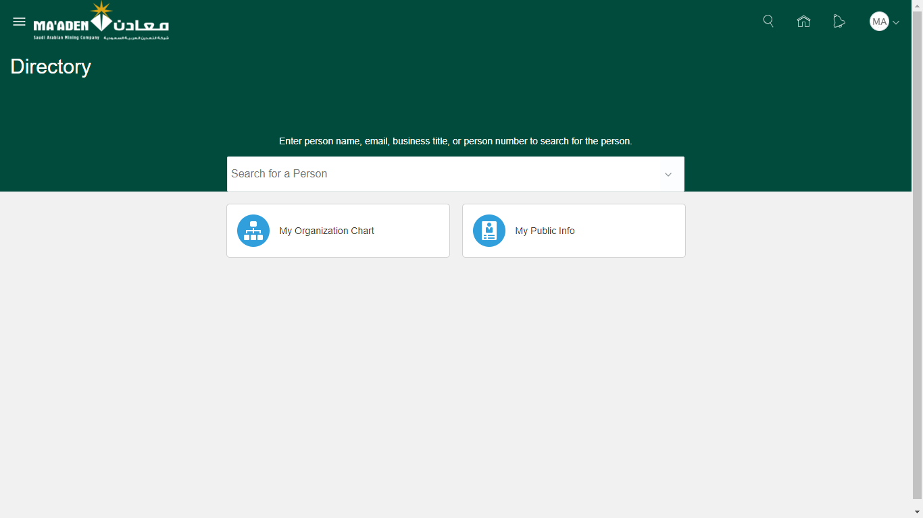

1. Click My Organization Chart to see the current manager hierarchy.

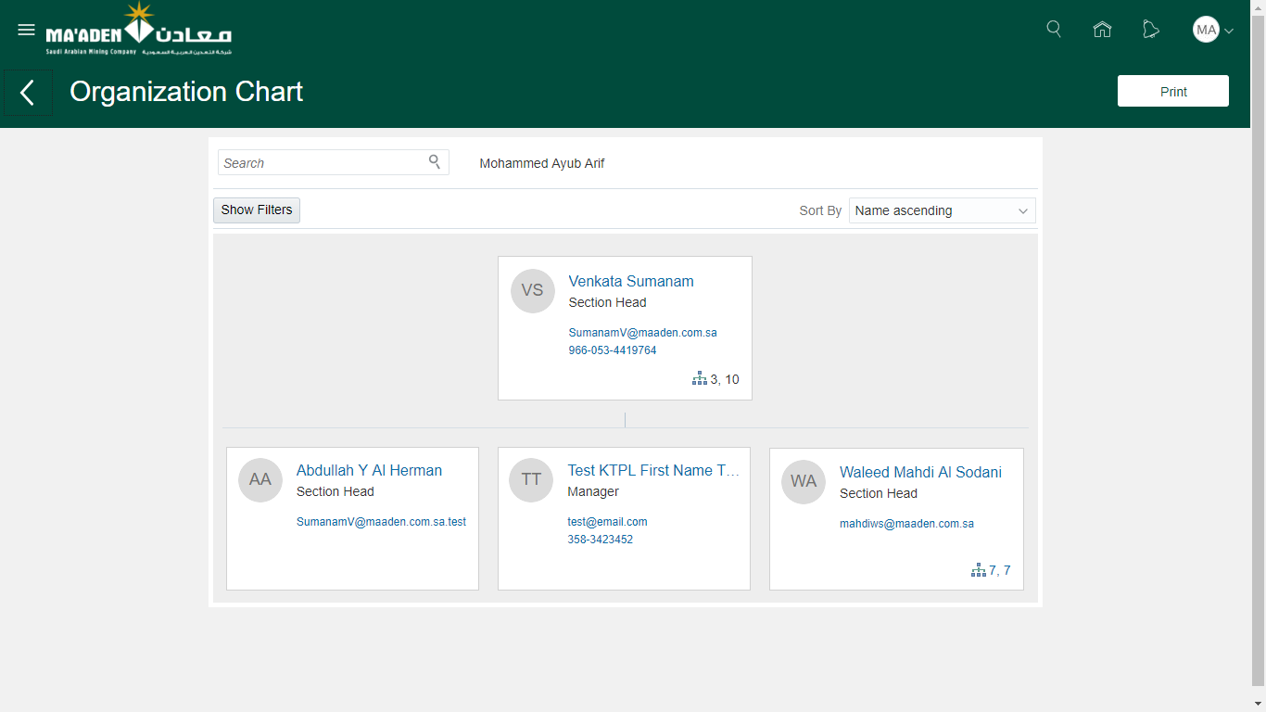

View Performance Rating History

1. Login as Employee to the Oracle HCM Cloud application.
2. Navigate to Me (tab) > Career and Performance (app)

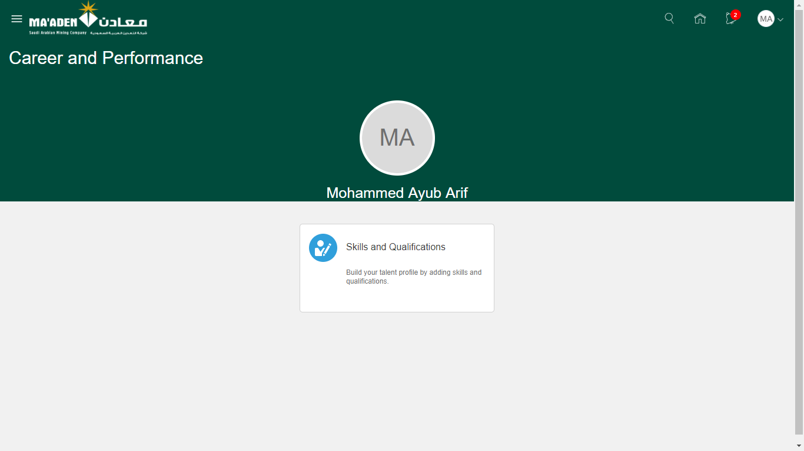

1. Open **Skills and Qualifications** card

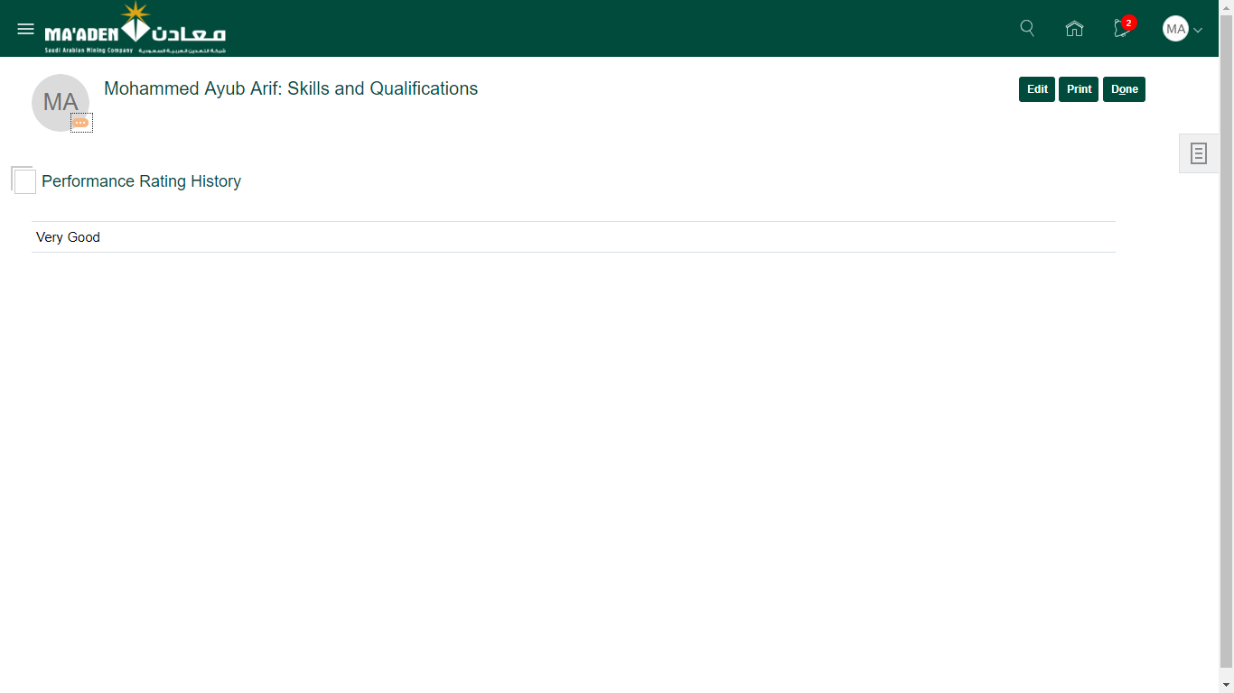

1. If the performance rating history is available for the employee, it will be displayed on the Skills and Qualification card under the Performance Rating History section.

View My Compensation

1. Login as Employee to the Oracle HCM Cloud application.
2. Navigate to Me (tab) > Personal Information (app)

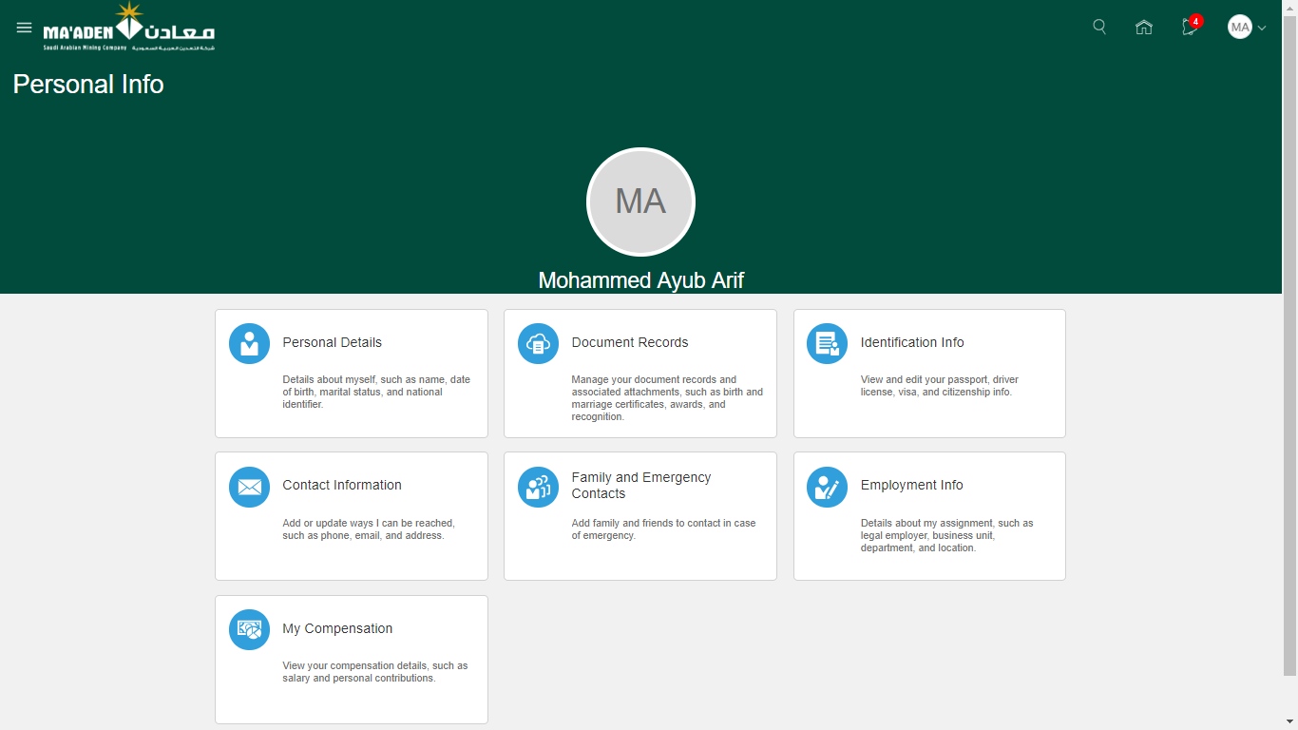

1. Click My Compensation (card) to see the current compensation.

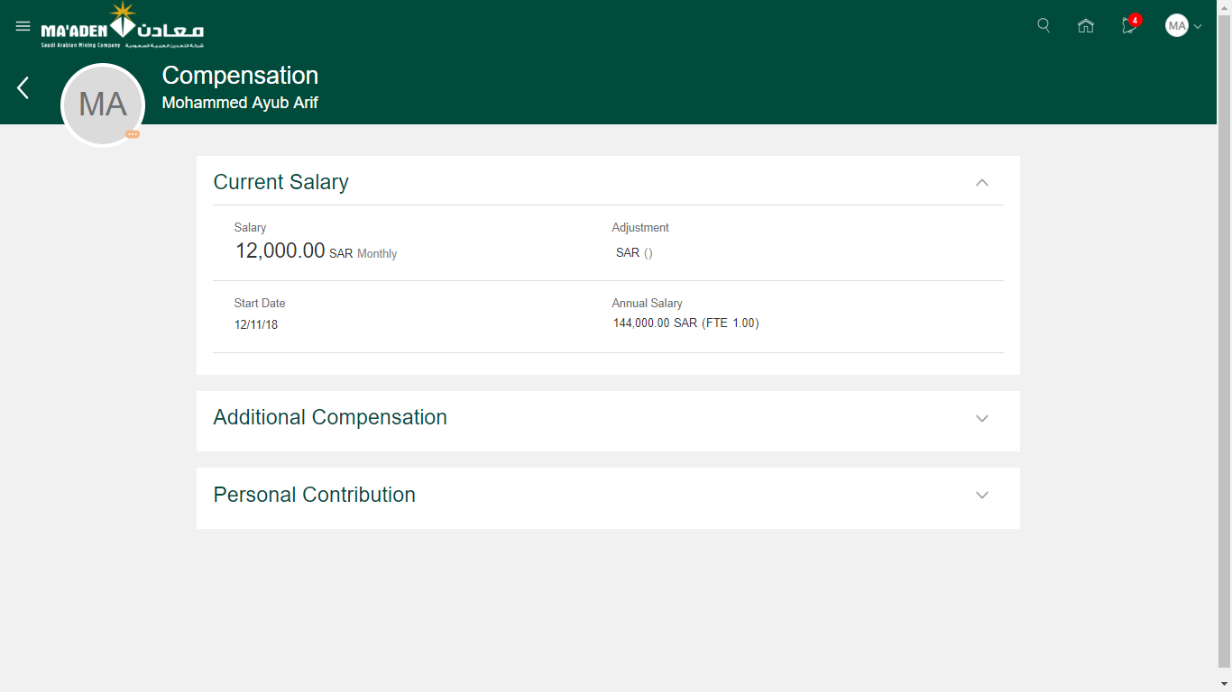

Add Previous Employment section

1. Login as Employee to the Oracle HCM Cloud application.
2. Navigate to Me (tab) > Career and Performance (app)



1. Open **Skills and Qualifications** card



1. Click **Edit** and then **Add Content.** Select **Previous Employment** from the list of values.

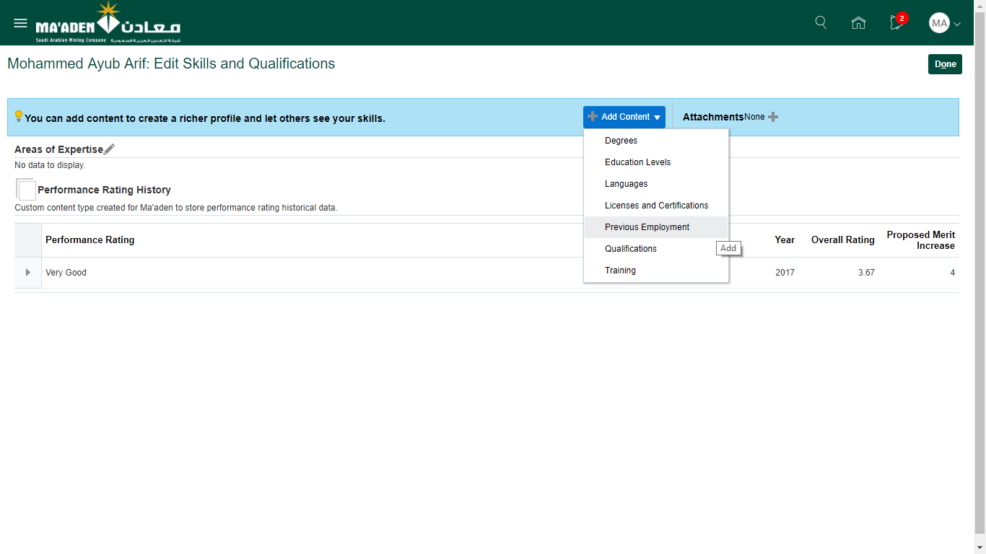

1. On the Previous Employement section, click the collapse/expand arrow next to the editable row.

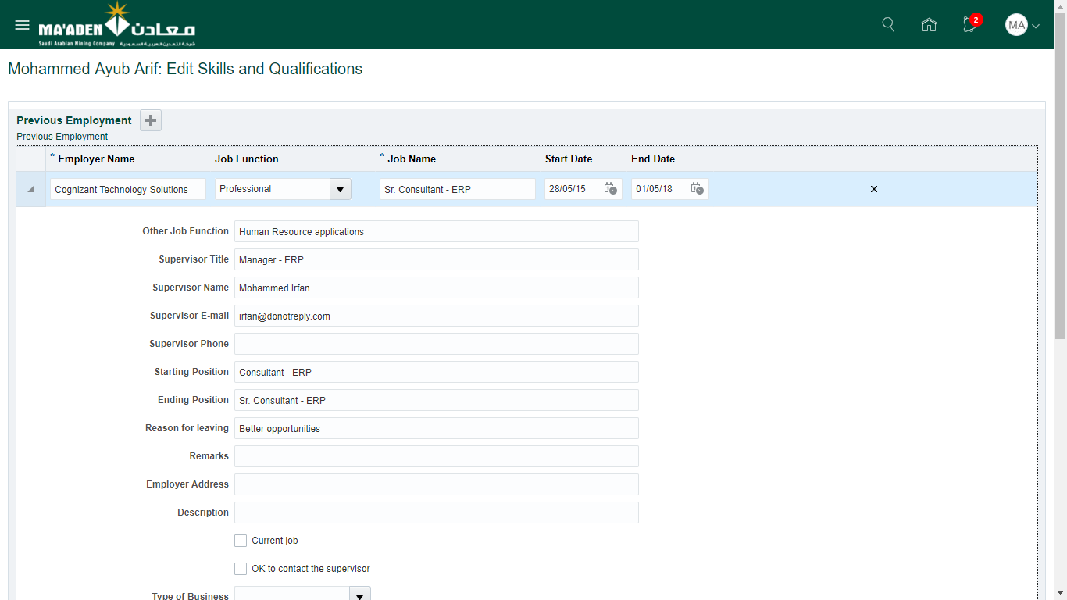

1. After all the relevant fields are entered, click **Submit** at the bottom of the section.
2. A confirmation dialogue box will be displayed that the request is submitted. Click **OK** to close the window.

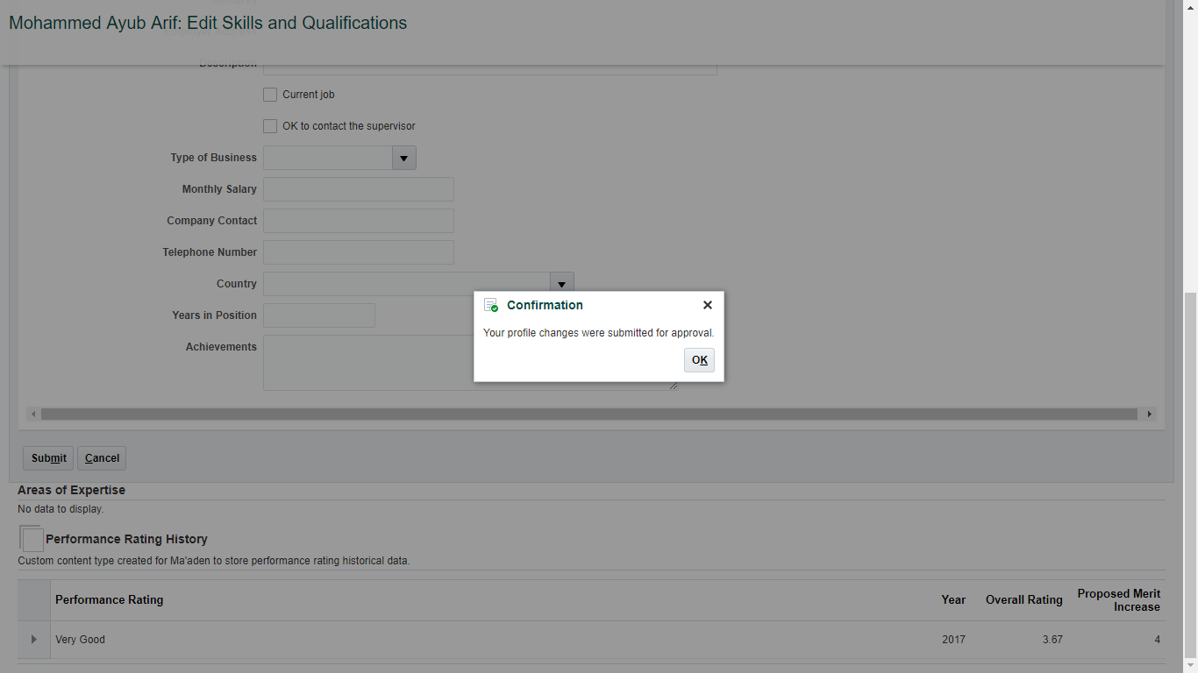

1. The request is redirected to Employee Relations to validate and approve. Once the request is approved, the contact details will be updated in the system.

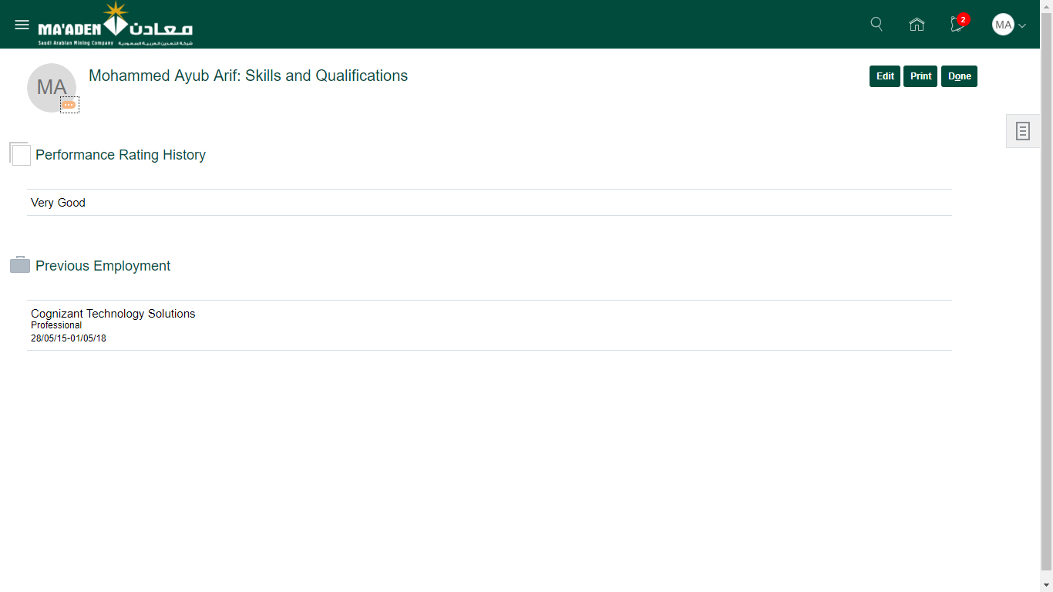

Update Previous Employment

1. Login as Employee to the Oracle HCM Cloud application.
2. Navigate to Me (tab) > Career and Performance (app)



1. Open **Skills and Qualifications** card

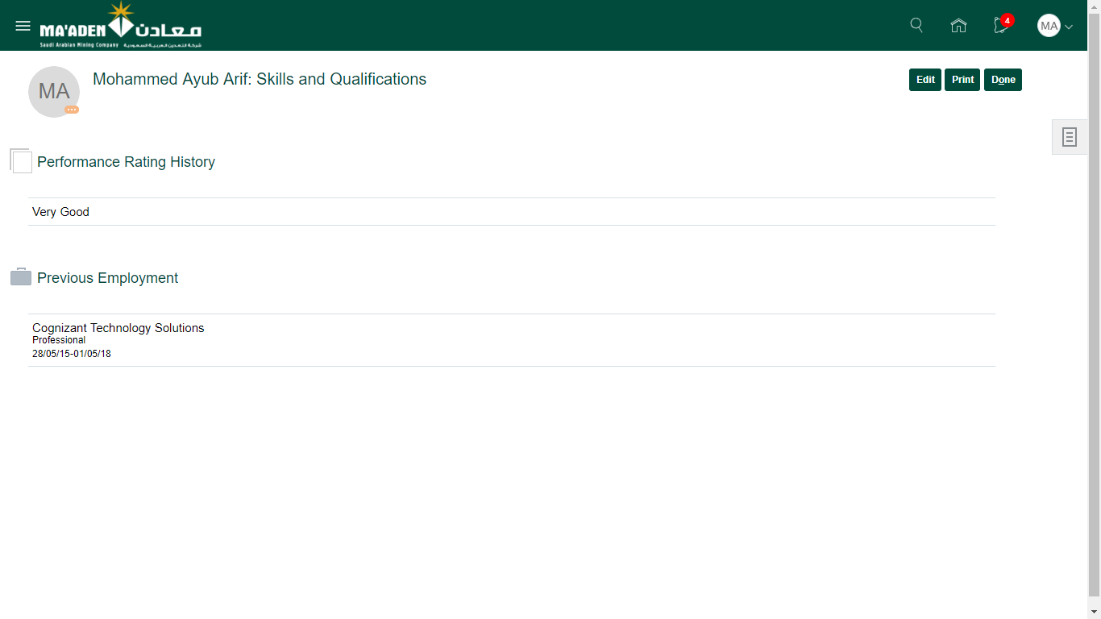

1. Click **Edit** andselect **Edit/ Add** from the **Previous Employment** section

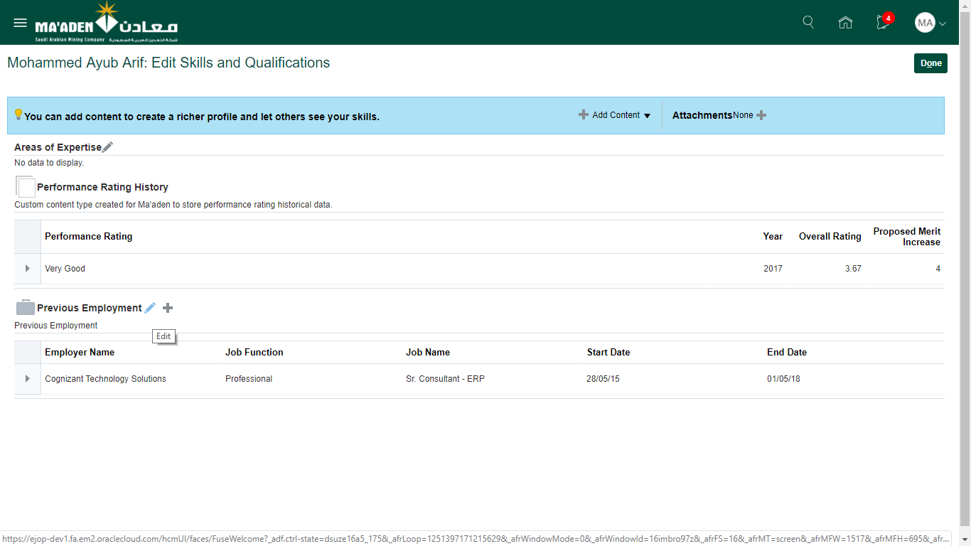

1. On the Previous Employement section, click the collapse/expand arrow next to the editable row to enter additional details for the employment.



1. After all the relevant fields are entered, click **Submit** at the bottom of the section.
2. A confirmation dialogue box will be displayed that the request is submitted. Click **OK** to close the window.



1. The request is redirected to Employee Relations to validate and approve. Once the request is approved, the previous employment details will be updated in the system.



Add Languages Section

1. Login as Employee to the Oracle HCM Cloud application.
2. Navigate to Me (tab) > Career and Performance (app)



1. Open **Skills and Qualifications** card

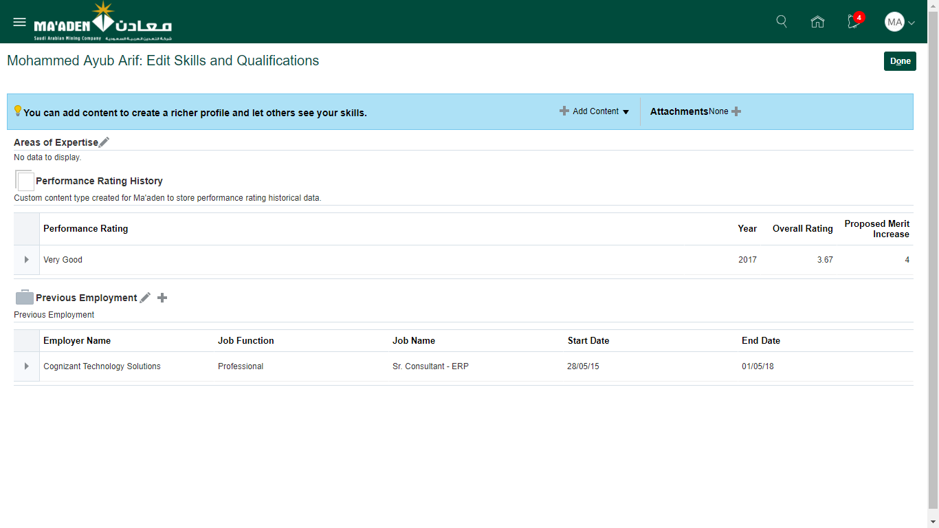

1. Click **Edit** and then **Add Content.** Select **Languages** from the list of values.

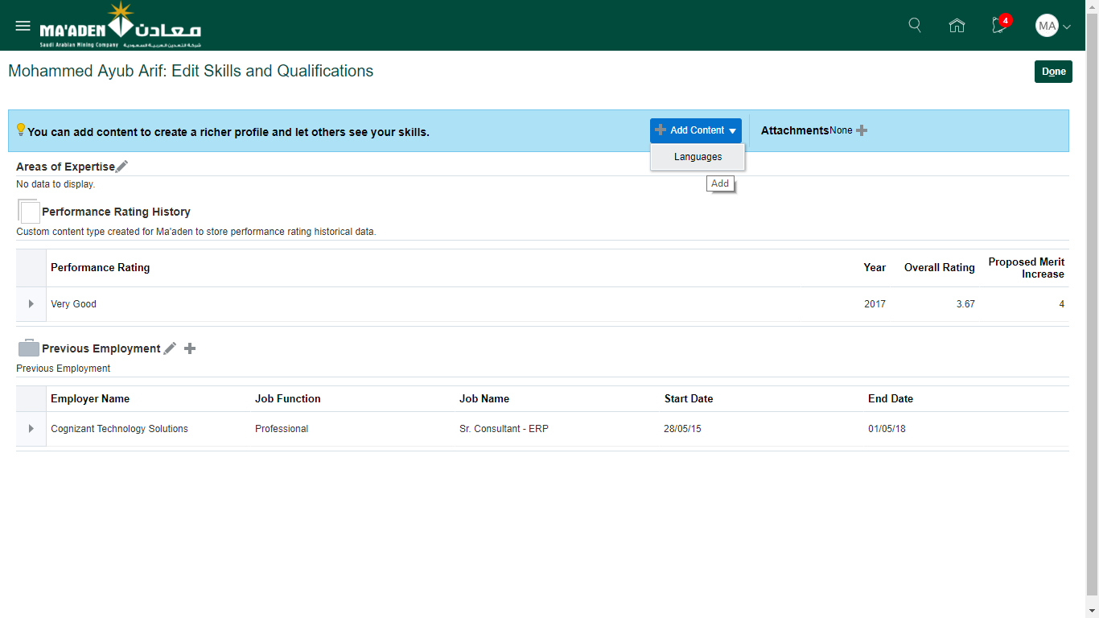

1. On the Language section, select the language name and the proficiency as per the below screenshot.

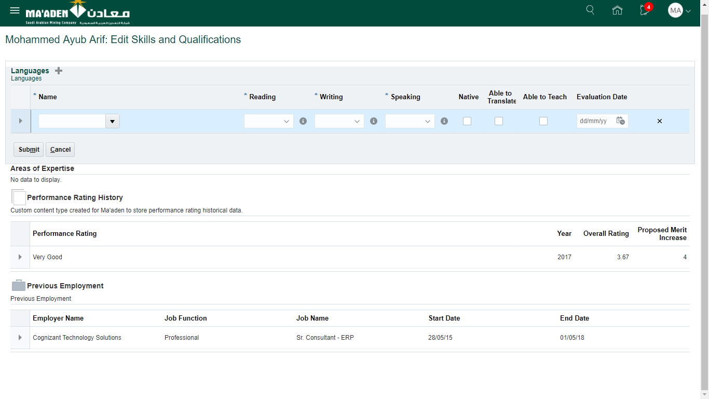

1. To search for languages, expand the **Name** list of values and click **Search**
2. Enter the value and search. Select the appropriate value and click **OK**

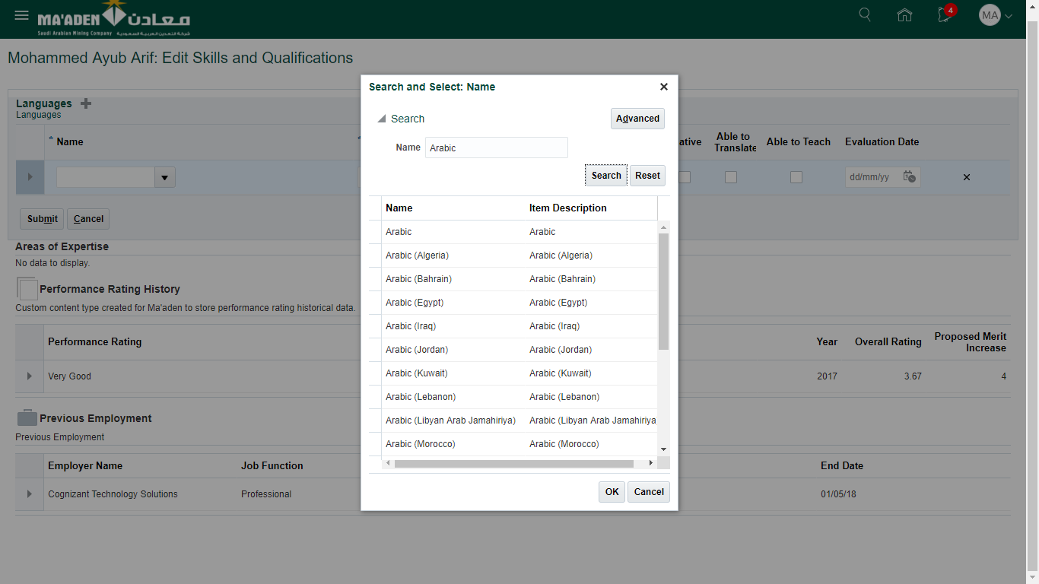

1. After all the relevant fields are entered, click **Submit** at the bottom of the section.
2. A confirmation dialogue box will be displayed that the request is submitted. Click **OK** to close the window.

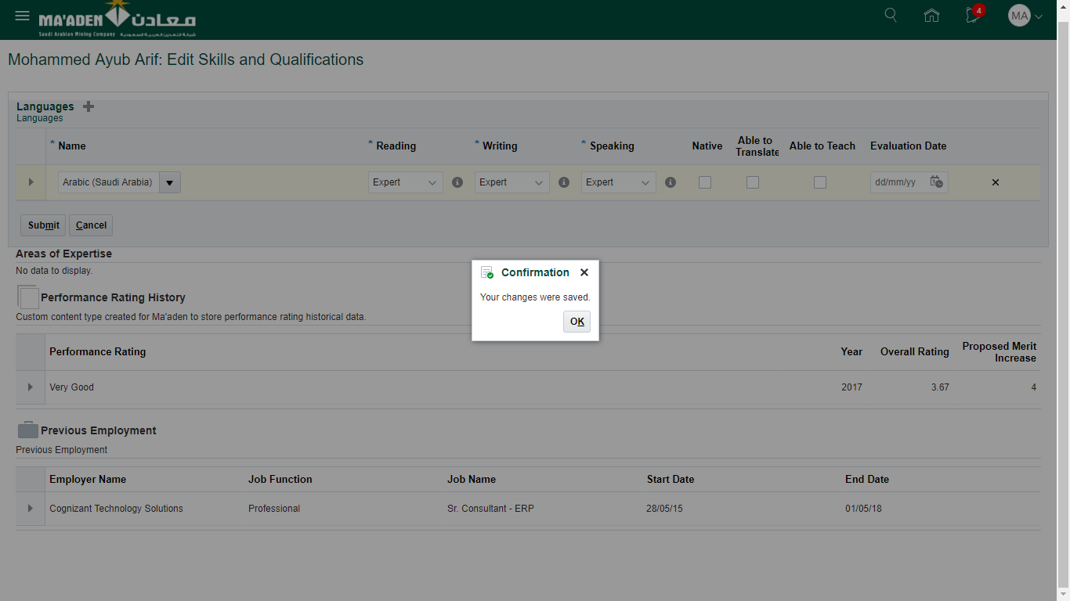

1. Once the request is submitted, the language details will be updated in the system.

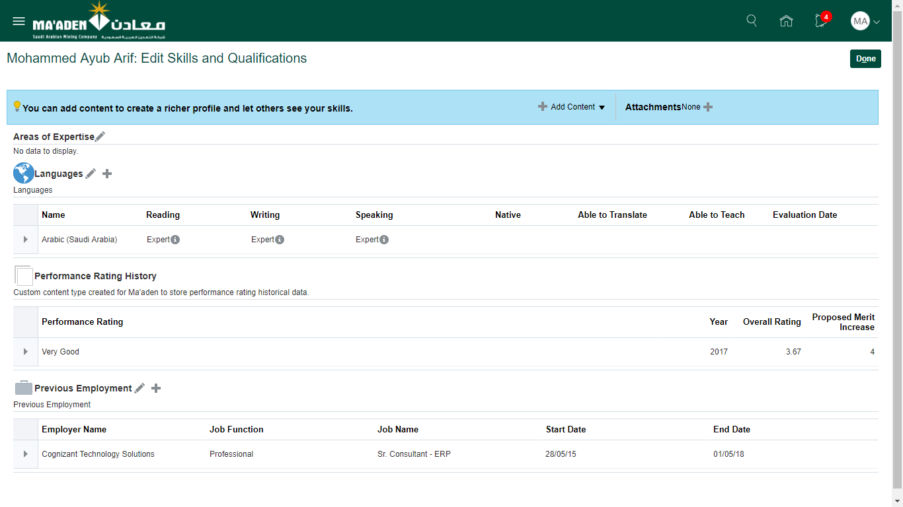

Submit Resignation

1. Login as Employee to the Oracle HCM Cloud application.
2. Navigate to Me (tab) > Personal Information (app) > Employment Info (card)

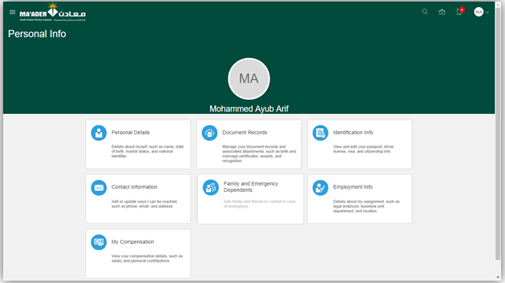

1. On the Employment Info page, under **Actions** menu, select **Submit Resignation**.

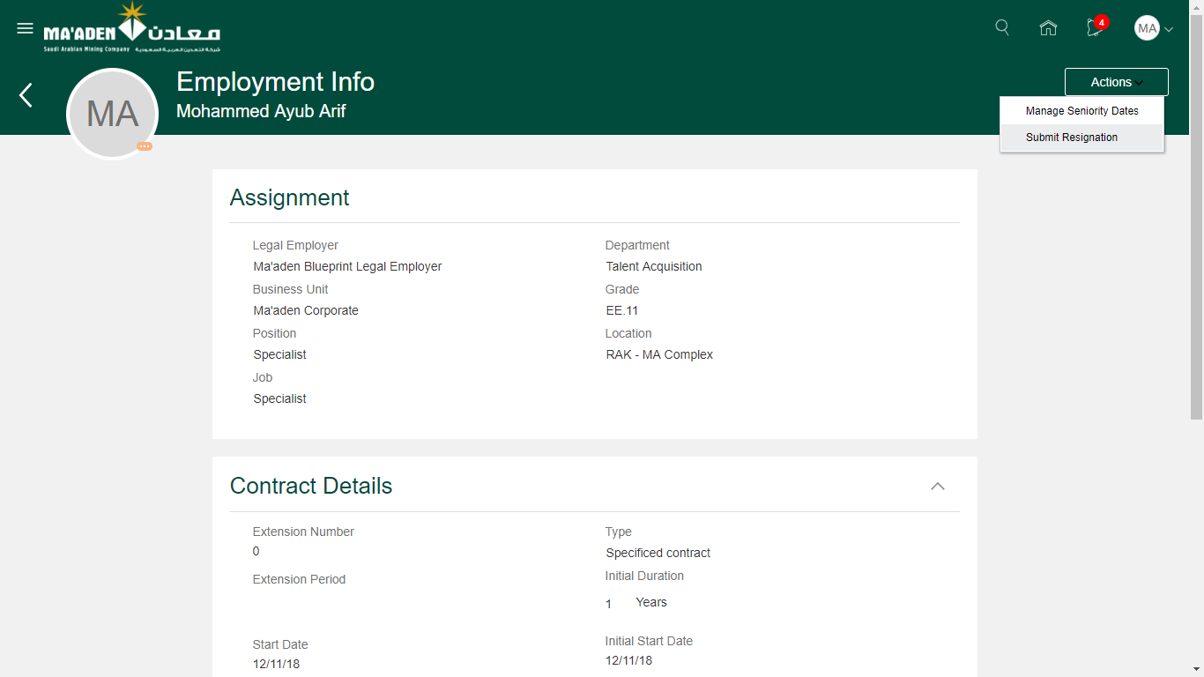

1. On the submit Resignation page, select the following fields under **When and Why** section.

|  |  |
| --- | --- |
| Attribute | Description |
| Date of Notification of the resignation | Auto-populated as the current date. This value cannot be edited by the employee. |
| Last Working date? | The last day of the employment. System auto-populates the value based on the notice period from the employee’s assignment. |

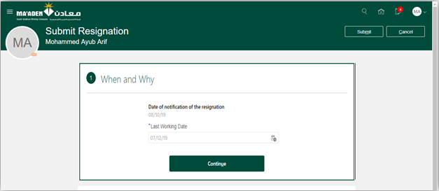

1. Click **Continue** to display Termination info section. Click continue here to display comments.

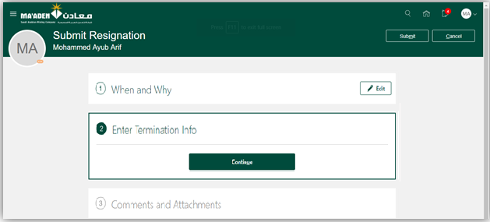

1. Employee may enter the comments and add attachments if necessary.

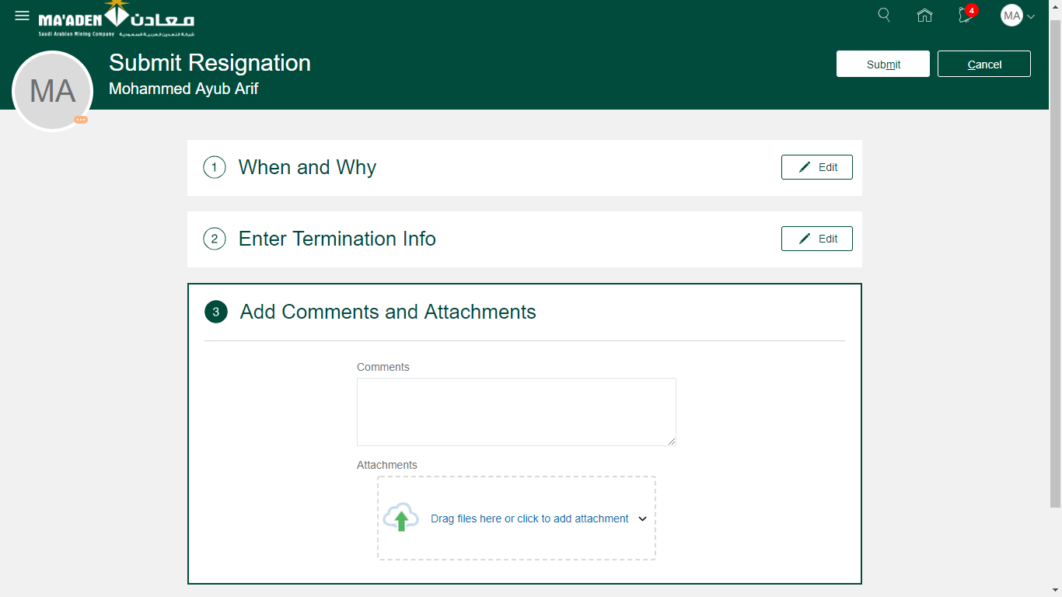

1. Once all the necessary information is entered, click **Submit**.
2. The request is redirected to the line manager and other approvers for approval and then to the Employee Relations. Once the request is fully approved, the resignation date will be updated in the system.

Worklist – Pending Actions/Approvals

1. Login as Employee to the Oracle HCM Cloud application.
2. Navigate to Tools (tab) > Worklist (app)

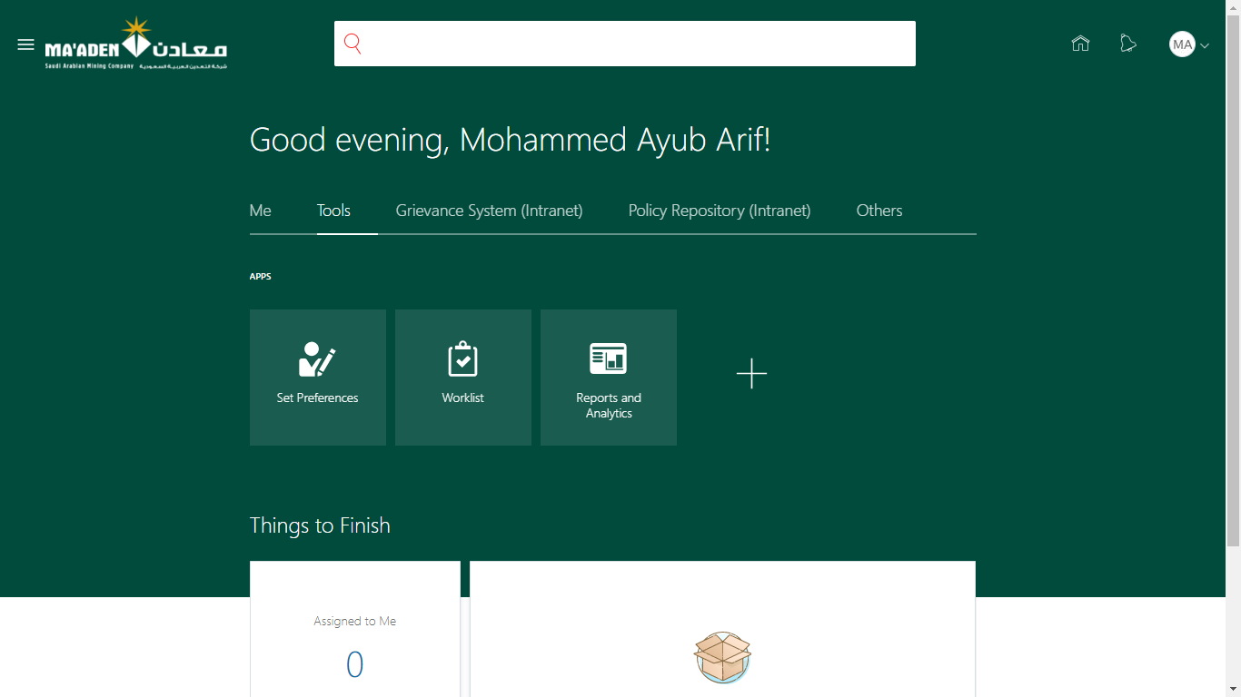

1. The Worklist : Notifications and Approvals page is displayed with all the tasks that require attention.

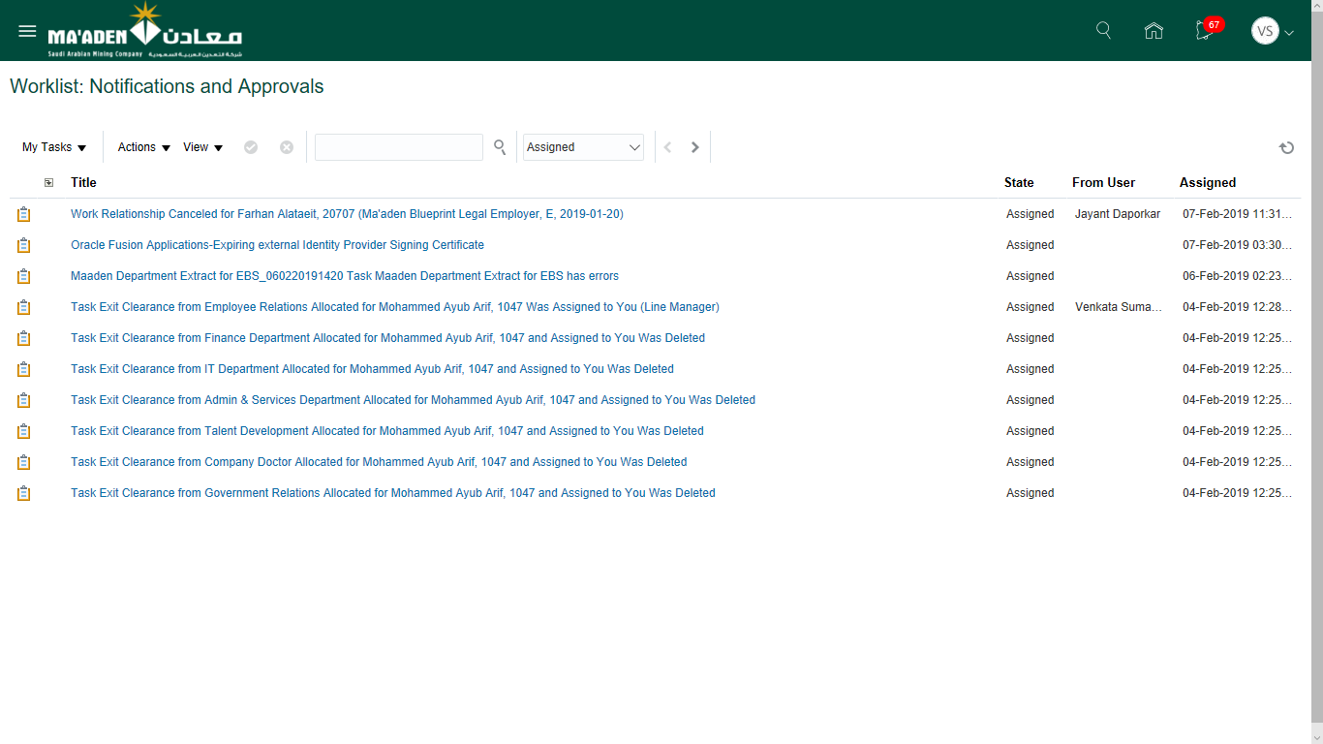

1. Click on the respective task to view more details.

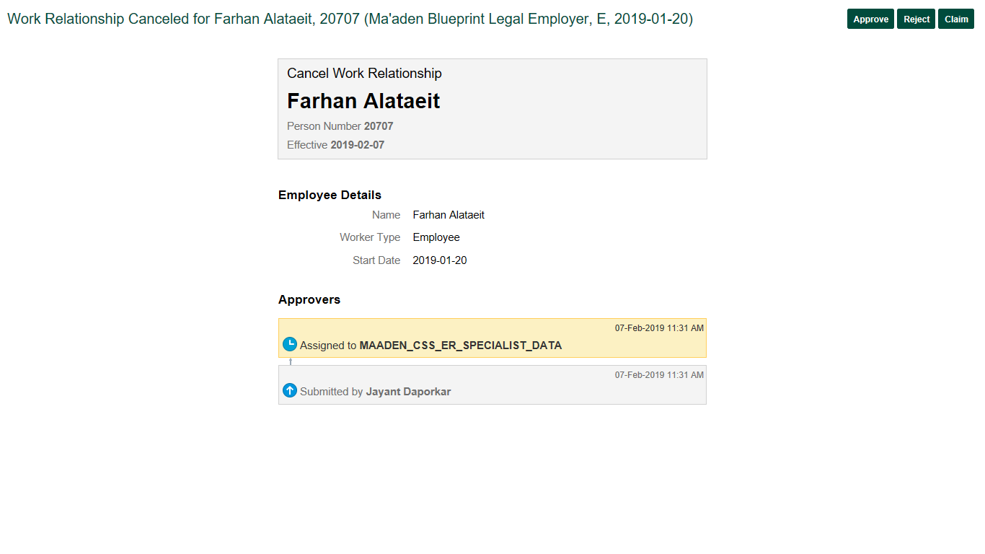

1. Click Approve or Reject based on the kind of transaction and appropriate decision being taken.

|  |  |
| --- | --- |
| Action | Description |
| Approve | Click this button if the details in the notification seem appropriate and can be recorde in the systen. |
| Reject | Click this button if the details in the notification are incorrect or do not seem appropriate. |
| Claim* | Click this button if the transaction has to be blocked for pursual and no other user can approve/ reject. |

* Few employee self service actions are routed to a group of users (For ex: employee relations team) so that one of the team members can approve/reject them. Claim button will be shown to this group of users. Once a group member claims the task, all other users in the group will loose their access.

**Claiming a transaction:**

1. Once the request is claimed, the Claim button is hidden and only Approve/ Reject buttons are visible.
2. Actions list of values will allow the users to do the following

|  |  |
| --- | --- |
| Action | Description |
| Request Information | Use this action to request more information from the initiator or previous approver. |
| Reassign | Use this action to assign this task to another approver. |
| Release | Use this action to to Release the transaction back to the group of users. |
| Withdraw | Use this action to cancel the transaction on behalf of the initiator. |

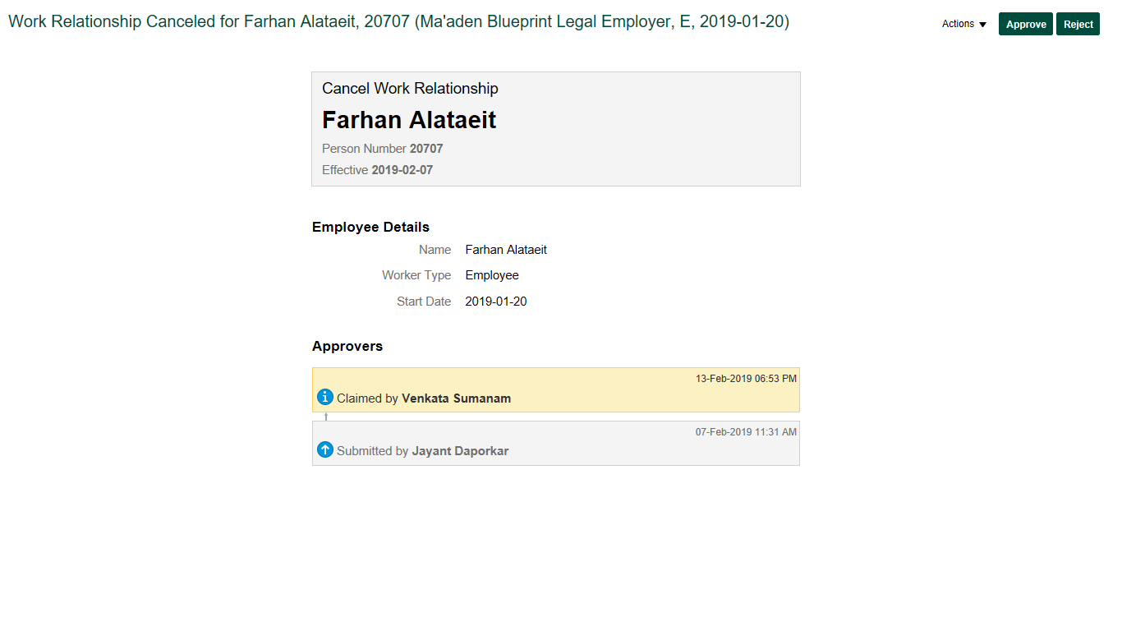

**Approving a transaction:**

1. Once the transaction details are verified and seem fine to be approved, click **Approve**.
2. Enter comments and add attachments if necessary while approving.

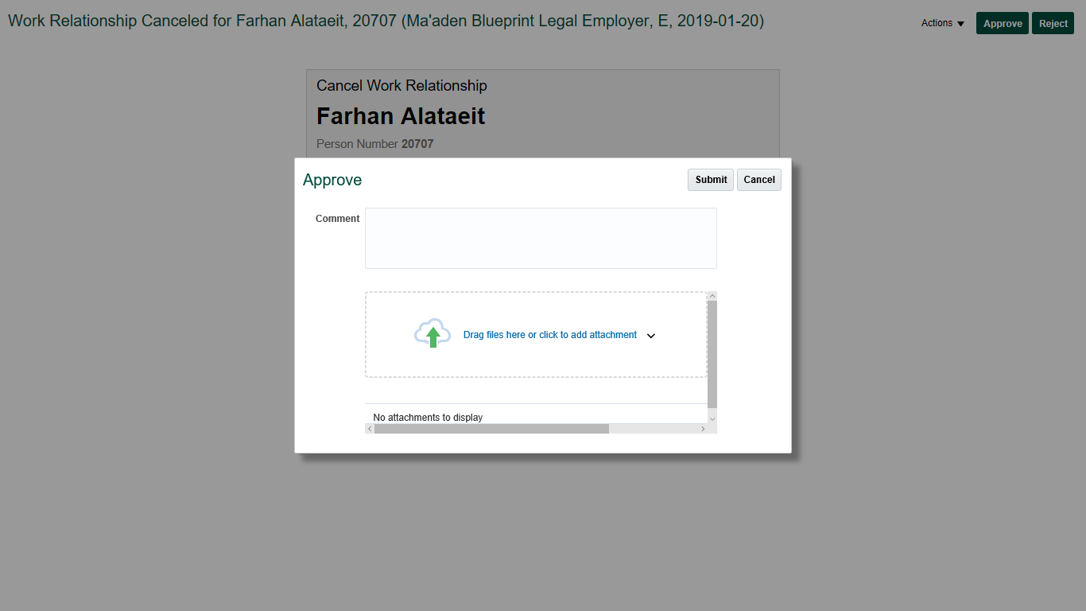

1. Click **Submit** to successfully approve the transaction.

**Rejecting a transaction:**

1. Once the transaction details are verified and do not seem fine to be approved, click **Reject**.
2. Enter comments and add attachments if necessary while rejecting.

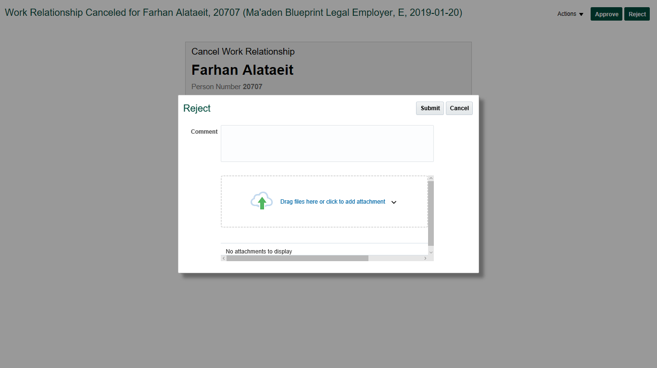

1. Click **Submit** to successfully reject the transaction.

Letters and Certificates

1. Login as Employee to the Oracle HCM Cloud application.
2. Navigate to Letters and Certificates (tab)

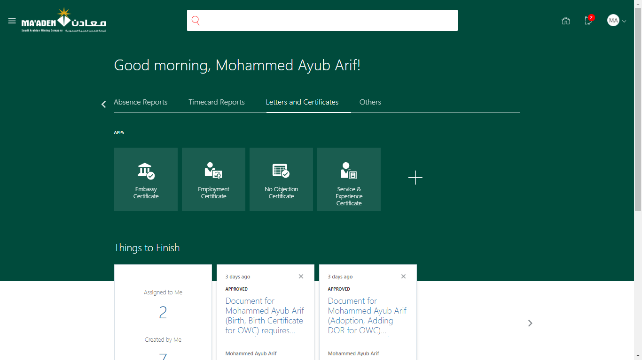

1. Click on the one of the icons to open the relevant certificate (For ex: No Objection Certificate). A new tab opens on the browser to generate the certificate.

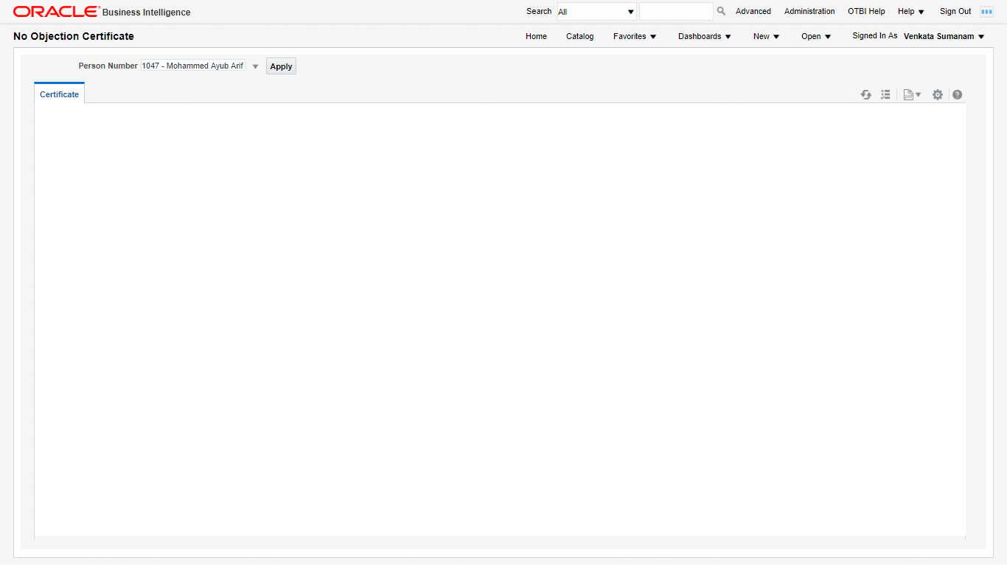

1. The certificate will have certain parameters based on the type of letter selected. The Person Number parameter will display the current employee number and name.

Note:

* 1. If the employee is also an Employee Relations team member, they will see list of all active employees in the system so that they can generate on the employee behalf.

1. Select the name of the employee (or self) and click **Apply**. The page is refreshed with the PDF format of the letter being selected.

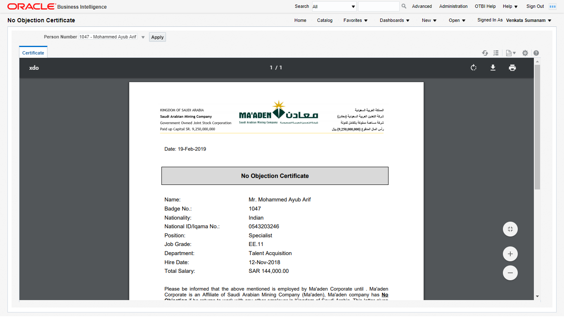

1. Click **Print** icon on the top right corner of the PDF and system prompts to selct a printer as a broswer feature.

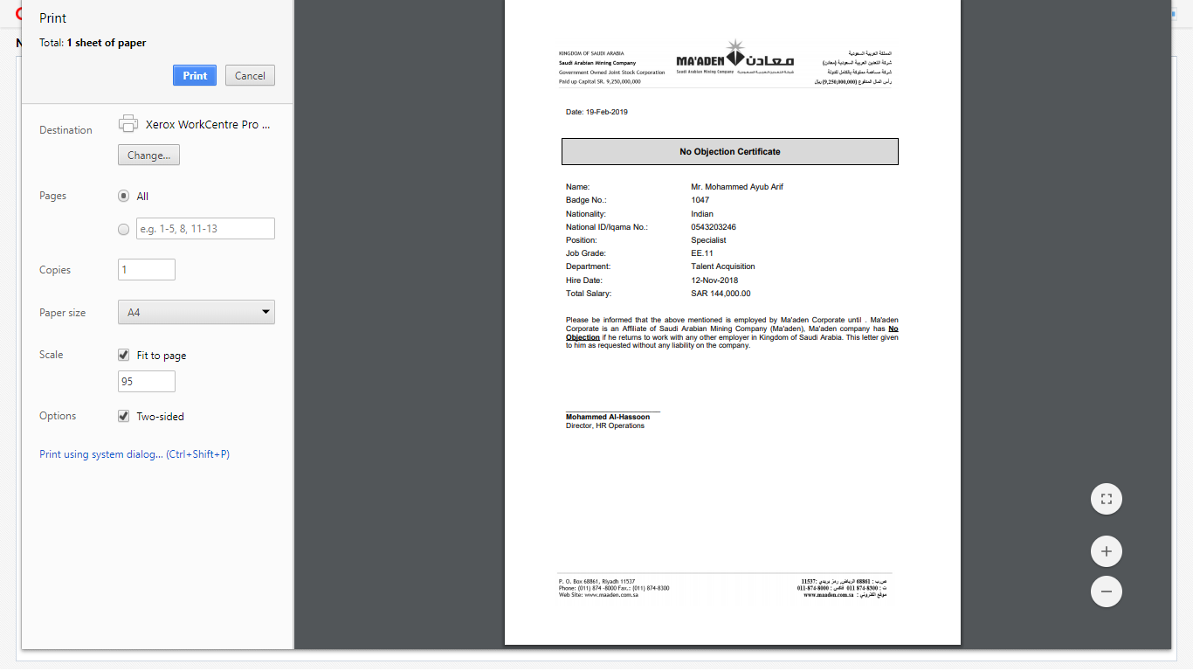

1. After taking the print, the employee may take the pysical copy of the letter for signatures.

Individual Compensation Plan Request

1. Login as Employee to the Oracle HCM Cloud application.

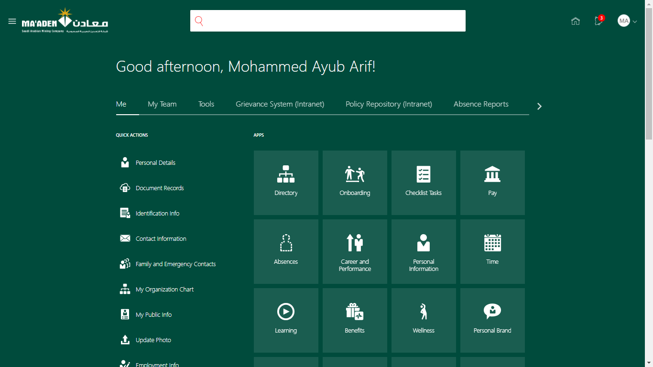

1. Navigate to Home Screen > Show More > Compensation > Manage Personal contributions

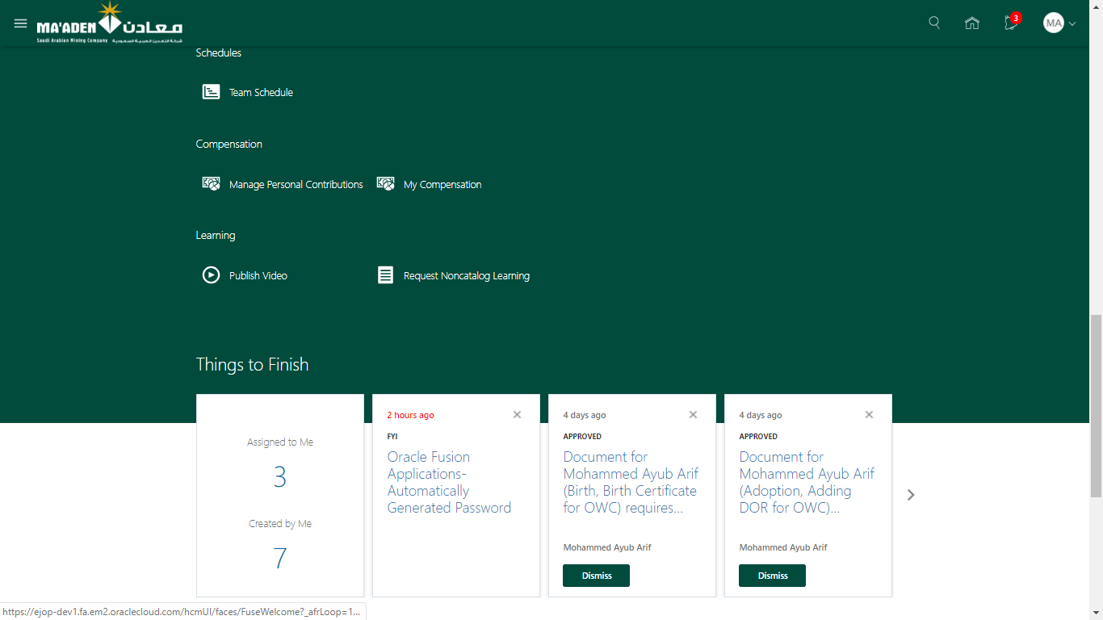

1. Click **Add.**

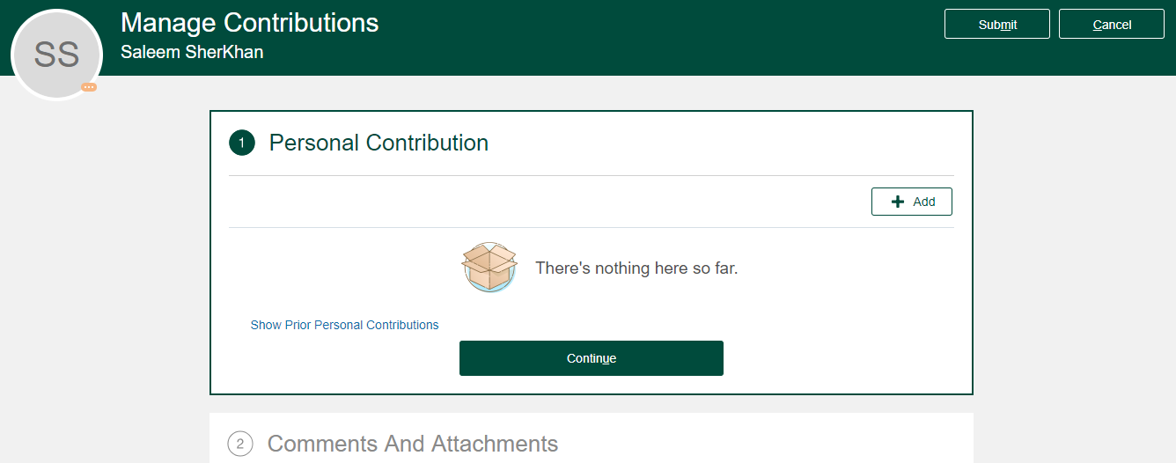

1. Below screen will be displayed.

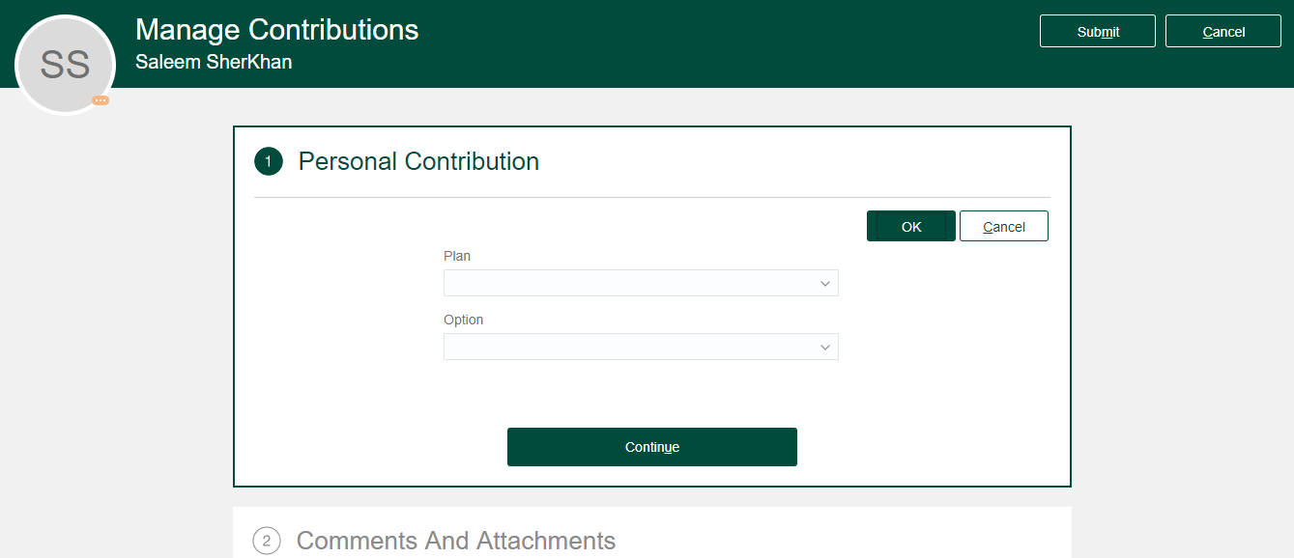

1. Select the ICP Plan, Option, enter the Amount and other required values. Click **Continue**.

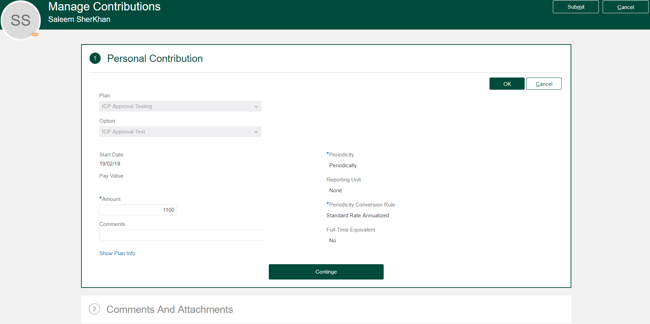

1. Enter Comments if any, attachments if any and click **Submit** to Submitting ICP request.

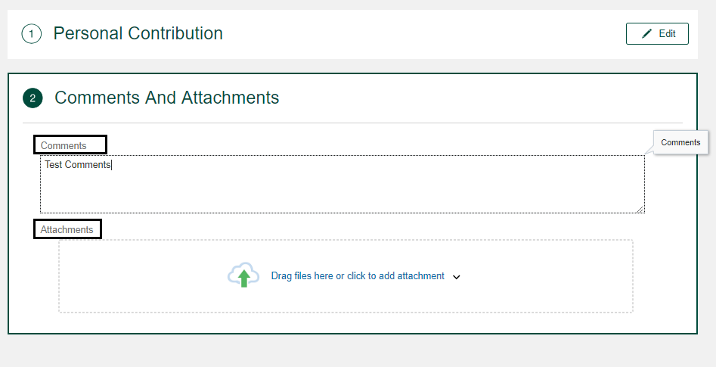

1. After successfully submitted the request, system Employees home screen will be displayed.

Note**:**

* 1. Employee cannot submit multiple ICP requests at the same time. Once the current request is completed, then Employee can submit a new request.

1. If the request is Approved or rejected, employee will get an email notification and the notifications area like in the screenshot below.

 

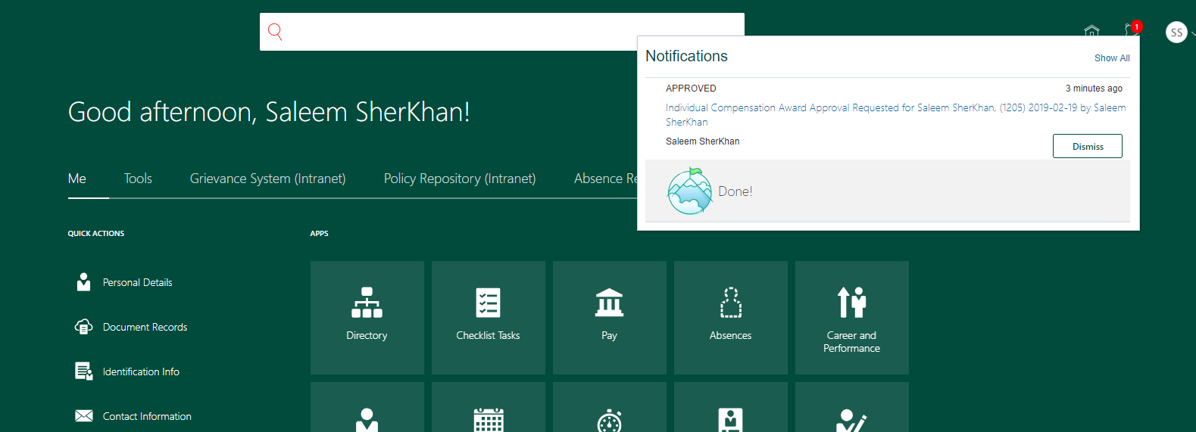

Applying Absence with Designated Work Schedule

This section explains the step by step process to create Absence for an employee with designated work schedule. Designated schedules are assigned by HR to the employee(s) based on their work rotation plan.

1. Login as an Employee and navigate to Me > Click Apply Leave.

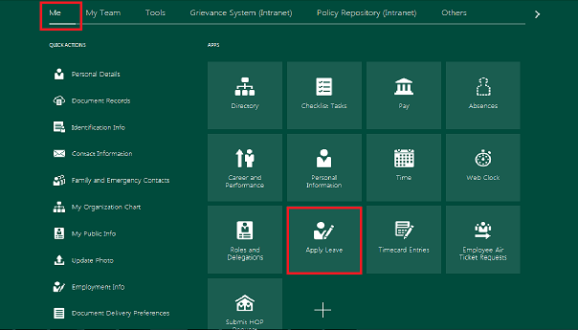

1. “Manage Absence Records” Page opens. Click on the ADD button.

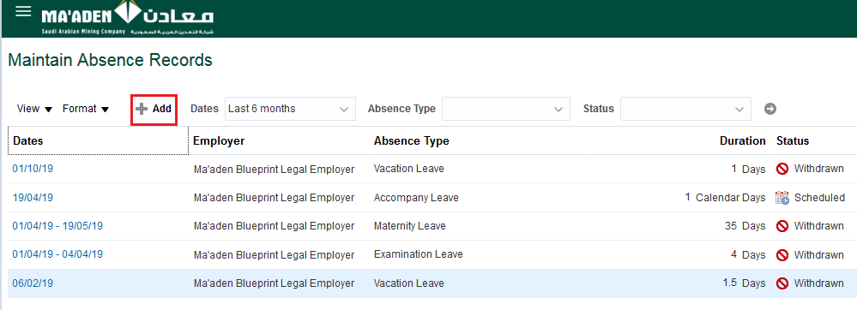

1. Select the Absence Type as Vacation Leave from the Absence Type drop down.
2. Enter the values like **Start date**, **end date**, **Rejoining Date** and **Replace by**. Click on the **Submit** Button.

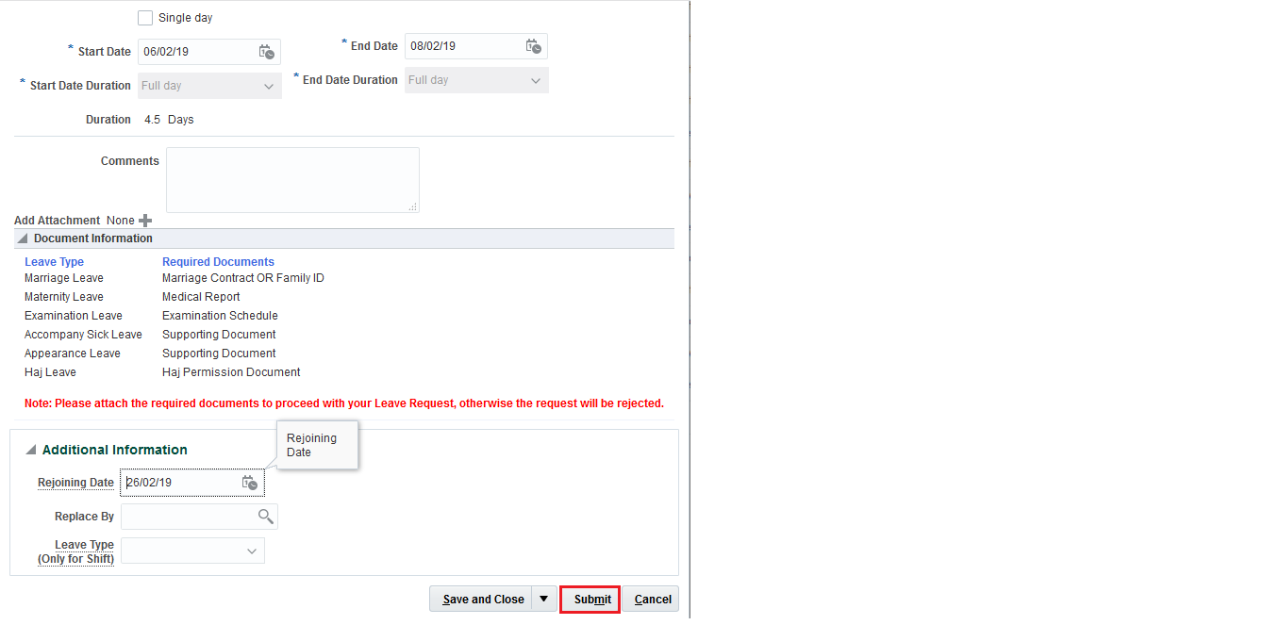

1. The Confirmation Window opens. Click on the **OK** button to complete the absence creation process**.**

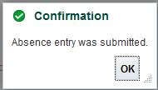

Applying Absence with Standard Work Schedule

This section explains the step by step process to create Absence for an employee with Standard work schedule. Standard work schedules are the default work schedule that runs on all the days.

1. Login as an Employee and navigate to Me > Click Apply Leave.



1. Manage Absence Records Page opens. Click on the ADD button.
2. Select the Absence Type as ‘Vacation Leave’ from the Absence Type drop down.
3. Select the parameters like Start Date, End Date, Rejoining Date and Replace By.
4. Select the Leave Type from the drop down. Select the option as Within Years when the leave period starts and ends within the same Calendar Year. Else, select the Option as Span Years when the leave period starts and ends in different Calendar Year.

For **Span Year** Option, please enter the following:

* Enter **number of non-working days in the current year** (Absence start date - 31-Dec). If all the days are working day, please enter ‘0’.
* Enter **number of non-working days in next year** (1-Jan – Absence end date). If all the days are working, then enter ‘0’.

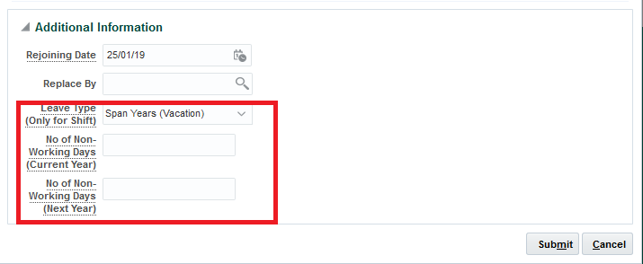

For **Within Year** Option:

* Enter **number of** **non-working days** during the absence period. If all the days are working day, please enter ‘0’.

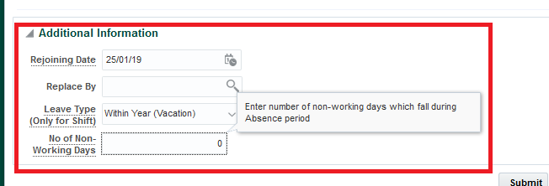

1. Click on the Submit Button.
2. The Confirmation Window opens. Click on the **OK** button to complete the absence process.



Submitting Rejoining Info

This section explains the step by step process to submit the Rejoining Information for the leave applied by an employee.

1. Login as Employee and navigate to Home > Me > Rejoining Information

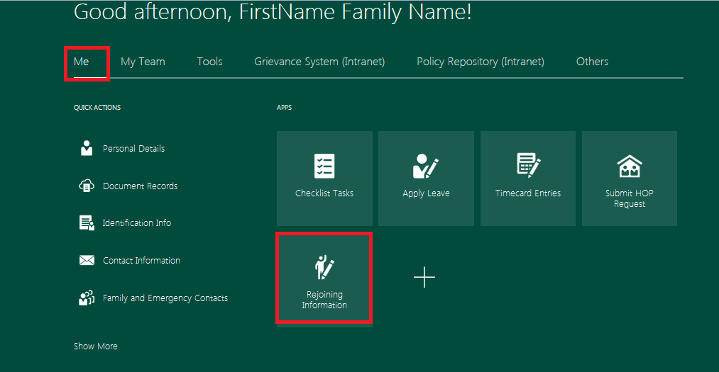

1. The **Manage** Personal **Contribution** pages opens and Click on **ADD** Button.

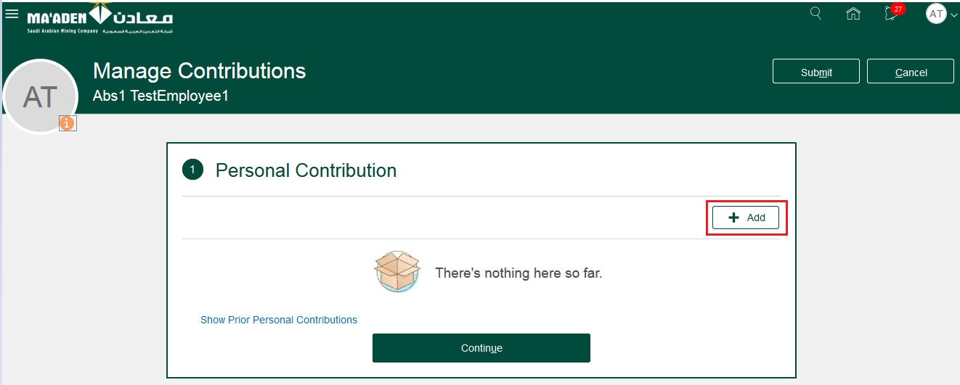

1. The Personal **Contribution** pages opens. Select the **Plan (Rejoining Request)** and **Option (Rejoining Detail)** from the drop down list.
2. The recent dated absence detail will be automatically populated. Provide the **Rejoining Date** and click on **Continue** button.

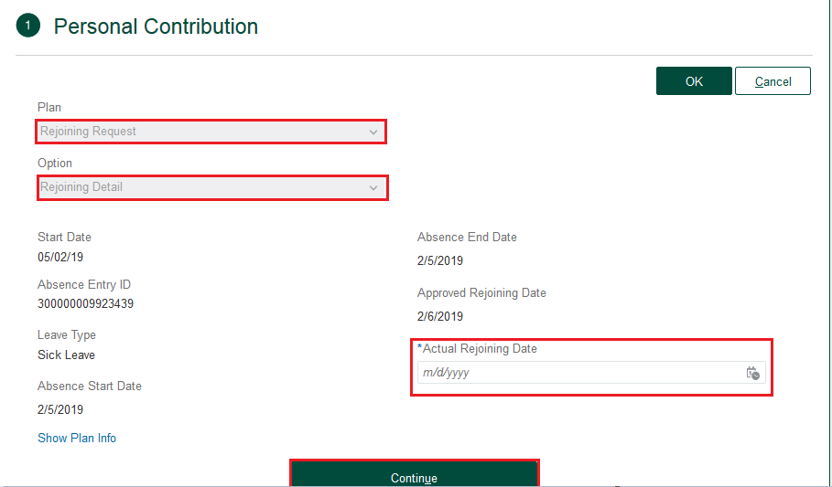

1. Provide the comments and Click on the **Submit** option.

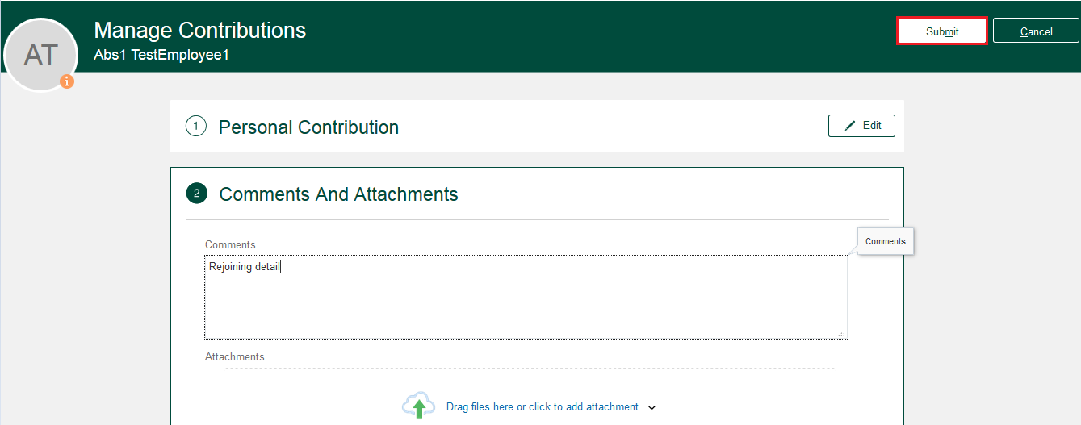

Time Card Submission

This section explains the step by step process to create Time card with eligible hour type(s).

1. Login as an Employee and navigate to Home > Me > Timecard Entries

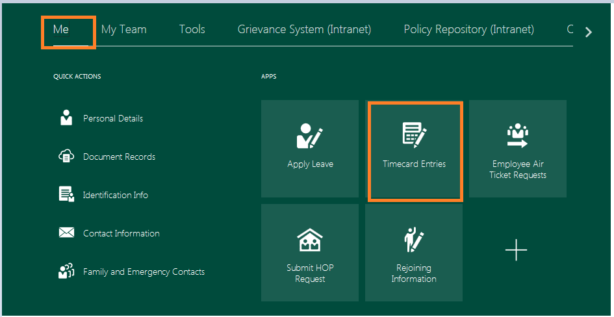

This will take you to “**Manage Time Cards**” page

1. Manage Time Card page opens and click on **Add** Button .

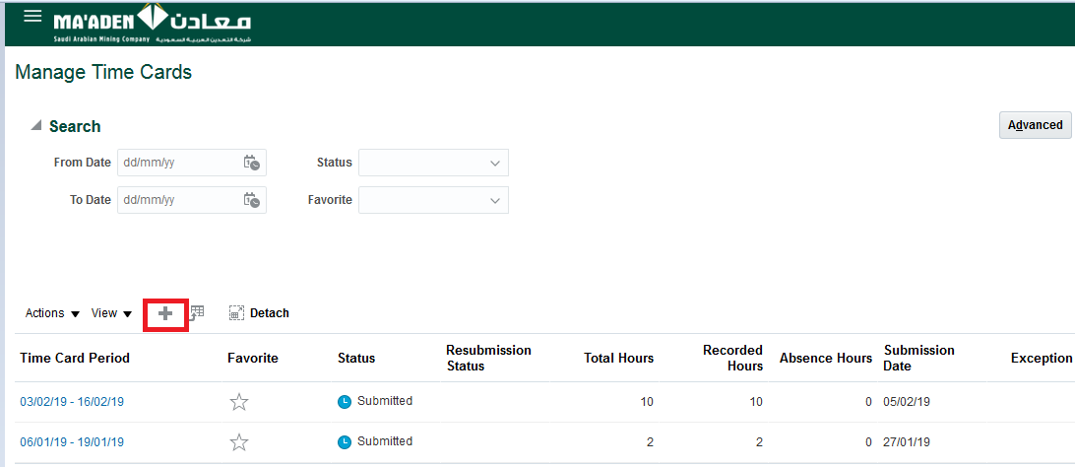

The **Create Time Card** page opens, select the time period for which the timecard needs to be created and click **Ok** button

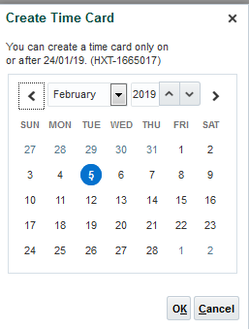

Note: In Fusion, Time card period is Bi-Weekly (14 days), that runs from Sunday through Saturday.

1. The Time card page opens and select the first row and select the hour type from the drop down.

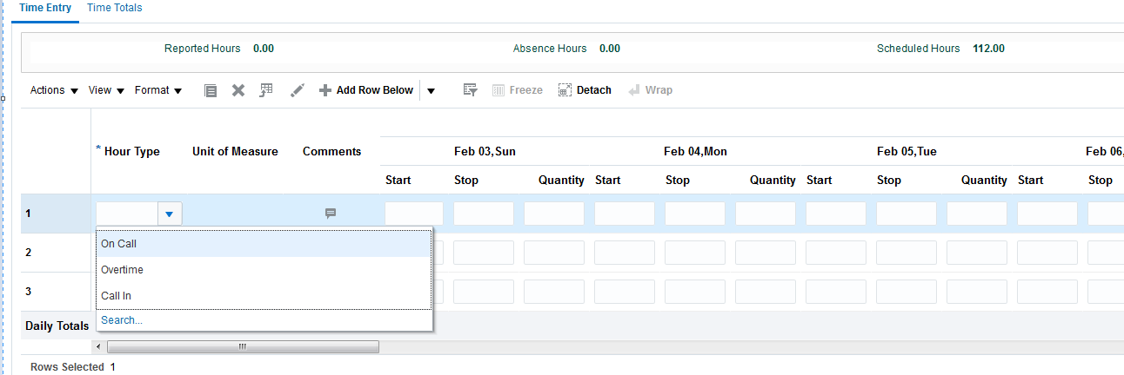

1. Then enter the corresponding time under the respective days.

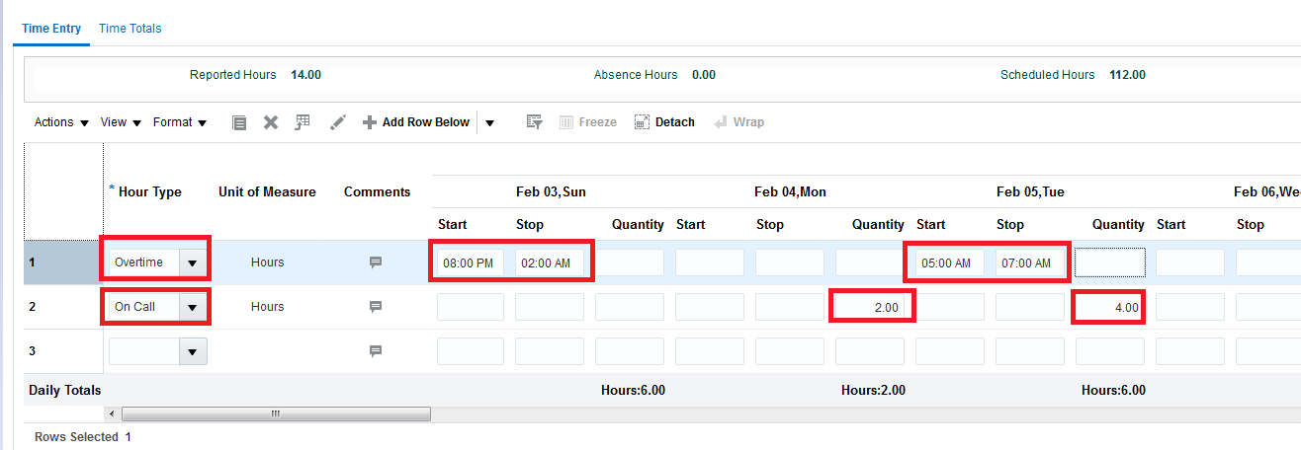

There are two ways of entering the hours.

1. Enter **Start** time and **Stop** time. System will calculate the hours based on the entered time.

**OR**

1. Enter the worked hour directly under **Quantity** column.

Note: You cannot enter both at the same time.

1. Please note that entering comments is mandatory to enter **‘Call-In’** Hours.

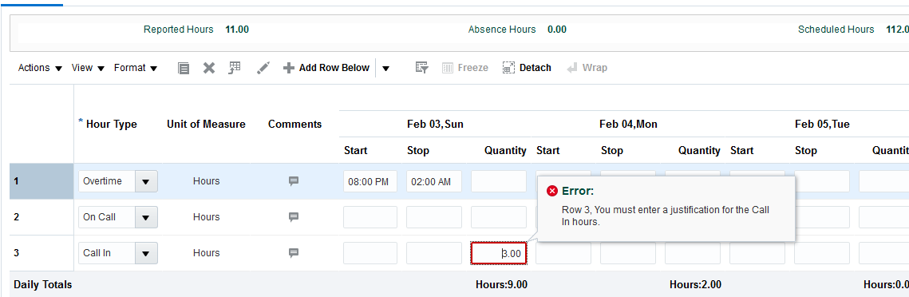

1. To Enter Justification, click on ‘**Comments’** icon.

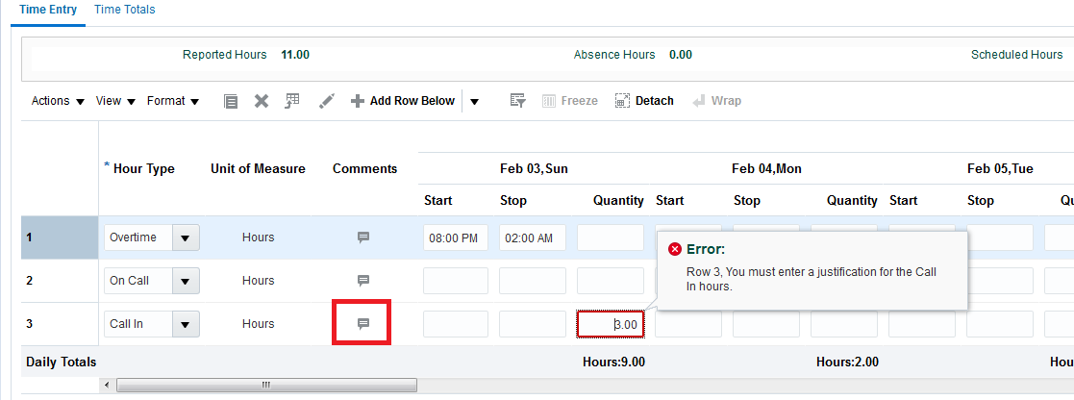

1. Provide the Justification as appropriate.

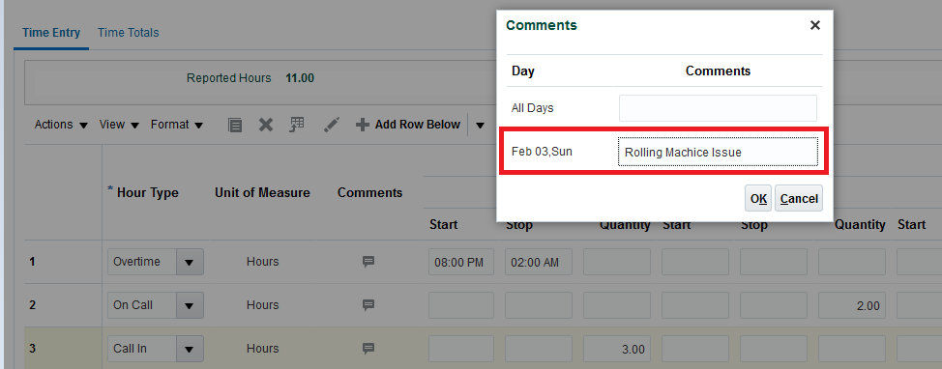

1. Click on the **Next** Button present on the right corner of the page.

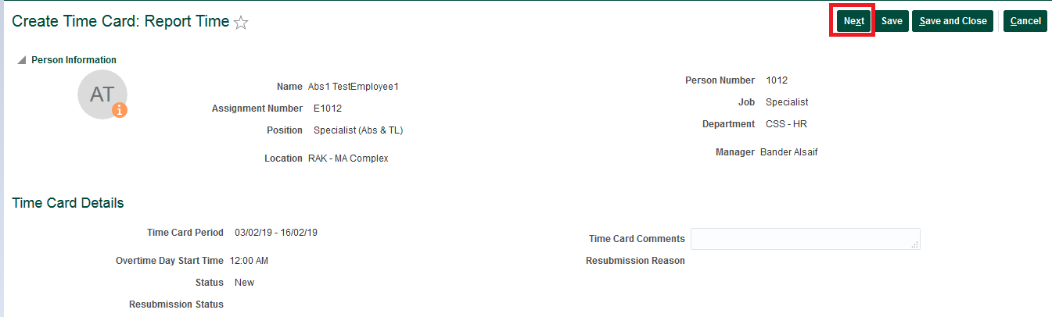

1. The Review page opens up. Click on the **Submit** option in the top right corner of the page.

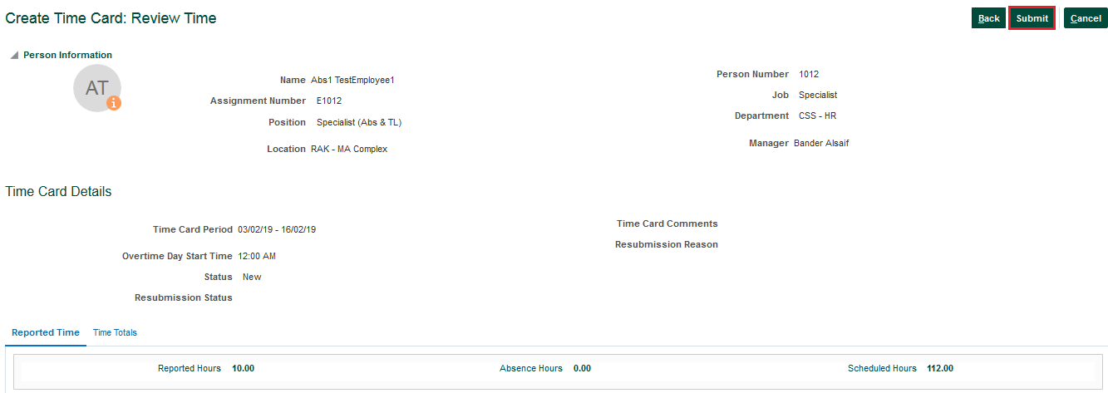

1. The Confirmation Window opens and click on the **OK** button to submit the absence.

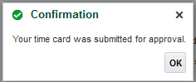

Air Ticket – Booking Request

**Step 1:** Employee log in the HCM Application with his/her credentials.

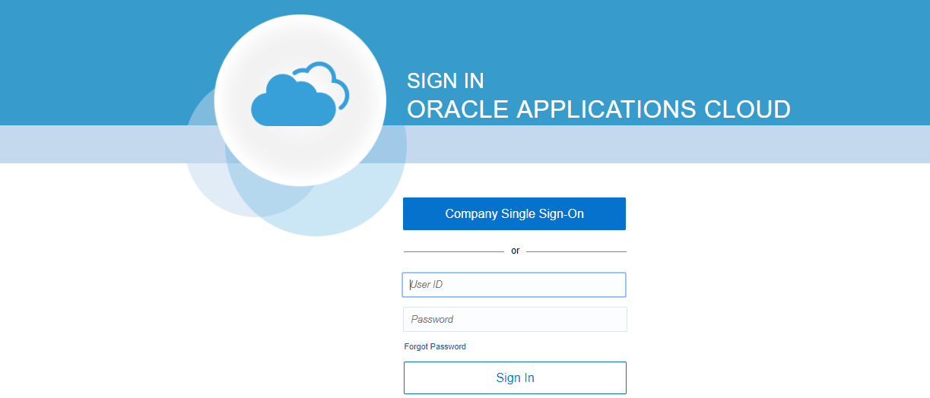

**Step 2:** Click on ‘Employee Air Ticket Requests’ icon highlighted in below screen. Or access the same from Navigation: Home Screen > Me > Employee Air Ticket Requests.

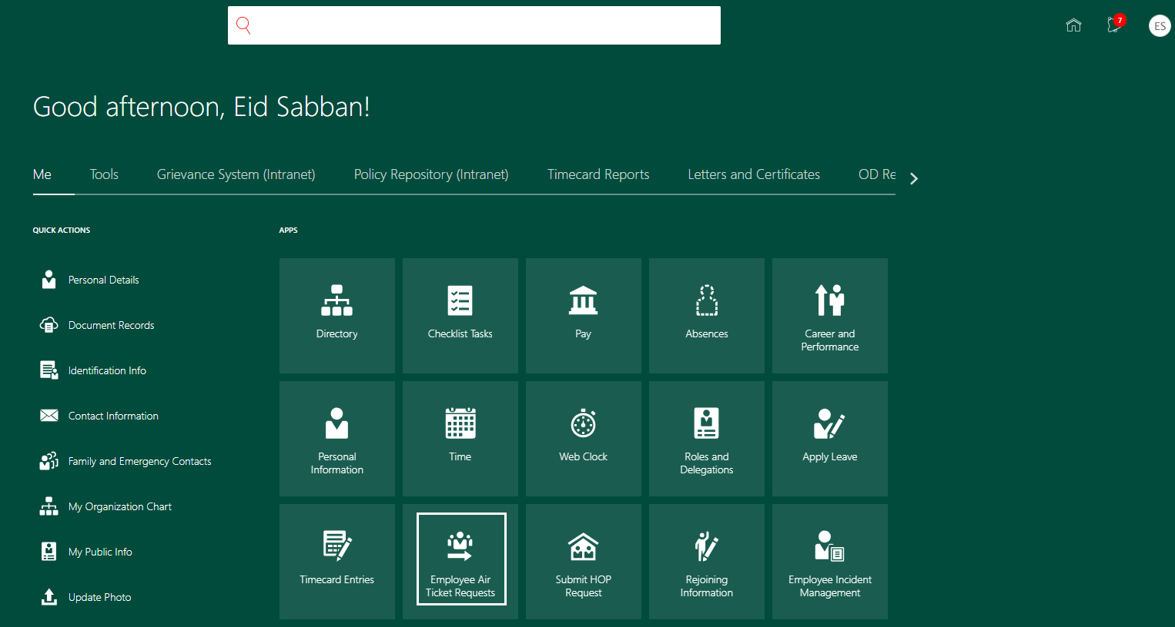

Below screen will be displayed, with Employee’s existing Air Ticket Booking and Encashment Requests with their related details like Status, Request type, Requested date, etc.

**Step 3:** Please note 2 buttons ‘Encashment Request’ and ‘Booking Request’ highlighted in below screen.

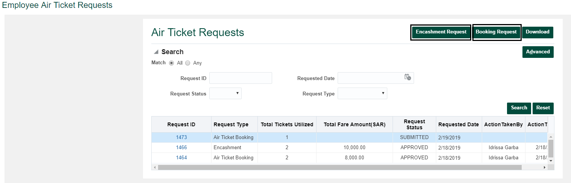

**Step 4:** Click ‘Booking Request’ to raise a request for **Air Ticket booking**. Below screen will be displayed with Employee’s and Eligible Dependents Air Ticket Entitlements Balance

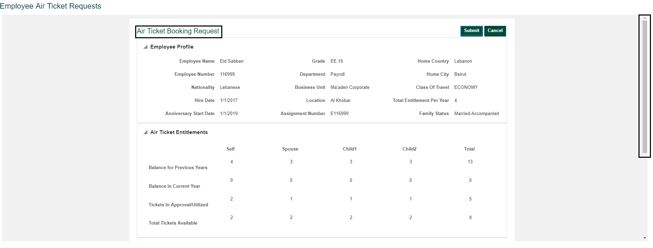

Use the page scroll bar (on the right side of the screen) to scroll up and down to view other details like displayed in below screen.

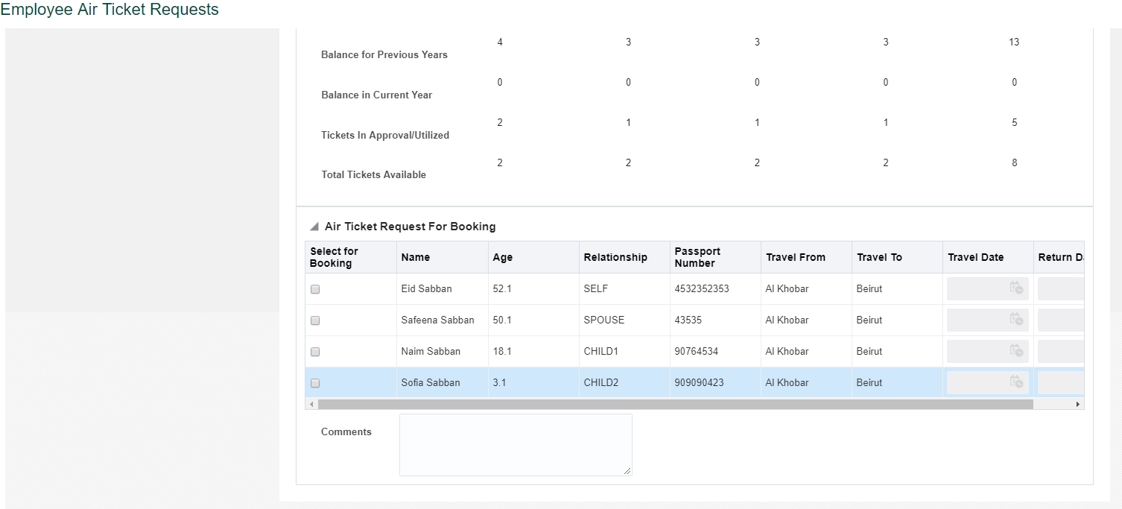

**Step 5:** Under ‘Air Ticket Request for Booking’ section, select ‘Select for Booking’ check box for the Persons for whom Ticket request need to be raised and also enter the Travel Date and Return Dates.

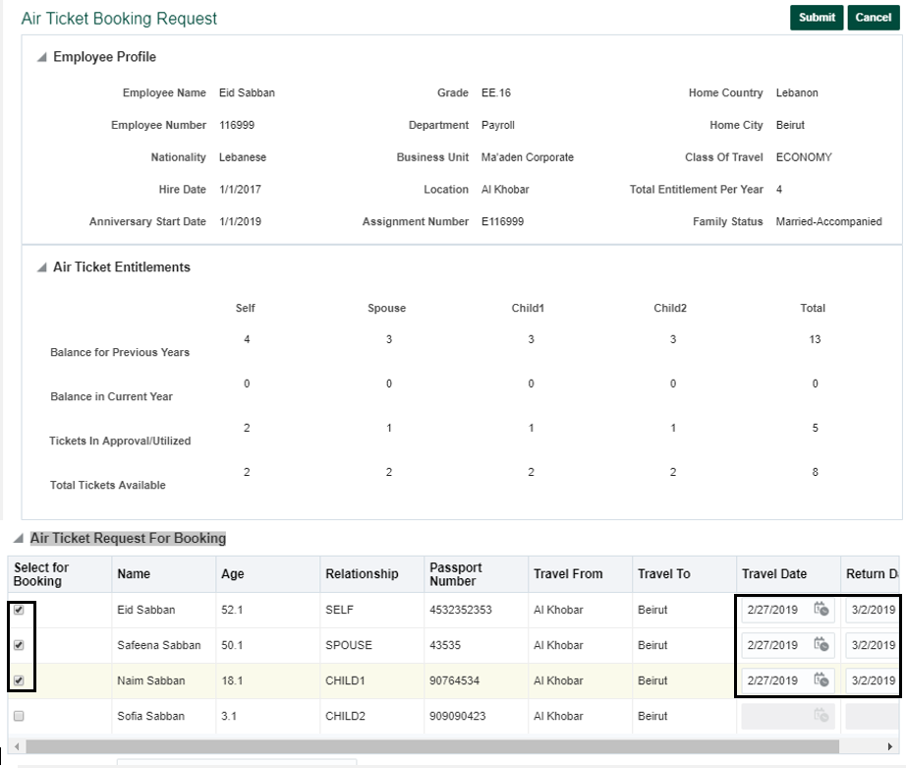

**Step 6:** Click Submit button. Employee Air Ticket Requests home screen will be displayed as below, showing the request submitted.

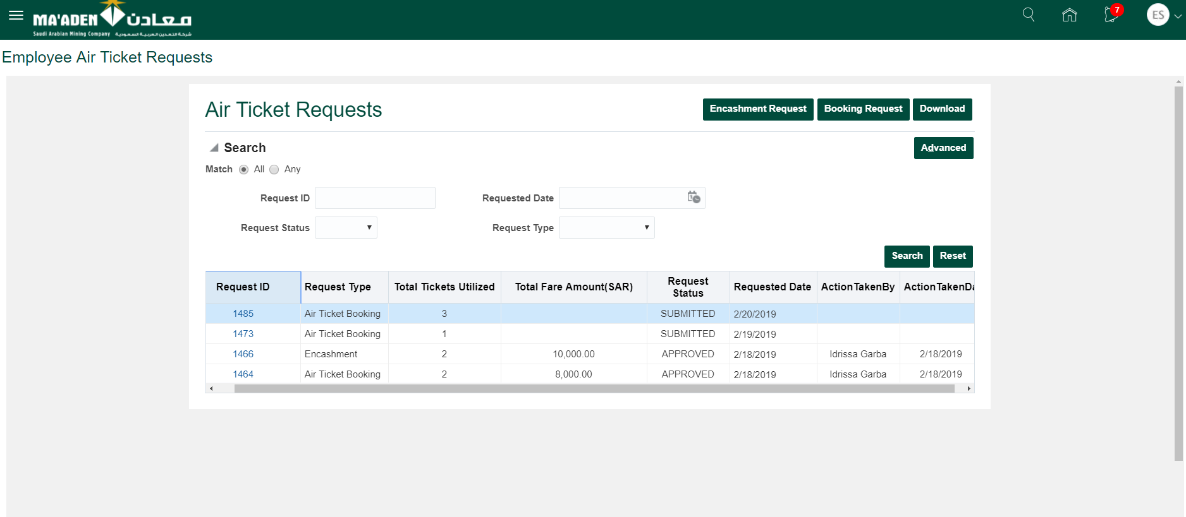

**Step 7:** Employee can click on the corresponding request id to view the details of request which was submitted, as displayed in below screen.

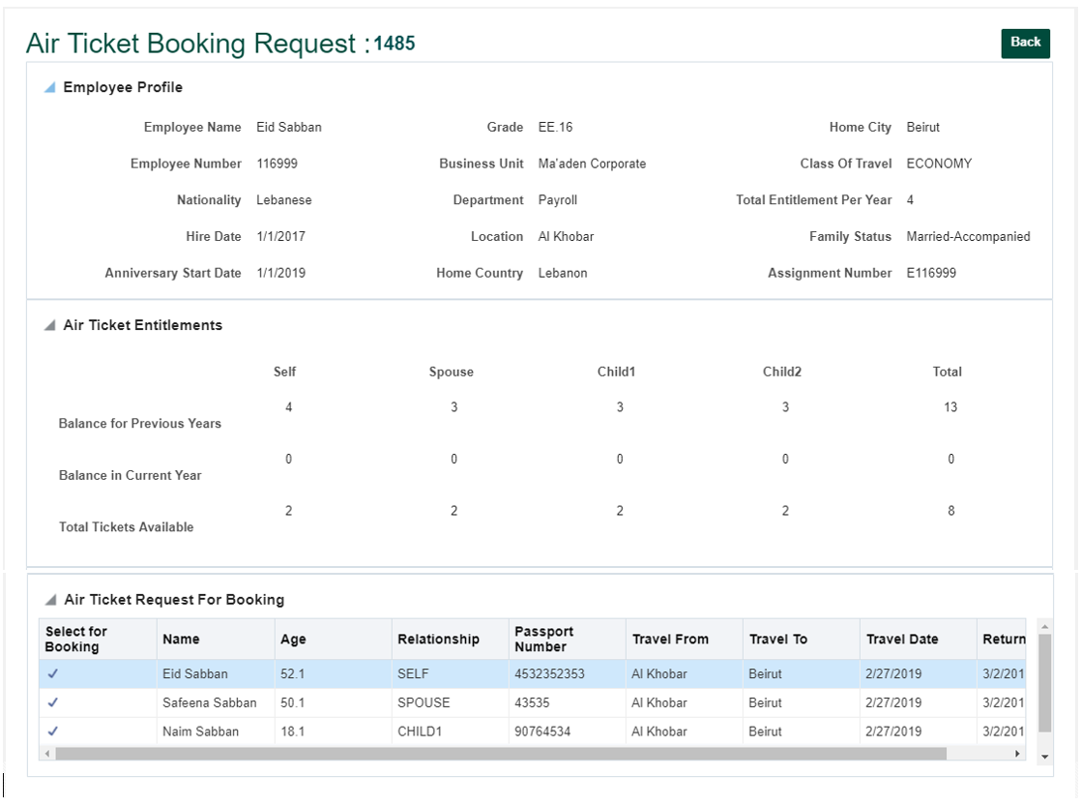

**Step 8:** After the request is approved or rejected by the approvers, status of the request will be changed accordingly to APPROVED or Rejected. Employee can check request status on ‘Air Ticket Requests’ Home screen.

Navigation: Home Screen > Me > Employee Air Ticket Requests.

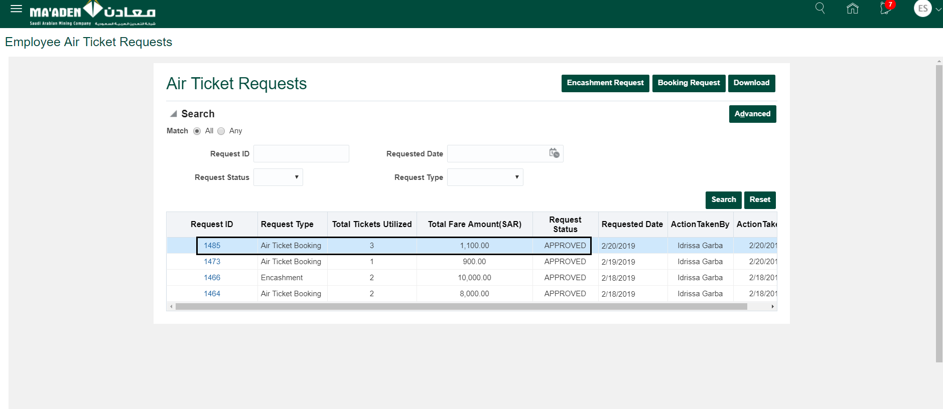

After the Request is approved, Employee will get email notification, below is the sample of such notification.

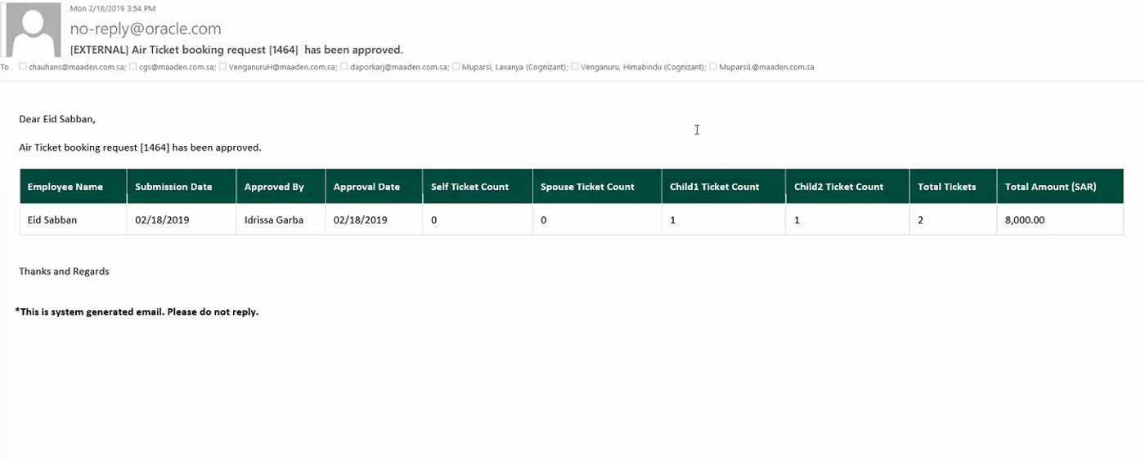

**Step 9:** If the request is rejected by approver, request status will be shown as Rejected.

Email notification will be sent to Employee.

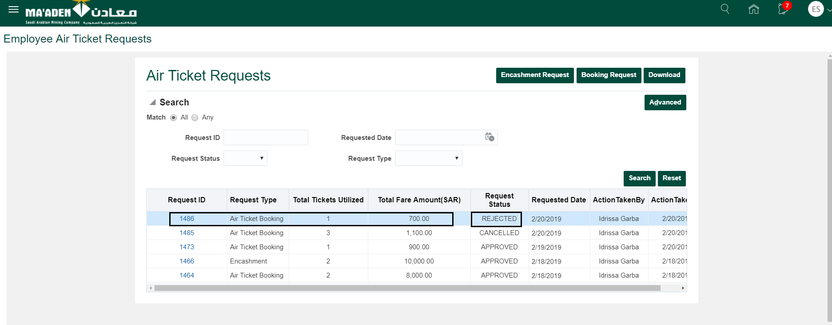

**Step 10:** If the request is cancelled by approver, request status will be shown as Cancelled.

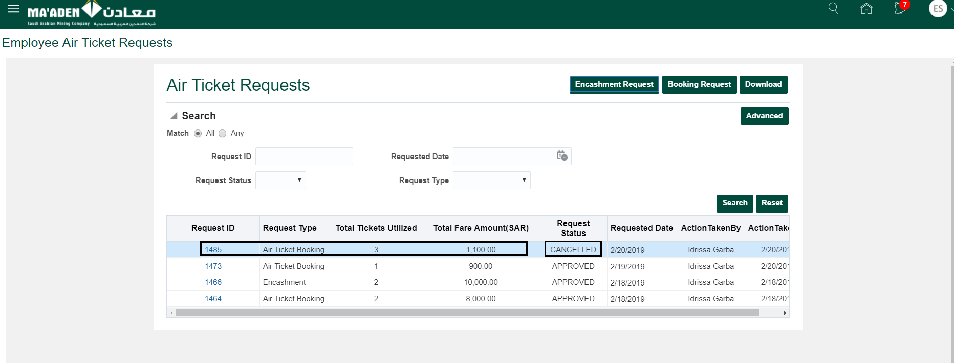

**Step 11:** Click on Download button to download the all the requests in excel.

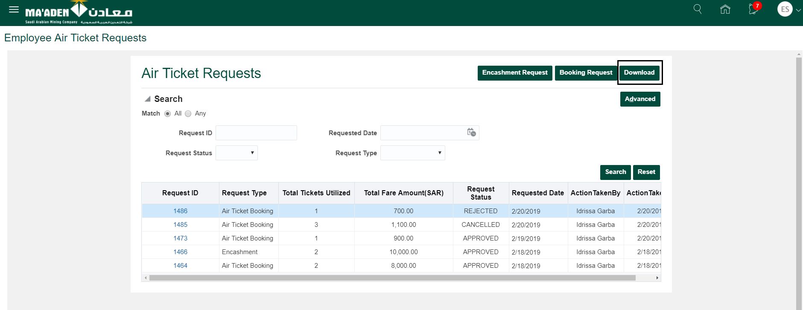

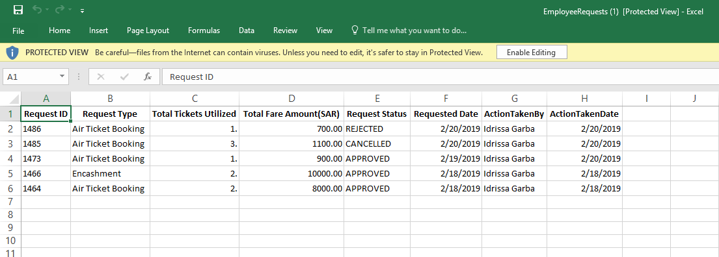

Air Ticket – Encashment Request

**Step 1:** Employee log in the HCM Application with his/her credentials.



**Step 2:** Click on ‘Employee Air Ticket Requests’ icon highlighted in below screen. Or access the same from Navigation: Home Screen > Me > Employee Air Ticket Requests.



Below screen will be displayed, with Employee’s existing Air Ticket Booking and Encashment Requests with their related details like Status, Request type, Requested date.etc

**Step 3:** Please note 2 buttons ‘Encashment Request’ and ‘Booking Request’ highlighted in below screen.



**Step 4:** Click ‘**Encashment Request**’ to raise a request for Air Ticket Encashment.

Below screen will be displayed with Employee’s and Eligible Dependents Air Ticket Entitlements Balance.

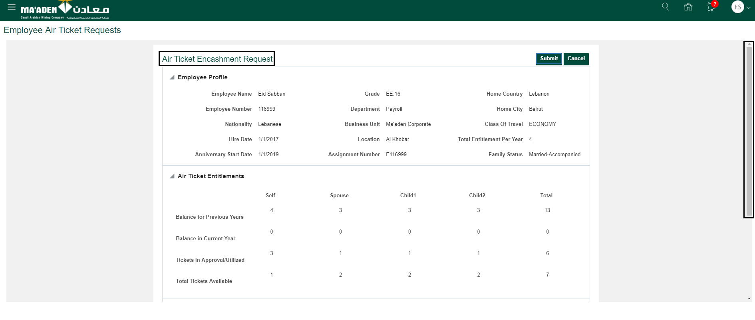

Use the page scroll bar (on the right side of the screen) to scroll up and down to view other details like displayed in below screen.

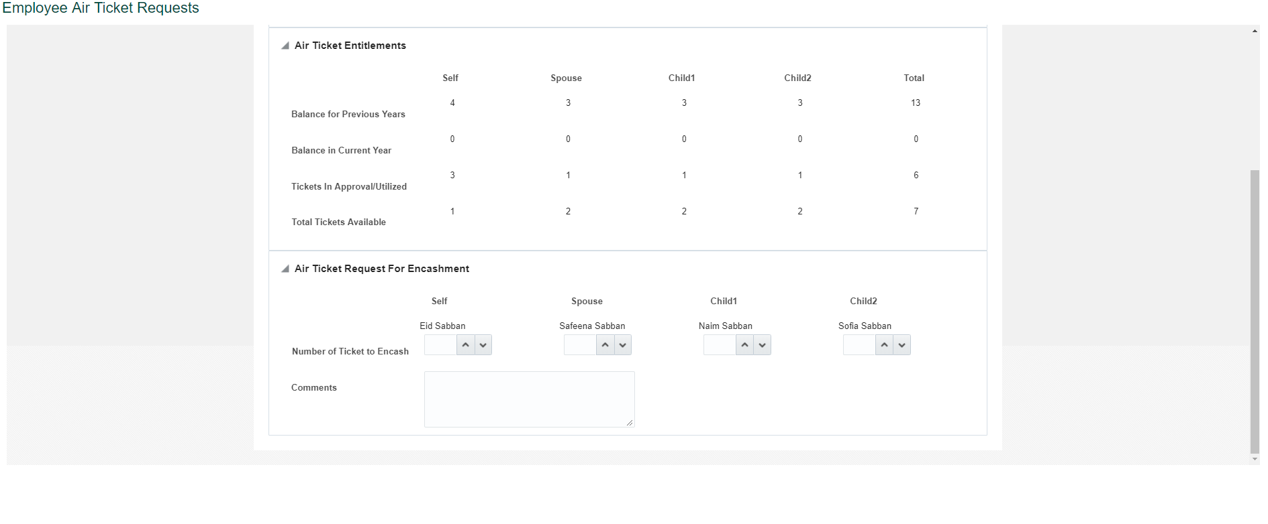

**Step 5:** Under ‘Air Ticket Request for Encashment’ section, select Number of Tickets to Encash for Self and Dependents. Enter comments as required.

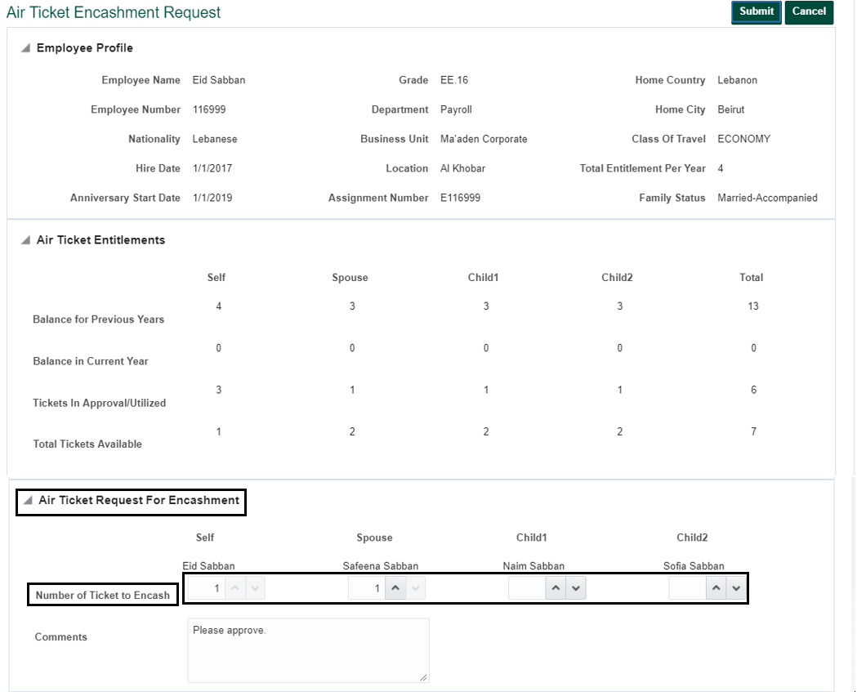

**Step 6:** Click Submit button. Employee Air Ticket Requests home screen will be displayed as below, showing the requests.

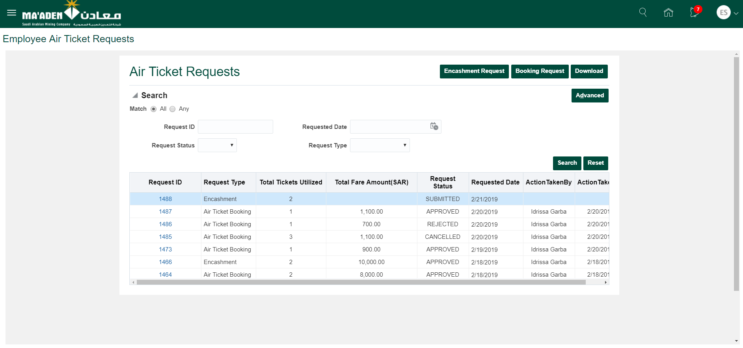

**Step 7:** Employee can click on the corresponding request id to view the details of request which was submitted, as displayed in below screen.

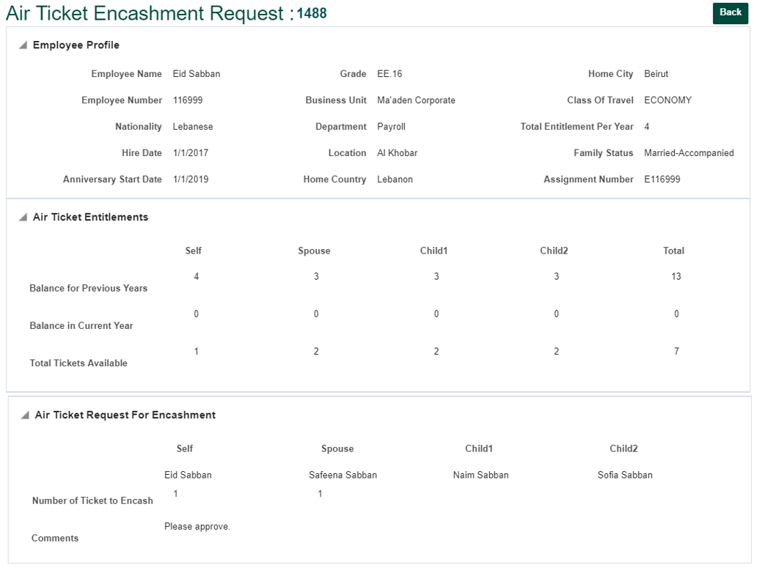

**Step 8:** After the request is approved or rejected by the approvers, status of the request will be changed accordingly to APPROVED or Rejected.

Employee can check request status on ‘Air Ticket Requests’ Home screen.

Navigation: Home Screen > Me > Employee Air Ticket Requests.

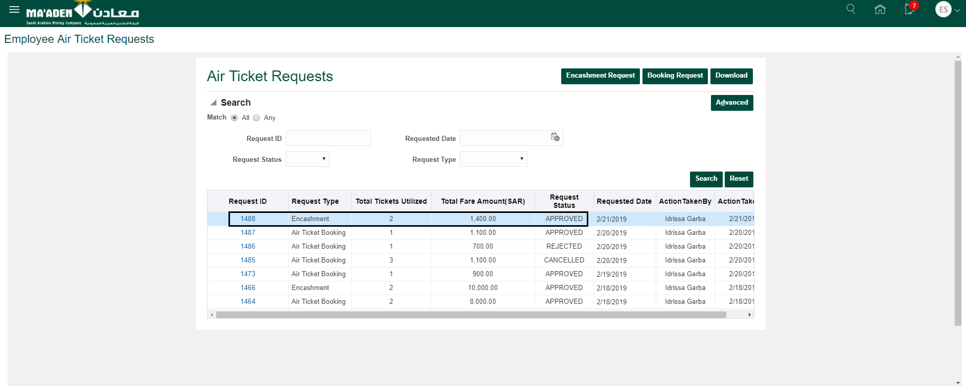

After the Request is approved, Employee will get email notification, below is the sample of such notification.

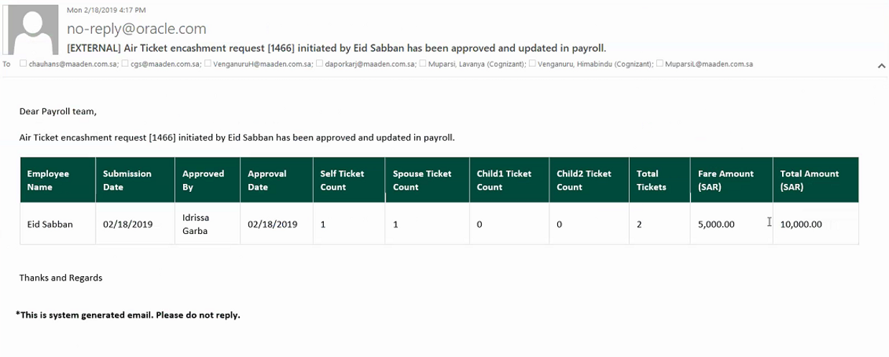

**Step 9:** If the request is rejected by approver, request status will be shown as Rejected.

Email notification will be sent to Employee.

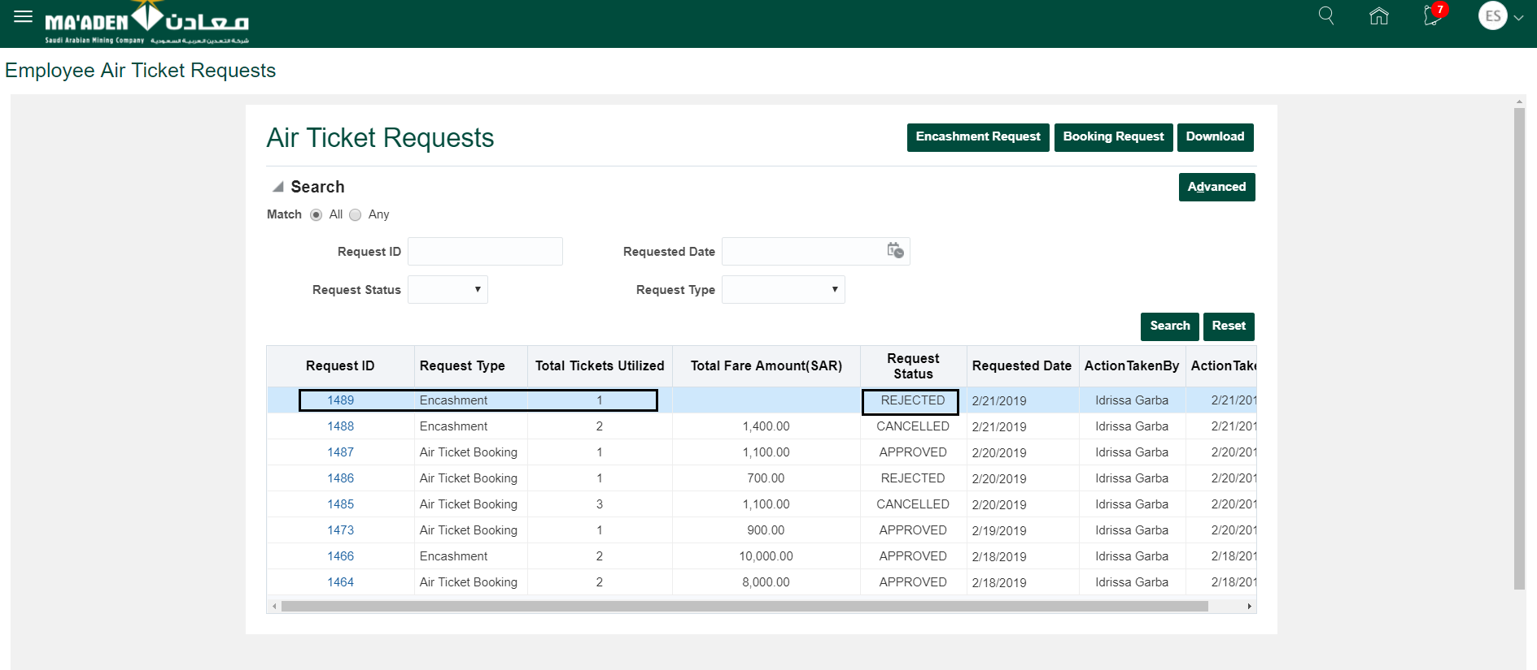

**Step 10:** If the request is cancelled by approver, request status will be shown as Cancelled.

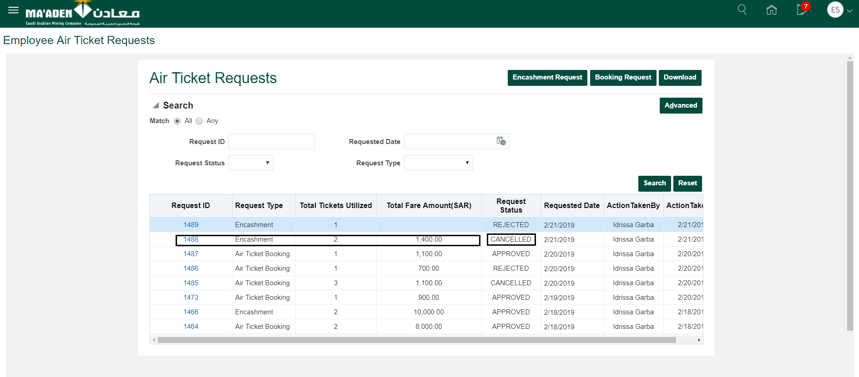

**Step 11:** Click on Download button to download the all the requests in excel.

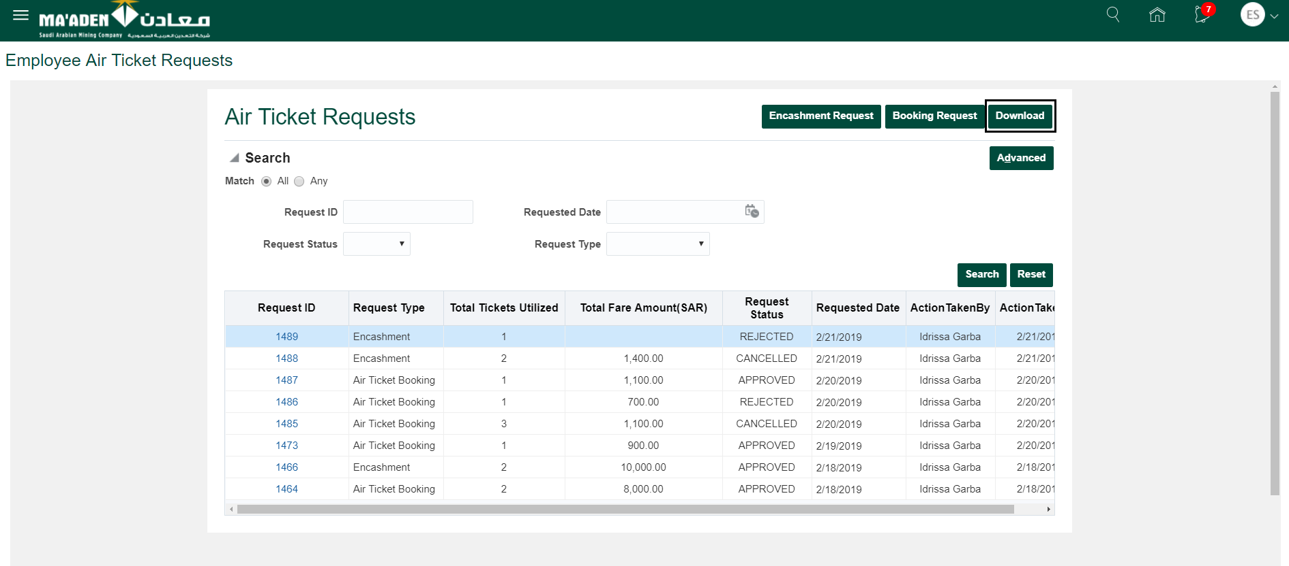

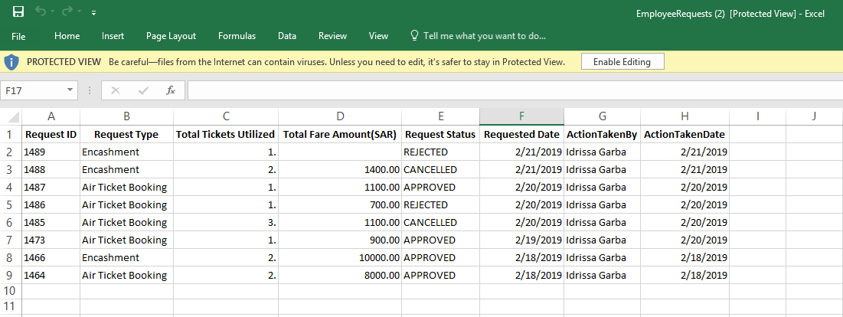

Employee Disciplinary Action Management

**Step 1:** Login as Employee in the HCM Application with credentials.



**Step 2: -** Go to Me > Employee Disciplinary Action Management.

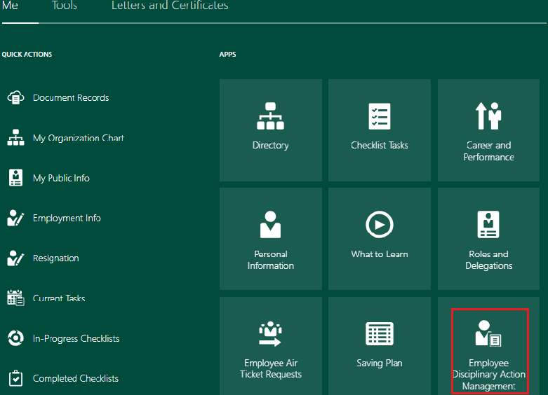

**Step 3**:- Click on Incident Number for which comment is to be updated.

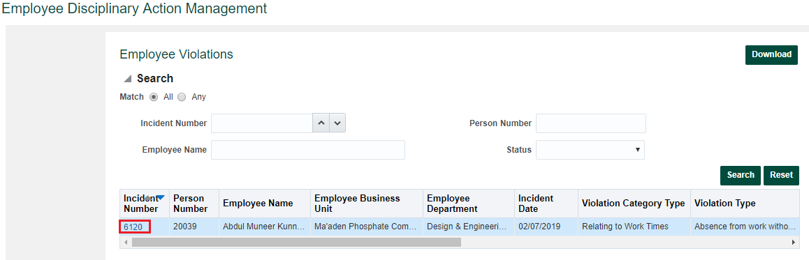

**Step 4:-** Case Details Page Will Open. You can upload supportive document (Optional) by clicking on Choose File. Click on Add Comments.

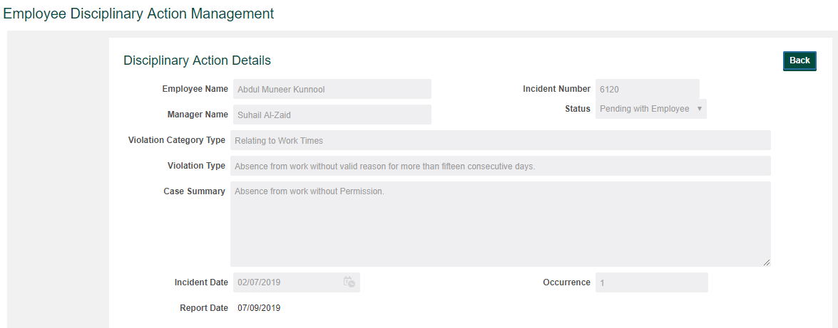

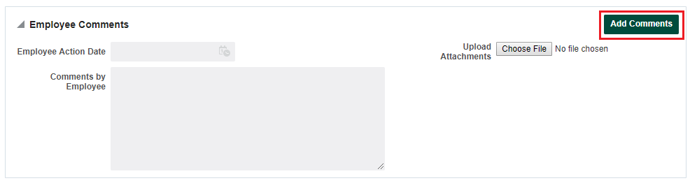

**Step 5:-** Enter Comments in popup window and click submit.

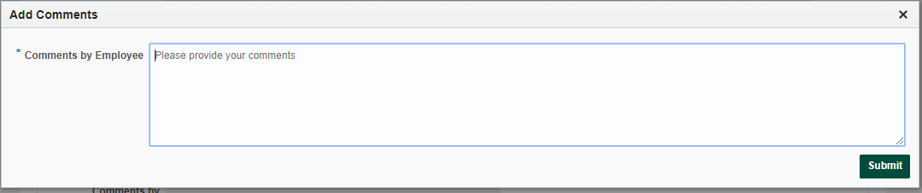

**Step 6**:- Click OK on Message Box.

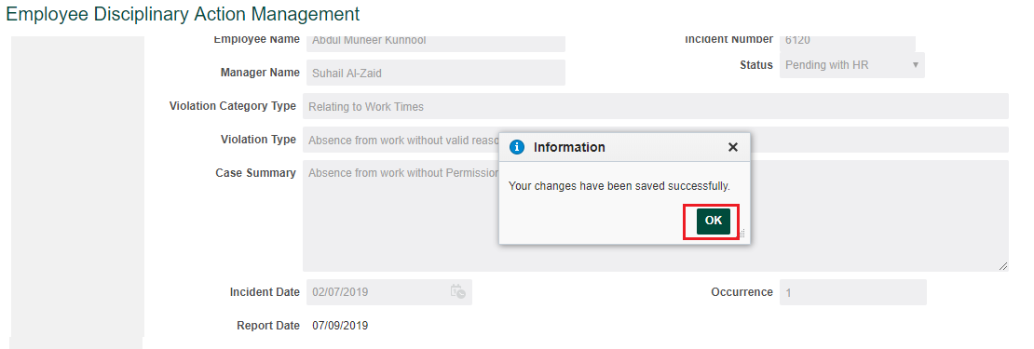

Sample of Notification Triggered to Line Manager

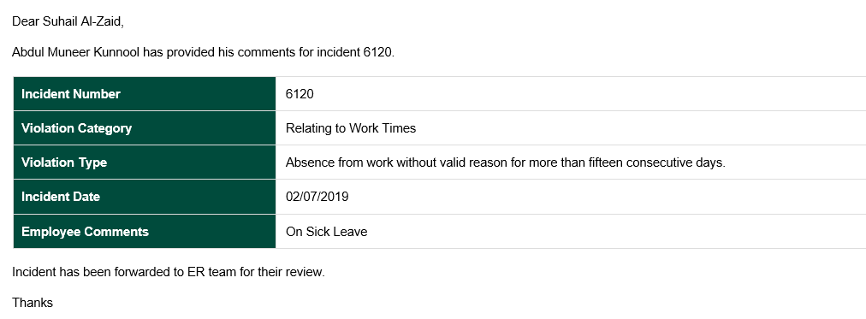

Sample of Notification Triggered to ER Team

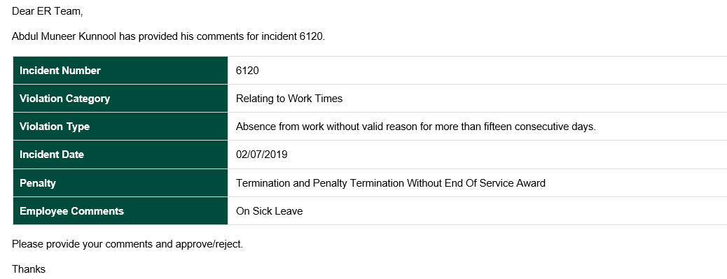

Submit Travel Request

**Step 1:** Login as Employee in the HCM Application with credentials.



**Step 2:-** Click on Business Travel Request.

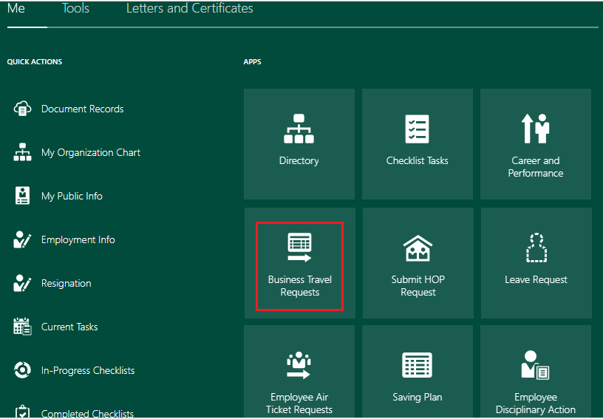

**Step 3:-** Click on Add Travel Request

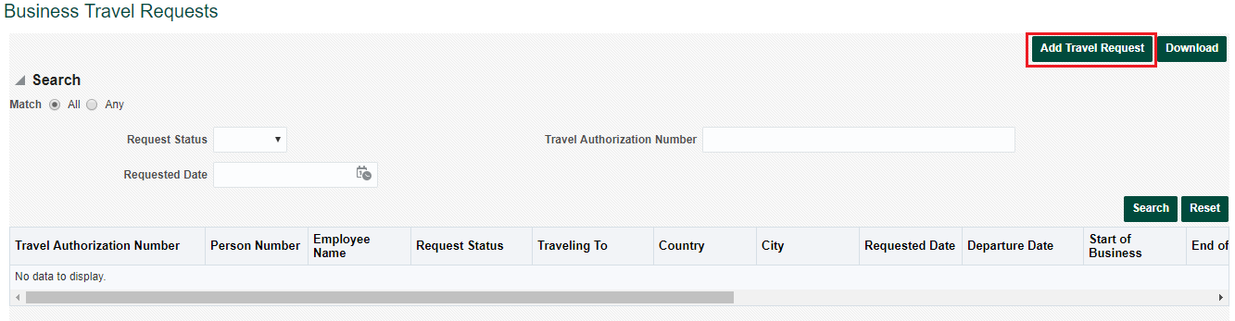

**Step 4:-** Enter all the mandatory details like Travelling Type (Business / Training), Travelling To, Departure & Return Dates etc. and click on Submit.

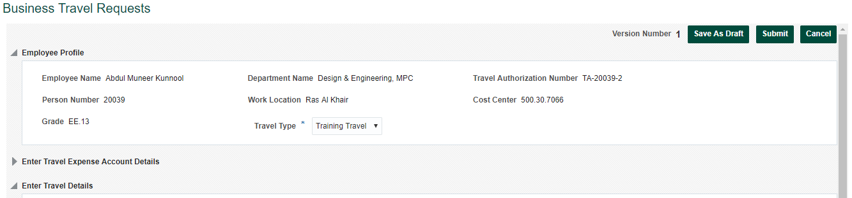

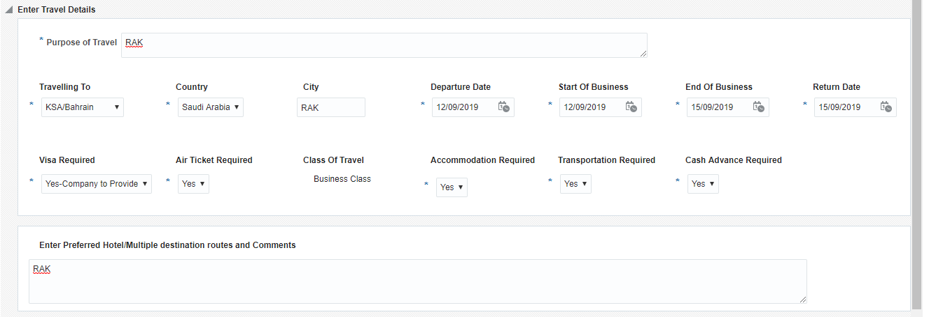

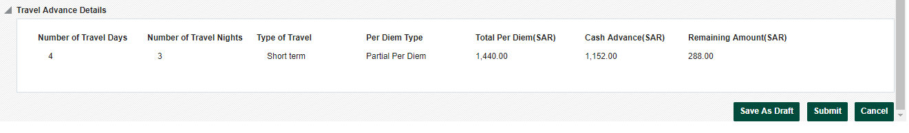

Click on OK once request is submitted.

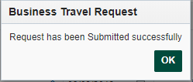

Sample of Notification sent to Approver.



Submit Travel Claim Request

**Step 1:** Login as Employee in the HCM Application with credentials.



**Step 2**:- Click on Business Travel Request.



**Step 3**: - Click on Create Claim button for which Claim Request is to be submitted. Claims can only be created only against those Travel Requests which have been Approved.

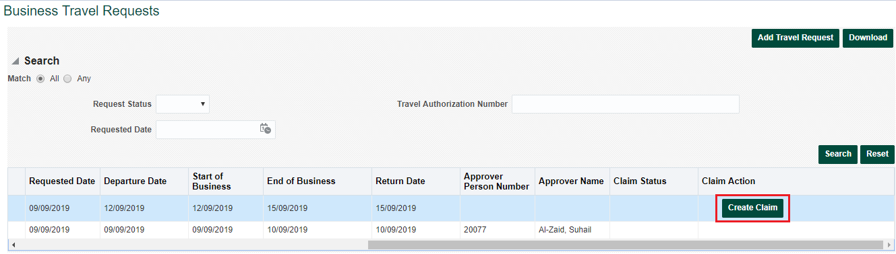

**Step 4:-** Verify the details & enter Claim Reimbursement Details.

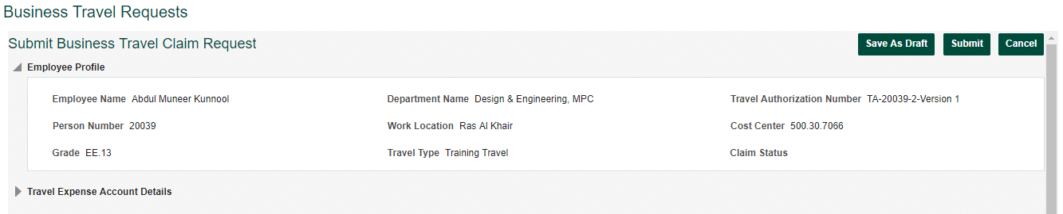

Click on Add Claim button and enter Expense Type, Expense Amount. Select Receipt Applicable as Yes / No. Upload

the receipt (if available) and click on Submit Button.

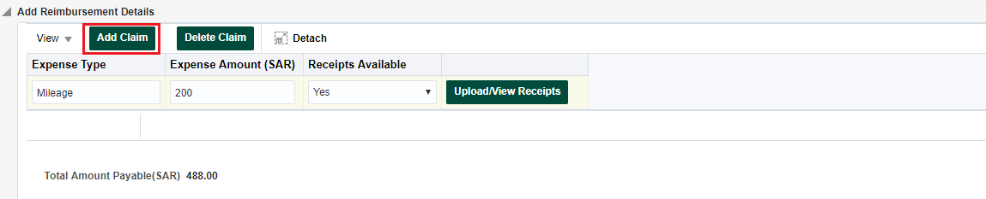

Click OK.

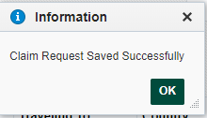

Sample of Notification Triggered to Payroll Team



Saving Plan Enrollment

**Step 1:** Login as Employee in the HCM Application with credentials.



**Step 2:** Click on Saving Plan.

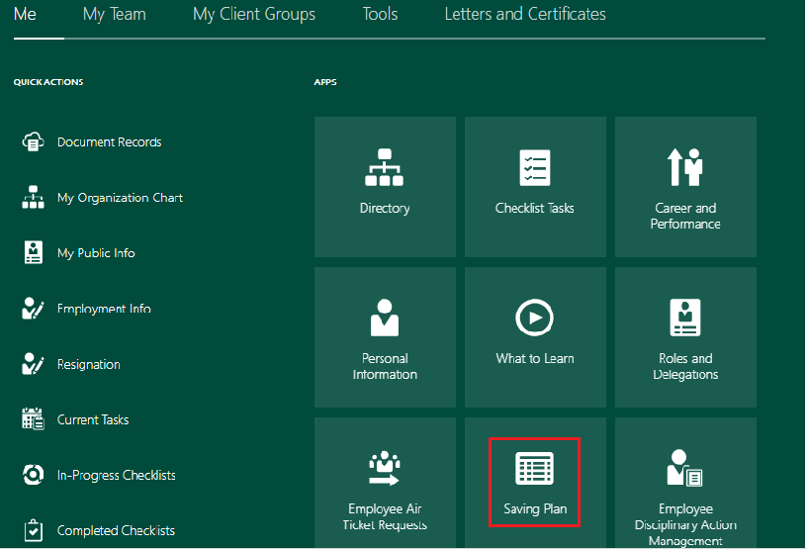

**Step 3:-** To enroll in a Saving Plan, click on Enroll.

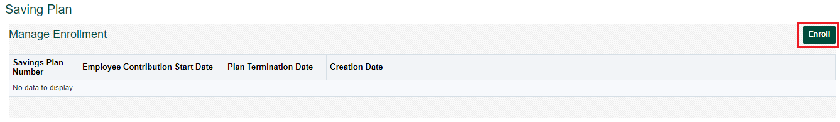

**Step 4**: - Choose Option as ‘Yes /No’ for Enrollment Saving Plan and enter Contribution Percentage value and click on Submit.

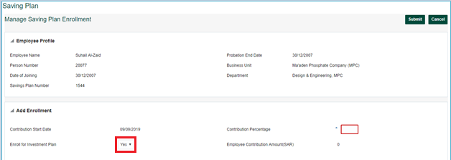

**Step 5**:- Click on OK.

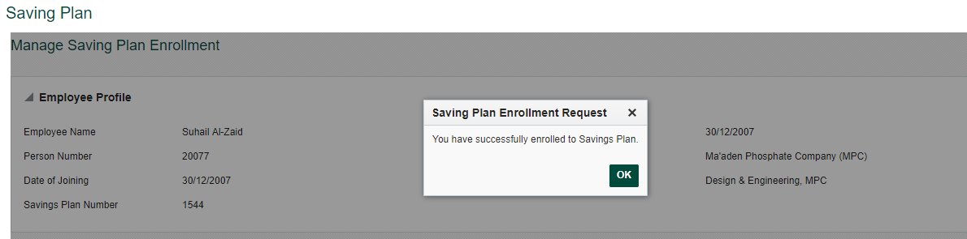

Sample of Notification sent to Payroll Team after enrollment

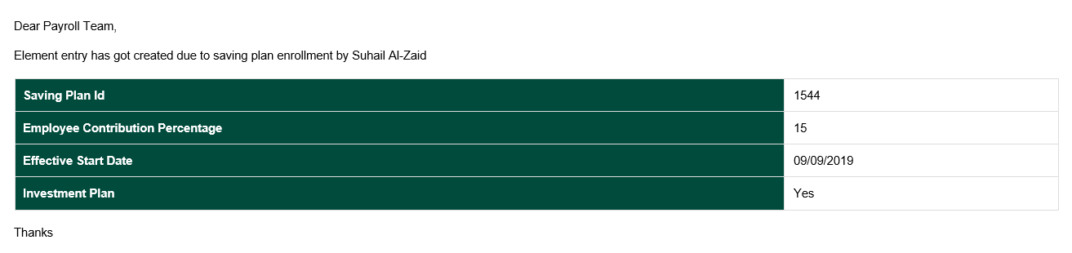

Saving Plan Update

**Step 1:** Login as Employee in the HCM Application with credentials.



**Step 2**:- Click on Saving Plan.



Click on Saving Plan Number to be Updated.

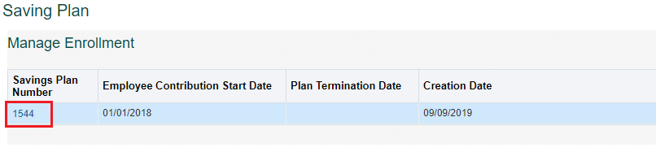

1. **To Revise Contribution**: - Go to Contribution Revision tab and click on Manage Contribution button.

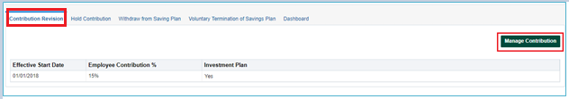

Update the value and click on Submit.

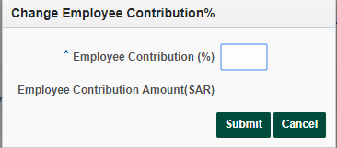

1. **To Put Hold on Contribution**:- Go to Hold Contribution tab and click on Hold Contribution button.

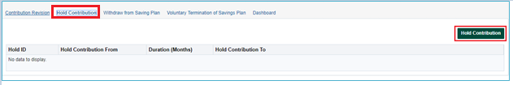

Select the Duration (in months) for which hold is to be created and click on submit.

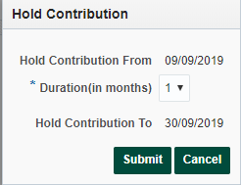

Sample of Notification sent to Payroll Team after Plan put on Hold

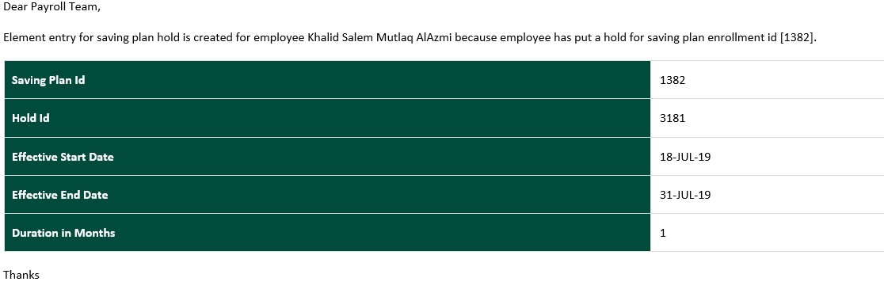

1. **Withdraw from Saving Plan**:- Click on Withdraw from Saving Plan and click on **Add withdrawal Request**.

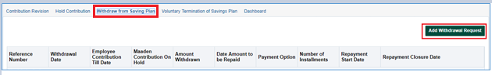

Enter the ‘Amount to Withdraw (SAR)’ & ‘Repayment Option’ (Fixed Payment / Installment) and submit the request.

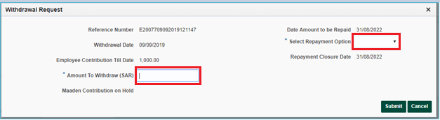

Sample of Notification sent to Payroll Team after Withdrawal

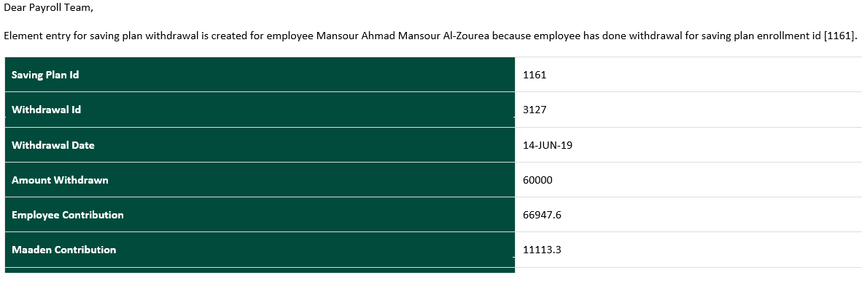

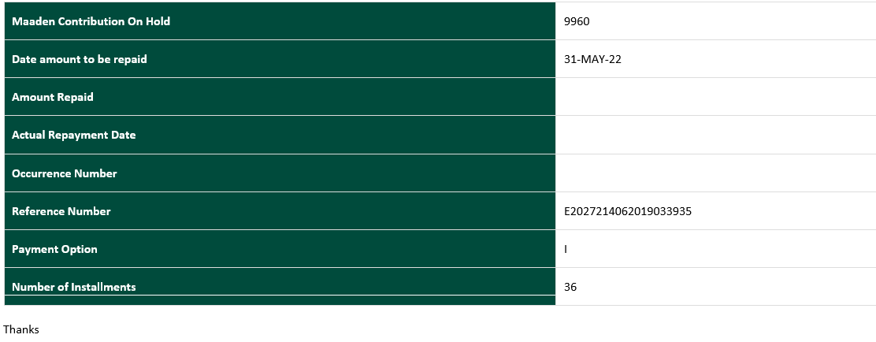

1. **Terminate Saving Plan**:- To Terminate the Saving Plan click on Voluntary Termination of Saving Plan tab. Enter Reason & click Submit.

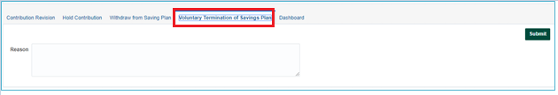

Sample of Notification sent to Payroll Team after Plan Termination

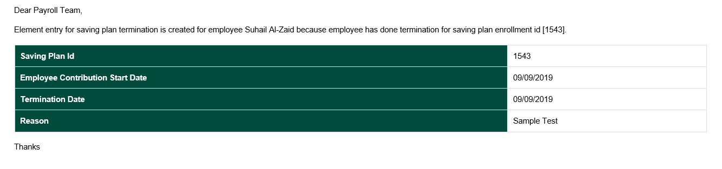

1. **Dashboard**:- Use this tab to view the Employee and Employer Contribution as per latest payroll data.

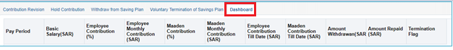

Open and Closed Issues

Open Issues

|  |  |  |  |  |  |
| --- | --- | --- | --- | --- | --- |
| ID | Issue | Resolution | Owner | Target Date | Impact Date |
|  |  |  |  |  |  |
|  |  |  |  |  |  |
|  |  |  |  |  |  |

Closed Issues

|  |  |  |  |  |  |
| --- | --- | --- | --- | --- | --- |
| ID | Issue | Resolution | Owner | Target Date | Impact Date |
|  |  |  |  |  |  |
|  |  |  |  |  |  |
|  |  |  |  |  |  |
|  |  |  |  |  |  |